MODULE 11
SYNTAX ANALYSIS
Syllabus
Syntax Analysis:
Review of Context-Free Grammars – Derivation trees and Parse Trees, A mbiguity.
Top-Down Parsing: Recursive Descent parsing, Predictive parsing, LL(1) Grammars.

1.NEED AND ROLE OF THE PARSER

The parser takes the token produced by lexical analysis and builds the syntax tree (parse tree). The syntax tree can be easily constructed from Context-Free Grammar.

The parser reports syntax errors in an intelligible fashion and recovers from commonly occurring errors to continue processing the remainder of the program.

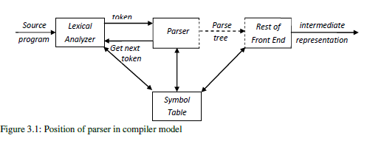
Figure 3.1: Position of parser in compiler model

Role of the Parser:

- Parser builds the parse tree.
- Parser Performs context free syntax analysis.
- Parser helps to construct intermediate code.
- Parser produces appropriate error messages.
- Parser attempts to correct few errors.

Types of parsers for grammars:

Universal parsers

Universal parsing methods such as the Cocke-Younger-Kasami algorithm and Earley's algorithm can parse any grammar. These general methods are too inefficient to use in production. This method is not commonly used in compilers.

Top-down parsers

Top-down methods build parse trees from the top (root) to the bottom (leaves)

Bottom-up parsers.

Bottom-up methods start from the leaves and work their way up to the root.

2 CONTEXT FREE GRAMMARS

2.1 The Formal Definition of a Context-Free Grammar

A context-free grammar G is defined by the 4-tuple: G= (V, T, P S) where

- V is a finite set of non-terminals (variable).
- T is a finite set of terminals.
- P is a finite ∪set of production rules of the form A→α. Where A is nonterminal and α is string of terminals∈ and/or nonterminals. P is a relation from V to (V ∪T)*.

- S is the start symbol (variable S£ V).
Example: The following grammar defines simple arithmetic expressions. In this grammar, the terminal symbols are id + - * / ( ). The nonterminal symbols are expression, term and factor, and expression is the start symbol.

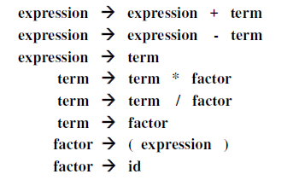
2.2 Notational Conventions

The following notational conventions for grammars can be used

- These symbols are terminals:
  - Lowercase letters early in the alphabet, such as a, b, e.
  - Operator symbols such as +,*, and so on.
  - Punctuation symbols such as parentheses, comma, and so on.
  - The digits 0,1,. . . ,9.
  - Boldface strings such as id or if, each of which represents a single terminal symbol.
- These symbols are nonterminals:
  - Uppercase letters early in the alphabet, such as A, B, C.
  - The letter S is usually the start symbol when which appears.
  - Lowercase, italic names such as expr or stmt.

  - When discussing programming constructs, uppercase letters may be used to represent nonterminals for the constructs. For example, nonterminals for expressions, terms, and factors are often represented by E, T, and F, respectively.

- Uppercase letters late in the alphabet, such as X, Y, Z, represent grammar symbols; that is, either nonterminals or terminals.
- Lowercase letters late in the alphabet, chiefly u, v, . . . , z, represent (possibly empty) strings of terminals.

5. Lowercase Greek letters, α, , for example, represent (possibly empty) strings of grammar symbols. Thus, a generic production can be written as A→ α, where A is the head and α the body.

- A set of productions A→ α₁ , A→ α₂ ,…, A→ α_{k} with a common head A (call them A-productions), may be written A→ α₁ | α₂ |…| α_{k}. call α₁, α₂,…, α_{k} the alternatives for A.

- Unless stated otherwise, the head of the first production is the start symbol.

Example: Using these conventions, the grammar can be rewritten concisely as
E → E + T | E - T | T

T → T * F | T / F | F

F → ( E ) | id

2.3 Derivations

The derivation uses productions to generate a string (set of terminals). The derivation is formed by replacing the nonterminal in the right hand side by suitable production rule.

The derivations are classified into two types based on the order of replacement of production. They are:

- Leftmost derivation

If the leftmost non-terminal is replaced by its production in derivation, then it called leftmost derivation.

- Rightmost derivation

If the rightmost non-terminal is replaced by its production in derivation, then it called rightmost derivation.

LMD and RMD
Leftmost derivation for “abaca”
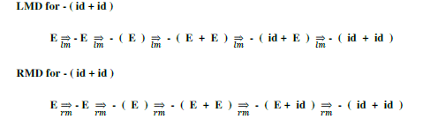

Example :Leftmost derivation for “abaca”
S → SbS
→ abS (using rule S→a)
→ abScS (using rule S→ScS )
→ abacS (using rule S→a)
→ abaca (using rule S →a)
Rightmost derivation for “abaca”
S → ScS
→ Sca (using rule S →a)
→ SbSca (using rule S →SbS )
→ Sbaca (using rule S →a)
→ abaca (using rule S →a)
3.2.4 Parse Trees and Derivations
A parse tree is a graphical representation of a derivation. t is convenient to see how strings are derived from the start symbol. The start symbol of the derivation becomes the root of the parse tree

Construction of parse tree for
- (id + id )

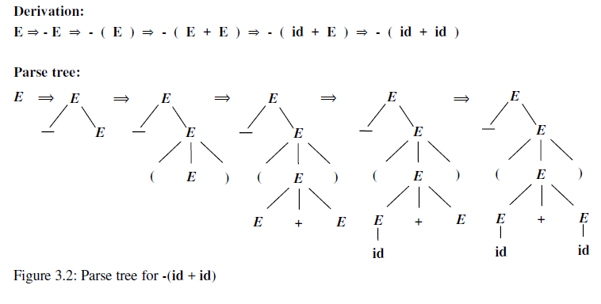

2.5 Ambiguity

A grammar that produces more than one parse tree for some sentence is said to be ambiguous. Put another way, an ambiguous grammar is one that produces more than one leftmost derivation or more than one rightmost derivation for the same sentence.

A grammar G is said to be ambiguous if it has more than one parse tree either in LMD or in RMD for at least one string.

Example The arithmetic expression grammar permits two distinct leftmost derivations for the sentence id + id * id:
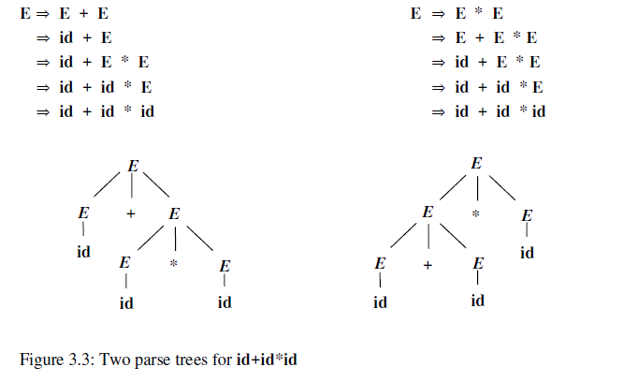
2.8 Left recursion

A context free grammar is said to be left recursive if it has a non terminal A with two productions in the following form.

- →A α | β

Where α and β are sequences of terminals and nonterminals that do not start with A.

Left recursion in top-down parsing can enter into infinite loop. It creates serious problems, so we have avoid Left recursion.

For example, in expr →expr + term | term

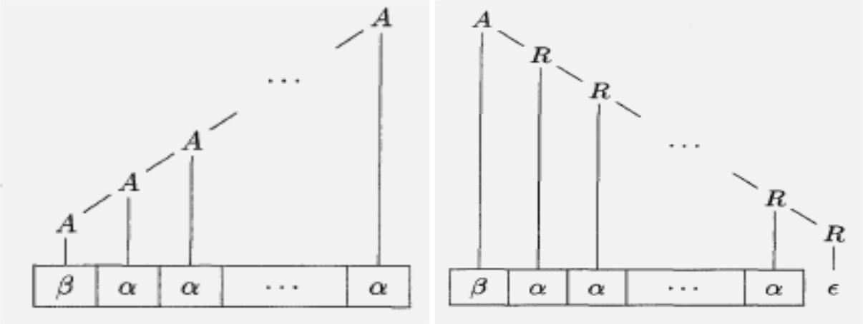

Figure 3.4: Left-recursive and right recursive ways of generating a string

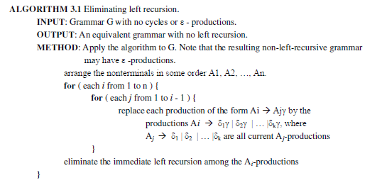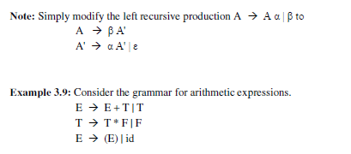

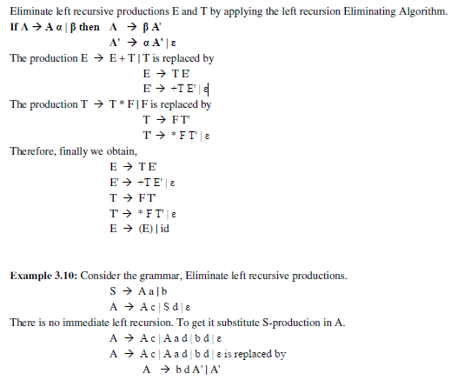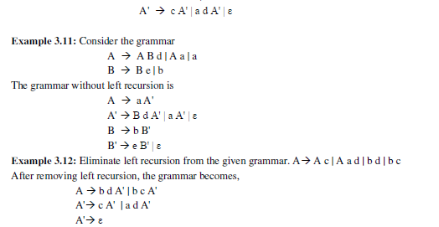

2.9 Left Factoring

Left factoring is a process of factoring out the common prefixes of two or more production alternates for the same nonterminal.
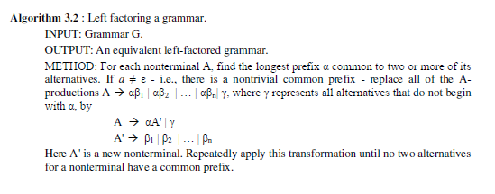

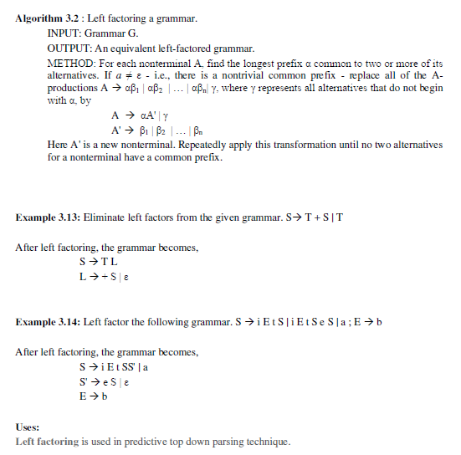

Parsers

There are basically two types of parser:
Top-down parser:
• starts at the root of derivation tree and fills in
• picks a production and tries to match the input
• may require backtracking
• some grammars are backtrack-free (predictive)
Bottom-up parser:
• starts at the leaves and fills in
• starts in a state valid for legal first tokens
• uses a stack to store both state and sentential forms
TOP DOWN PARSING -GENERAL STRATEGIES

Top-down parsing can be viewed as the problem of constructing a parse tree for the input string, starting from the root and creating the nodes of the parse tree in preorder (depth-first). Top-down parsing can be viewed as finding a leftmost derivation for an input string.

Top-down parsers include recursive-descent and LL parsers, while the most common forms of bottom-up parsers are LR parsers.

A top-down parser starts with the root of the parse tree, labeled with the start or goal symbol of the grammar.
• To build a parse, it repeats the following steps until the leaf nodes of the parse tree matches the input string

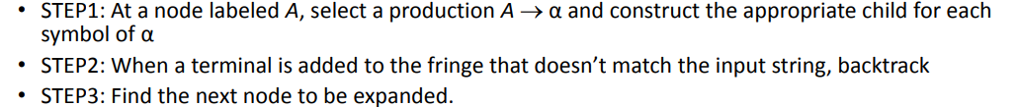

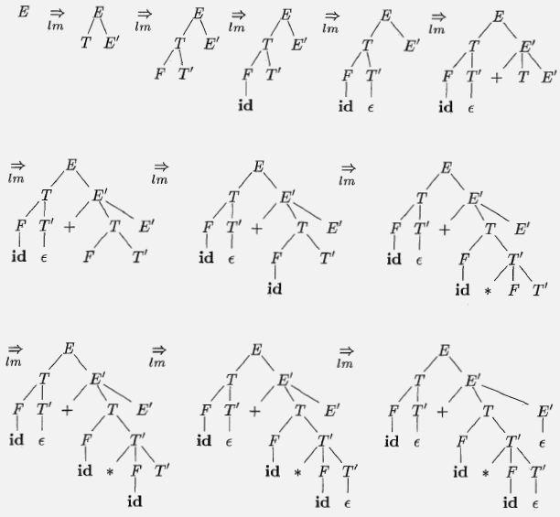

PROBLEMS WITH TOPDOWN PARSING
1)BACKTRACKING
Backtracking is a technique in which for expansion of non-terminal symbol we choose one alternative and if some mismatch occurs then we try another alternative if any. If for a non-terminal there are multiple production rules beginning with the same input symbol then to get the correct derivation we need to try all these alternatives.
2) LEFT RECURSION
Left recursion is a case when the left-most non-terminal in a production of a non-terminal is the non-terminal itself( direct left recursion ) or through some other non-terminal definitions, rewrites to the non-terminal again(indirect left recursion). Consider these examples
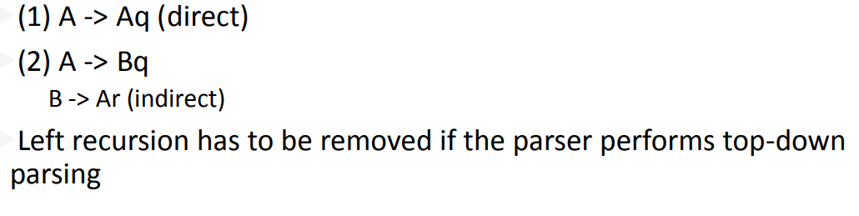
3)LEFT FACTORING
Left factoring is removing the common left factor that appears in two productions of the same non-terminal. It is done to avoid backtracking by the parser.

4)AMBIGUITY

A grammar that produces more than one parse tree for some sentence is said to be ambiguous. Put another way, an ambiguous grammar is one that produces more than one leftmost derivation or more than one rightmost derivation for the same sentence.
Example Consider the grammar

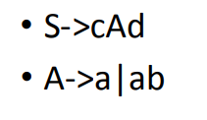
To construct a parse tree top-down for the input string w = cad, begin with a tree consisting of a single node labeled S, and the input pointer pointing to c, the first symbol of w. S has only one production, so we use it to expand S and obtain the tree of Figure 3.7(a). The leftmost leaf, labeled c, matches the first symbol of input w, so we advance the input pointer to a, the second symbol of w, and consider the next leaf, labeled A.

Now, we expand A using the first alternative A→ a b to obtain the tree of Figure 3.7(b). We have a match for the second input symbol, a, so we advance the input pointer to d, the third input symbol, and compare d against the next leaf, labeled b. Since b does not match d, we report failure and go back to A to see whether there is another alternative for A that has not been tried, but that might produce a match

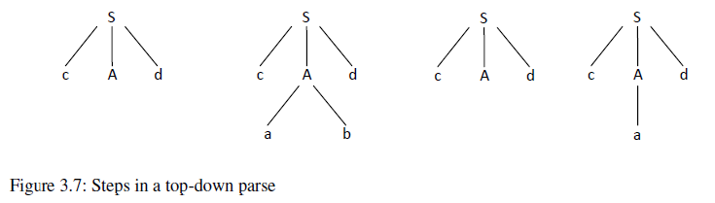

Figure 3.7: Steps in a top-down parse tree

The second alternative for A produces the tree of Figure 3.7(c). The leaf a matches the second symbol of w and the leaf d matches the third symbol. Since we have produced a parse tree for w, we halt and announce successful completion of parsing.

RECURSIVE DESCENT PARSER
A recursive descent parser is a kind of top-down parser built from a set of mutually recursive procedures (or a non-recursive equivalent) where each such procedure usually implements one of the productions of the grammar.

These parsers use a procedure for each nonterminal. The procedure looks at its input and decides which production to apply for its nonterminal. Terminals in the body of the production are matched to the input at the appropriate time, while nonterminals in the body result in calls to their procedure. Backtracking, in the case when the wrong production was chosen, is a possibility.

void A()

{
Choose an A-production, A → X₁ X₂ . . . X_{k};

for (i=l to k)

{
if ( X_{i} is a nonterminal )
call procedure X_{i} () ;

else if ( Xi equals the current input symbol a )

advance the input to the next symbol;

else /* an error has occurred */;

}

}

Suppose the grammar given is as follows:
E -> iE’
E’ -> +iE’
Program:

E()
{
if(l==‘i’)
{
match(‘i’);
E’();
}
}
l=getchar();
E’()
{
if(l==‘+”)
{
match(‘+’);
match(‘i’);
E’();
}
else return ;
}
match(char t)
{
if(l==t)
l=getchar();
else printf(“Error”);
}
main()
{
E();
If(l==‘$’)
{
printf(“parsing successful”);
}
}

PREDICTIVE LL(1) PARSING
• Non-Recursive predictive parsing is a table-driven parser.
• It is a top-down parser.
• It is also known as LL(1) Parser.
• In LL(1) the first “L “ scanning the input from left to right and second “L” producing a leftmost derivation and The “1” in parentheses implies that LL(1) parsing uses only one symbol of input to predict the next grammar rule that should be used.
• It uses stack explicity
• In non recursive predictive parser, production is applied on the parsing
Table

PROPERTIES OF LL(1) GRAMMARS
A grammar whose parsing table has no multiply-defined entries is said
to be LL(1) grammar.

A grammar G is LL(1) if and only if the following conditions hold for
two distinctive production rules A →α and A → β

1.Both α and β cannot derive strings starting with same terminals.

2. At most one of α and βcan derive to ε.

3. If β can derive to ε, then α cannot derive to any string starting with a terminal in FOLLOW(A).

Example:
S→ as | a is not LL(1) because FIRST(aS) = FIRST(a) = { a }

S→aS´
S´ → ε|aS accepts the same language and is LL(1)

The data structures used by LL(1) parser are
1. Input buffer
2. Stack
3. Parsing table

Predictive parser is a recursive descent parser, which has the capability to predict which production is to be used to replace the input string. The predictive parser does not suffer from backtracking.

The construction of predictive LL(1) parser is based on two very important functions and those are First and Follow.

For construction of predictive LL(1) parser we have to follow the following steps

STEP1: compute FIRST and FOLLOW function.
STEP2: construct predictive parsing table using first and follow function.
STEP3: parse the input string with the help of predictive parsing table

First Function

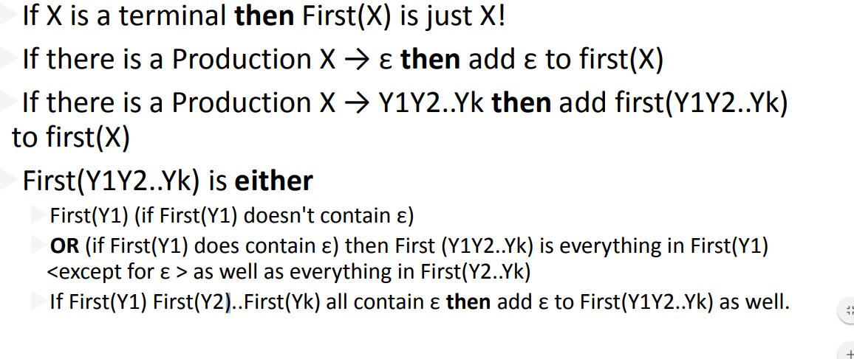
Follow Function

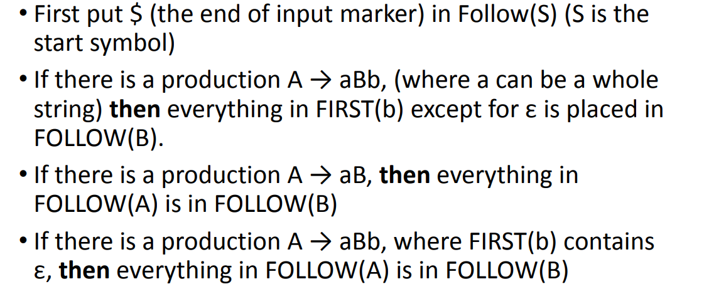

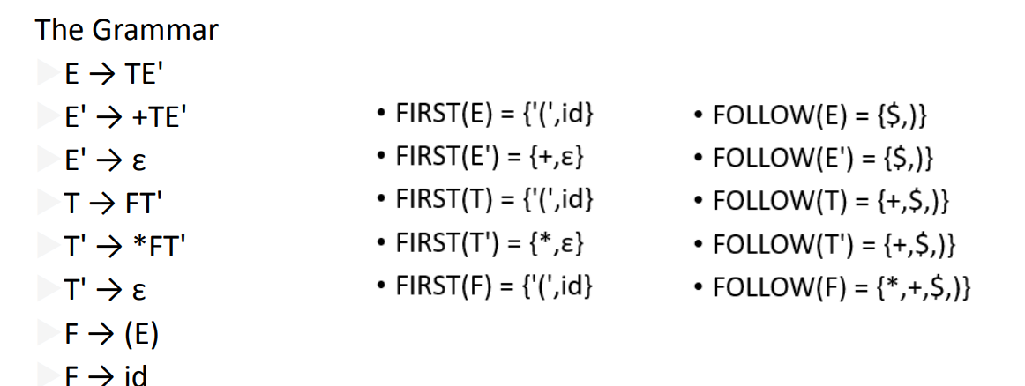

PREDICTIVE PARSING TABLE

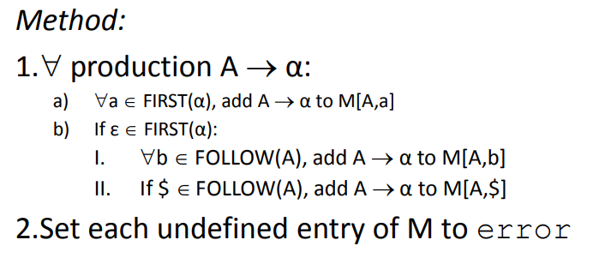

A nonrecursive predictive parser can be built by maintaining a stack explicitly, rather than implicitly via recursive calls. The parser mimics a leftmost derivation.

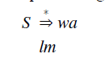
The table-driven parser in Figure 3.8 has an input buffer, a stack containing a sequence of grammar symbols, a parsing table constructed, and an output stream. The input buffer contains the string to be parsed, followed by the endmarker $. We reuse the symbol $ to mark the bottom of the stack, which initially contains the start symbol of the grammar on top of $.

The parser is controlled by a program that considers X, the symbol on top of the stack, and a, the current input symbol. If X is a nonterminal, the parser chooses an X-production by consulting entry M[X, a] of the parsing table M. Otherwise, it checks for a match between the terminal X and current input symbol a.

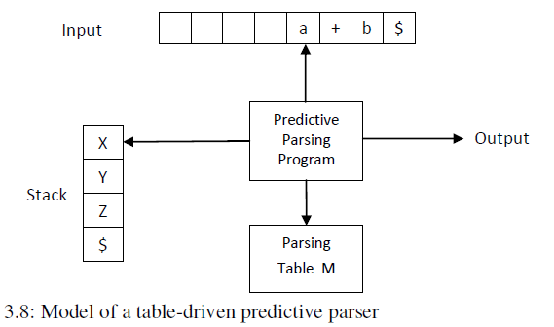

Algorithm for Table-driven predictive parsing.
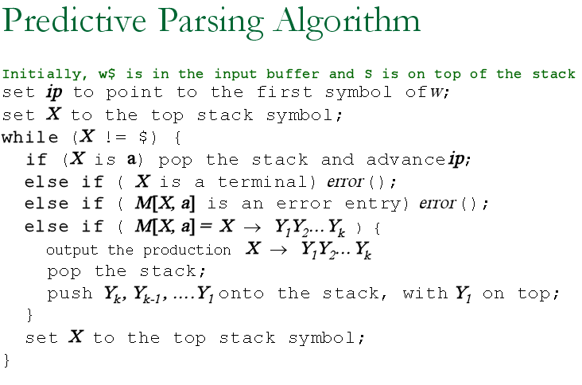

Consider grammar for the input id + id * id using the nonrecursive predictive parser.
E →TE'
E' →+ T E' | ε
T → F T'
T' → * F T' | ε
F → ( E ) | id
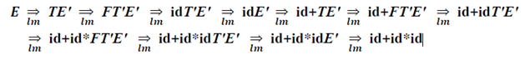
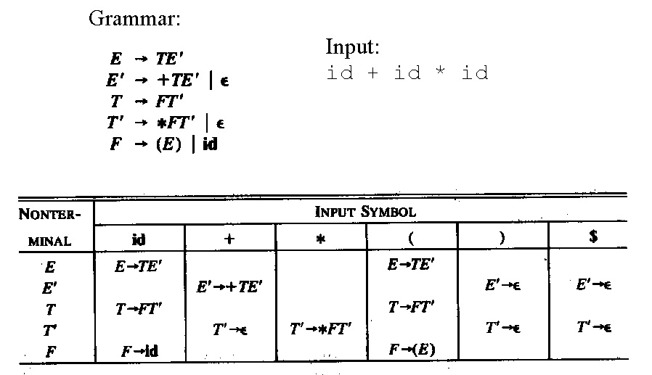

and the execution trace of the interpreter for the sentence "id + id * id"

