CS 304: COMPILER DESIGN

MODULE 1
Syllabus
Introduction to compilers – Analysis of the source program,
Phases of a compiler, Grouping of phases, compiler writing tools
– bootstrapping
Lexical Analysis:
The role of Lexical Analyzer, Input Buffering, Specification of
Tokens using Regular Expressions, Review of Finite Automata,
Recognition of Tokens.

TRANSLATORS

A translator is one kind of program that takes one form of program (input) and converts into another form (output). The input program is called source language and the output program is called target language.

The source language can be low level language like assembly language or a high level language like C, C++, JAVA, FORTRAN, and so on.

The target language can be a low level language (assembly language) or a machine language (set of instructions executed directly by a CPU).

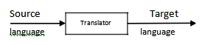

Figure : Translator

Types of Translators are:

(1). Compilers

(2). Interpreters

(3). Assemblers

COMPILATION AND INTERPRETATION

A compiler is a program that reads a program in one language and translates it into an equivalent program in another language. The translation done by a compiler is called compilation.

An interpreter is another common kind of language processor. Instead of producing a target program as a translation, an interpreter appears to directly execute the operations specified in the source program on inputs supplied by the user. An interpreter executes the source program statement by statement. The translation done by an interpreter is called Interpretation.

LANGUAGE PROCESSORS

Compiler

A compiler is a program that can read a program in one language (the source language) and translate it into an equivalent program in another language (the target language) compilation is shown in Figure

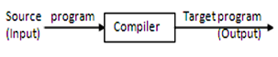

An important role of the compiler is to report any errors in the source program that it detects during the translation process.
Interpreter

An interpreter is another common kind of language processor. Instead of producing a target program as a translation, an interpreter appears to directly execute the operations specified in the source program on inputs supplied by the user, as shown in Figure

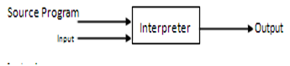

Language Processing System
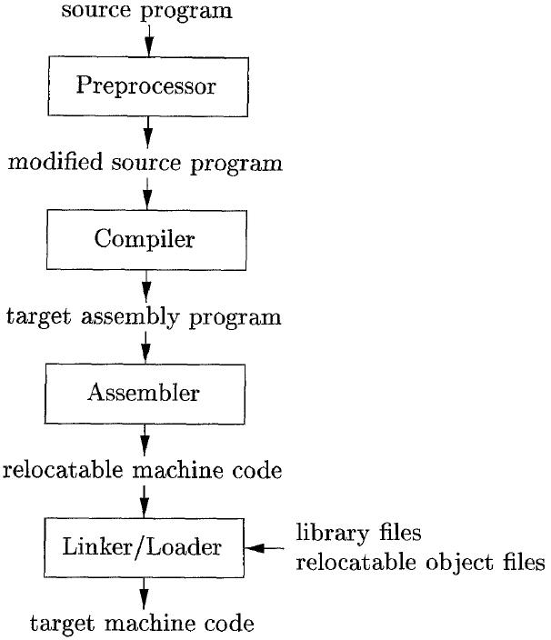
We have learnt that any computer system is made of hardware and software. The hardware understands a language, which humans cannot understand. So we write programs in high-level language, which is easier for us to understand and remember. These programs are then fed into a series of tools and OS components to get the desired code that can be used by the machine. This is known as Language Processing System

Preprocessor
A preprocessor, generally considered as a part of compiler, is a tool that produces input for compilers. It deals with macro-processing, augmentation, file inclusion, language extension, etc.

Interpreter
An interpreter, like a compiler, translates high-level language into low-level machine language. The difference lies in the way they read the source code or input. A compiler reads the whole source code at once, creates tokens, checks semantics, generates intermediate code, executes the whole program and may involve many passes. In contrast, an interpreter reads a statement from the input, converts it to an intermediate code, executes it, then takes the next statement in sequence. If an error occurs, an interpreter stops execution and reports it; whereas a compiler reads the whole program even if it encounters several errors.

Assembler
An assembler translates assembly language programs into machine code. The output of an assembler is called an object file, which contains a combination of machine instructions as well as the data required to place these instructions in memory.

Linker
Linker is a computer program that links and merges various object files together in order to making executable file. All these files might have been compiled by separate assemblers. The major task of a linker is to search and locate referenced module/routines in a program and to determine the memory location where these codes will be loaded, making the program instruction to have absolute references.

Loader
Loader is a part of operating system and is responsible for loading executable files into memory and executes them. It calculates the size of a program (instructions and data) and creates memory space for it. It initializes various registers to initiate execution.

PHASES OF A COMPILER:

A compiler operates in phases. A phase is a logically interrelated operation that takes source program in one representation and produces output in another representation. The phases of a compiler are shown in below

There are two phases of compilation.
a) Analysis (Machine Independent/Language Dependent)
b) Synthesis (Machine Dependent/Language independent)

The analysis part carried out in three phases, they are lexical analysis, syntax analysis and Semantic Analysis. The analysis part is often called the front end of the compiler. The synthesis part constructs the desired target program from the intermediate representation and the information in the symbol table.

The synthesis part carried out in three phases, they are Intermediate Code Generation, Code Optimization and Code Generation. The synthesis part is called the back end of the compiler.
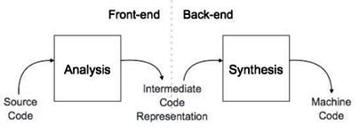
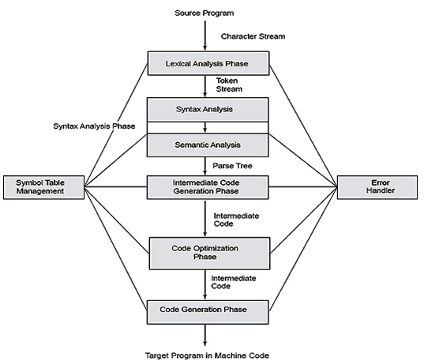

Lexical Analysis

The first phase of a compiler is called lexical analysis or scanning or linear analysis. The lexical analyzer reads the stream of characters making up the source program and groups the characters into meaningful sequences called lexemes.For each lexeme, the lexical analyzer produces as output a token of the form

<token-name, attribute-value>

The first component token-name is an abstract symbol that is used during syntax analysis, and the second component attribute-value points to an entry in the symbol table for this token. Information from the symbol-table entry 'is needed for semantic analysis and code generation. For example, suppose a source program contains the assignment statement

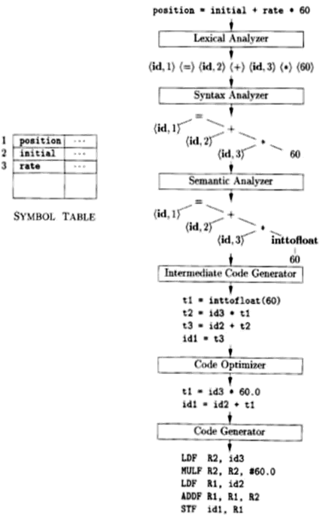

Fig: Translation of an assignment statement position = initial + rate * 60

The characters in this assignment could be grouped into the following lexemes and mapped into the following tokens.

- position is a lexeme that would be mapped into a token <id,1>. where id is an abstract symbol standing for identifier and 1 points to the symbol able entry for position.

- The assignment symbol = is a lexeme that is mapped into the token <=>.
- initial is a lexeme that is mapped into the token <id, 2>.
- + is a lexeme that is mapped into the token <+>.
- rate is a lexeme that is mapped into the token <id, 3>.
- * is a lexeme that is mapped into the token <*>.
- 60 is a lexeme that is mapped into the token <60>.

Blanks separating the lexemes would be discarded by the lexical analyzer. The sequence of tokens produced as follows after lexical analysis.

<id, 1> <=> <id, 2> <+> <id, 3> <*> <60>

Syntax Analysis

The second phase of the compiler is syntax analysis or parsing or hierarchical analysis.

The parser uses the first components of the tokens produced by the lexical analyzer to create a tree-like intermediate representation that depicts the grammatical structure of the token stream.

The hierarchical tree structure generated in this phase is called parse tree or syntax tree.

In a syntax tree, each interior node represents an operation and the children of the node represent the arguments of the operation.

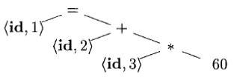

Figure 1.9: Syntax tree for position = initial + rate * 60

The tree has an interior node labeled * with <id, 3> as its left child and the integer 60 as its right child. The node <id, 3> represents the identifier rate. Similarly <id,2> and <id, 1> are represented as in tree. The root of the tree, labeled =, indicates that we must store the result of this addition into the location for the identifier position.

Semantic Analysis

The semantic analyzer uses the syntax tree and the information in the symbol table to check the source program for semantic consistency with the language definition.

It ensures the correctness of the program, matching of the parenthesis is also done in this phase.

It also gathers type information and saves it in either the syntax tree or the symbol table, for subsequent use during intermediate-code generation.

An important part of semantic analysis is type checking, where the compiler checks that each operator has matching operands.

The compiler must report an error if a floating-point number is used to index an array. The language specification may permit some type conversions like integer to float for float addition is called coercions.

The operator * is applied to a floating-point number rate and an integer 60. The integer may be converted into a floating-point number by the operator inttofloat explicitly as shown in the
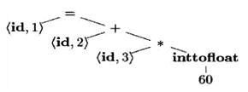
Fig: Semantic tree for position = initial + rate * 60

Intermediate Code Generation

After syntax and semantic analysis of the source program, many compilers generate an explicit low-level or machine-like intermediate representation.

The intermediate representation has two important properties:

- It should be easy to produce
- It should be easy to translate into the target machine.
Three-address code is one of the intermediate representations, which consists of a sequence of assembly-like instructions with three operands per instruction. Each operand can act like a register. The output of the intermediate code generator consists of the three-address code sequence for position = initial + rate * 60

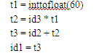

Code Optimization

The machine-independent code-optimization phase attempts to improve the intermediate code so that better target code will result. Usually better means faster.

Optimization has to improve the efficiency of code so that the target program running time and consumption of memory can be reduced.

The optimizer can deduce that the conversion of 60 from integer to floating point can be done once and for all at compile time, so the inttofloat operation can be eliminated by replacing the integer 60 by the floating-point number 60.0.

Moreover, t3 is used only once to transmit its value to id1 so the optimizer can transform) into the shorter sequence

t1= id3 * 60.0

id1 = id2 + t1

Code Generation

The code generator takes as input an intermediate representation of the source program and maps it into the target language. If the target language is machine code, then the registers or memory locations are selected for each of the variables used by the program. The intermediate instructions are translated into sequences of machine instructions. For example, using registers R1 and R2, the intermediate code might get translated into the machine code

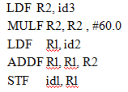

The first operand of each instruction specifies a destination. The F in each instruction tells us that it deals with floating-point numbers.

The code loads the contents of address id3 into register R2, then multiplies it with floating-point constant 60.0. The # signifies that 60.0 is to be treated as an immediate constant. The third instruction moves id2 into register R1 and the fourth adds to it the value previously computed in register R2. Finally, the value in register R1 is stored into the address of id1, so the code correctly implements the assignment statement

Symbol-Table Management

- The symbol table, which stores information about the entire source program, is used by all phases of the compiler.

- An essential function of a compiler is to record the variable names used in the source program and collect information about various attributes of each name.

- These attributes may provide information about the storage allocated for a name, its type, its scope.

- In the case of procedure names, such things as the number and types of its arguments, the method of passing each argument (for example, by value or by reference), and the type returned are maintained in symbol table.

- The symbol table is a data structure containing a record for each variable name, with fields for the attributes of the name. The data structure should be designed to allow the compiler to find the record for each name quickly and to store or retrieve data from that record quickly.

- A symbol table can be implemented in one of the following ways:
  - Linear (sorted or unsorted) list
  - Binary Search Tree
  - Hash table

- Among the above all, symbol tables are mostly implemented as hash tables, where the source code symbol itself is treated as a key for the hash function and the return value is the information about the symbol.

- A symbol table may serve the following purposes depending upon the language in hand:
  - To store the names of all entities in a structured form at one place.
  - To verify if a variable has been declared.
  - To implement type checking, by verifying assignments and expressions.
  - To determine the scope of a name (scope resolution).

ERRORS ENCOUNTERED IN DIFFERENT PHASES

- An important role of the compiler is to report any errors in the source program that it detects during the entire translation process.

- Each phases of compiler can encounter errors, after detecting errors, must be corrected to precede compilation process.

- The syntax and semantic phases handles large number of errors in compilation process.

- Error handler handles all types of errors like lexical errors, syntax errors, semantic errors and logical errors.

Lexical errors:

  - Lexical analyzer detects errors from input characters.
  - Name of some keywords identifiers typed incorrectly.

  - Example: switch is written as swich.

Syntax errors:

  - Syntax errors are detected by syntax analyzer.
  - Errors like semicolon missing or unbalanced parenthesis.
  - Example: ((a+b* (c-d)). In this statement ) missing after b.

Semantic errors:

  - Data type mismatch errors handled by semantic analyzer.
  - Incompatible data type vale assignment.
  - Example: Assigning a string value to integer.

Logical errors:

    - Code note reachable and infinite loops.
    - Misuse of operators . Codes written after end of main() block

THE GROUPING OF PHASES

Each phases deals with the logical organization of a compiler.

Activities of several phases may be grouped together into a pass that reads an input file and writes an output file.

The front-end phases of lexical analysis, syntax analysis, semantic analysis, and intermediate code generation might be grouped together into one pass.

Code optimization might be an optional pass.
A back end pass consisting of code generation for a particular target machine.

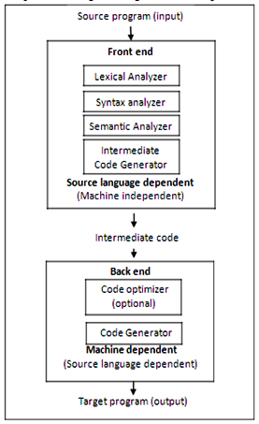

Fig: The Grouping of Phases of compiler

Some compiler collections have been created around carefully designed intermediate representations that allow the front end for a particular language to interface with the back end for a certain target machine.

Advantages:

With these collections, we can produce compilers for different source languages for one target machine by combining different front ends.

Similarly, we can produce compilers for different target machines, by combining a front end for different target machines.

Passes
• The phases of compiler can be implemented in a single pass by marking the primary actions viz. reading of input file and writing to the output file.
• Several phases of compiler are grouped into one pass in such a way that the operations in each and every phase are incorporated during the pass.
• (eg.) Lexical analysis, syntax analysis, semantic analysis and intermediate code generation might be grouped into one pass. If so, the token stream after lexical analysis may be translated directly into intermediate code.

Reducing the Number of Passes
• Minimizing the number of passes improves the time efficiency as reading from and writing to intermediate files can be reduced.
• When grouping phases into one pass, the entire program has to be kept in memory to ensure proper information flow to each phase because one phase may need information in a different order than the information produced in previous phase.
The source program or target program differs from its internal representation. So, the memory for internal form may be larger than that of input and output.
COMPILER CONSTRUCTION TOOLS

The compiler writer, like any software developer, can profitably use modern software development environments containing tools such as language editors, debuggers, version managers, profilers, test harnesses, and so on.

Writing a compiler is a tedious and time consuming task; there are some specialized tools to implement various phases of a compiler. These tools are called Compiler Construction Tools.

Some commonly used compiler-construction tools are given below:

• | Scanner generators | [Lexical Analysis]
• | Parser generators | [Syntax Analysis]
• | Syntax-directed translation engines | [Intermediate Code]
• | Data-flow analysis engines | [Code Optimization]
• | Code-generator generators | [Code Generation]
• | Compiler-construction toolkits | [For all phases]

- Scanner generators that produce lexical analyzers from a regular-expression description of the tokens of a language. Unix has a tool for Scanner generator called LEX.

- Parser generators that automatically produce syntax analyzers (parse tree) from a grammatical description of a programming language. Unix has a tool called YACC which is a parser generator.

- Syntax-directed translation engines that produce collections of routines for walking a parse tree and generating intermediate code.

- Data-flow analysis engines that facilitate the gathering of information about how values are transmitted from one part of a program to each other part. Data-flow analysis is a key part of code optimization.

- Code-generator generators that produce a code generator from a collection of rules for translating each operation of the intermediate language into the machine language for a target machine.

- Compiler-construction toolkits that provide an integrated set of routines for constructing various phases of a compiler.

BOOTSTRAPPING

Bootstrapping is a process in which simple language is used to translate more complicated program which in turn may handle far more complicated program.
This complicated program can further handle even more complicated program and so on.
Writing a compiler for any high level language is a complicated process. It takes lot of time to write a compiler from scratch. Hence, simple language is used to generate target code in some stages.
A compiler is characterized by three languages:
- Source Language
- Target Language
- implementation Language
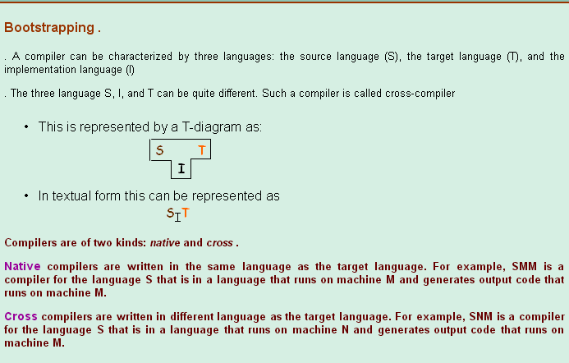
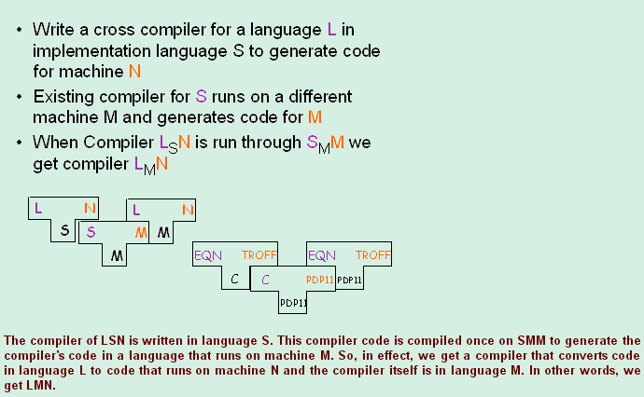

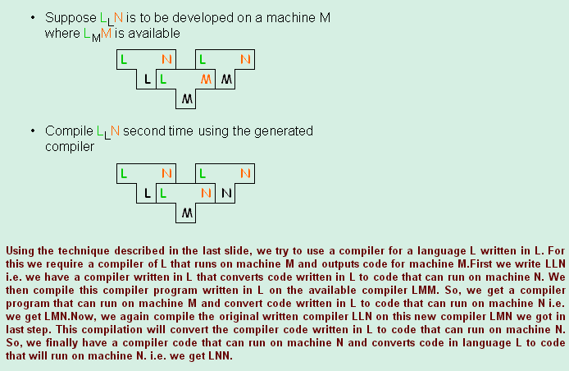

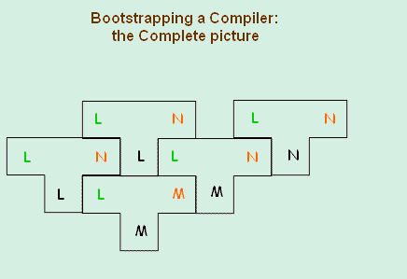

LEXICAL ANALYSIS

NEED AND ROLE OF LEXICAL ANALYZER

- Lexical Analysis is the first phase of compiler. It reads the input characters from left to right, one character at a time, from the source program.

- It generates the sequence of tokens for each lexeme. Each token is a logical cohesive unit such as identifiers, keywords, operators and punctuation marks.

- It needs to enter that lexeme into the symbol table and also reads from the symbol table.

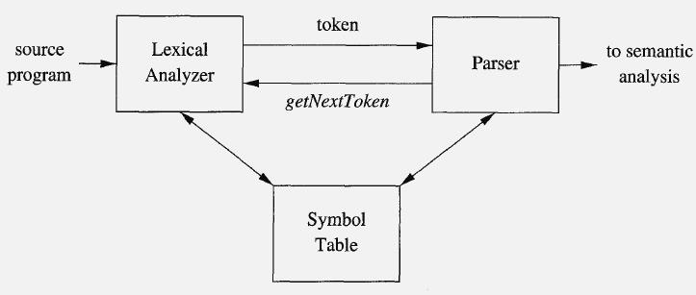

Figure: Interactions between the lexical analyzer and the parser

Since the lexical analyzer is the part of the compiler that reads the source text, it may perform certain other tasks besides identification of lexemes. One such task is stripping out comments and whitespace (blank, newline, tab). Another task is correlating error messages generated by the compiler with the source program.

Needs / Roles / Functions of lexical analyzer

- It produces stream of tokens.
- It eliminates comments and whitespace.
- It keeps track of line numbers.
- It reports the error encountered while generating tokens.
- It stores information about identifiers, keywords, constants and so on into symbol table.

Lexical analyzers are divided into two processes:

- Scanning consists of the simple processes that do not require tokenization of the input, such as deletion of comments and compaction of consecutive whitespace characters into one.

- Lexical analysis is the more complex portion, where the scanner produces the sequence of tokens as output.

Lexical Analysis versus Parsing / Issues in Lexical analysis

- Simplicity of design: It is the most important consideration. The separation of lexical and syntactic analysis often allows us to simplify tasks. whitespace and comments removed by the lexical analyzer.

- Compiler efficiency is improved. A separate lexical analyzer allows us to apply specialized techniques that serve only the lexical task, not the job of parsing. In addition, specialized buffering techniques for reading input characters can speed up the compiler significantly.

- Compiler portability is enhanced. Input-device-specific peculiarities can be restricted to the lexical analyzer.

Tokens, Patterns, and Lexemes

A token is a pair consisting of a token name and an optional attribute value. The token name is an abstract symbol representing a kind of single lexical unit, e.g., a particular keyword, or a sequence of input characters denoting an identifier. Operators, special symbols and constants are also typical tokens.

A pattern is a description of the form that the lexemes of a token may take. Pattern is set of rules that describe the token. A lexeme is a sequence of characters in the source program that matches the pattern for a token.

Tokens and Lexemes

TOKEN | INFORMAL | DESCRIPTION | SAMPLE LEXEMES
 | (PATTERN)
if | characters i, f |  | if
else | characters e, l, s, e |  | else
comparison | < or > or <= or >= or == or != |  | <=, !=
id | Letter, followed by letters and digits |  | pi, score, D2, sum, id_1, AVG
number | any numeric constant |  | 35, 3.14159, 0, 6.02e23
literal | anything surrounded by “ ” |  | “Core”, “Design”

In many programming languages, the following classes cover most or all of the tokens:

- One token for each keyword. The pattern for a keyword is the same as the keyword itself.

- Tokens for the operators, either individually or in classes such as the token comparison
- One token representing all identifiers.
- One or more tokens representing constants, such as numbers and literal strings.

- Tokens for each punctuation symbol, such as left and right parentheses, comma, and semicolon

Attributes for Tokens

When more than one lexeme can match a pattern, the lexical analyzer must provide the subsequent compiler phases additional information about the particular lexeme that matched.

The lexical analyzer returns to the parser not only a token name, but an attribute value that describes the lexeme represented by the token.

The token name influences parsing decisions, while the attribute value influences translation of tokens after the parse.

Information about an identifier - e.g., its lexeme, its type, and the location at which it is first found (in case an error message) - is kept in the symbol table.

Thus, the appropriate attribute value for an identifier is a pointer to the symbol-table entry for that identifier.

Note that in certain pairs, especially operators, punctuation, and keywords, there is no need for an attribute value. In this example, the token number has been given an integer-valued attribute.

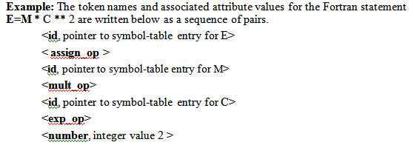

LEXICAL ERRORS

It is hard for a lexical analyzer to tell that there is a source-code error without the aid of other components.

Consider a C program statement fi ( a == f(x)). The lexical analyzer cannot tell whether fi is a misspelling of the keyword if or an undeclared function identifier. Since fi is a valid lexeme for the token id, the lexical analyzer must return the token id to the parser.

The lexical analyzer is unable to proceed because none of the patterns for tokens matches any prefix of the remaining input. The simplest recovery strategy is "panic mode" recovery.

We delete successive characters from the remaining input, until the lexical analyzer can find a well-formed token at the beginning of what input is left.

Other possible error-recovery actions are:

- Delete one character from the remaining input.
- Insert a missing character into the remaining input.
- Replace a character by another character.
- Transpose two adjacent characters.

Transformations like these may be tried in an attempt to repair the input. The simplest such strategy is to see whether a prefix of the remaining input can be transformed into a valid lexeme by a single transformation.

In practice most lexical errors involve a single character. A more general correction strategy is to find the smallest number of transformations needed to convert the source program into one that consists only of valid lexemes.

EXPRESSING TOKENS BY REGULAR EXPRESSIONS

Specification of Tokens

Regular expressions are an important notation for specifying lexeme patterns. We cannot express all possible patterns, they are very effective in specifying those types of patterns that we actually need for tokens.

Strings and Languages

An alphabet is any finite set of symbols. Examples of symbols are letters, digits, and punctuation. The set {0,1) is the binary alphabet. ASCII is an important example of an alphabet.

A string (sentence or word) over an alphabet is a finite sequence of symbols drawn from that alphabet. The length of a string s, usually written |s|, is the number of occurrences of symbols in s. For example, banana is a string of length six. The empty string, denoted ε, is the string of length zero.

A language is any countable set of strings over some fixed alphabet. Abstract languages like Φ, the empty set, or { ε }, the set containing only the empty string, are languages under this definition.

Parts of Strings:

- A prefix of string s is any string obtained by removing zero or more symbols from the end of s. For example, ban, banana, and ε are prefixes of banana.

- A sufix of string s is any string obtained by removing zero or more symbols from the beginning of s. For example, nana, banana, and ε are suffixes of banana.

- A substring of s is obtained by deleting any prefix and any suffix from s. For instance, banana, nan, and ε are substrings of banana.

- The proper prefixes, suffixes, and substrings of a string s are those, prefixes, suffixes, and substrings, respectively, of s that are not ε or not equal to s itself.

- A subsequence of s is any string formed by deleting zero or more not necessarily consecutive positions of s. For example, baan is a subsequence of banana.

- If x and y are strings, then the concatenation of x and y, denoted xy, is the string formed by appending y to x.

Operations on Languages

In lexical analysis, the most important operations on languages are union, concatenation, and closure, which are defined in Foll table.

Table: Definitions of operations on languages
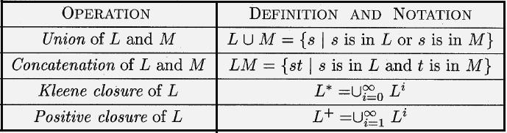

Example:: Let L be the set of letters {A, B, . . . , Z, a, b, . . . , z) and let D be the set of digits {0,1,..
.9). Other languages that can be constructed from languages L and D

- L U D is the set of letters and digits - strictly speaking the language with 62 strings of length one, each of which strings is either one letter or one digit.

- LD is the set df 520 strings of length two, each consisting of one letter followed by one digit.
- L4 is the set of all 4-letter strings.
- L* is the set of ail strings of letters, including e, the empty string.
- L(L U D)* is the set of all strings of letters and digits beginning with a letter.
- D+ is the set of all strings of one or more digits.

Regular expression

Regular expression can be defined as a sequence of symbols and characters expressing a string or pattern to be searched.

Regular expressions are mathematical representation which describes the set of strings of specific language.

Regular expression for identifiers represented by letter_ ( letter_ | digit )*. The vertical bar means union, the parentheses are used to group subexpressions, and the star means "zero or more occurrences of".

Each regular expression r denotes a language L(r), which is also defined recursively from the languages denoted by r's subexpressions.

The rules that define the regular expressions over some alphabet Σ.

Basis rules:

- ε is a regular expression, and L(ε) is { ε }.
- If a is a symbol in Σ , then a is a regular expression, and L(a) = {a}, that is, the language with one string of length one.

- Induction rules: Suppose r and s are regular expressions denoting languages L(r) and L(s), respectively.

- (r) | (s) is a regular expression denoting the language L(r) U L(s).
- (r) (s) is a regular expression denoting the language L(r) L(s) .
- (r) * is a regular expression denoting (L (r)) * .

- (r) is a regular expression denoting L(r). i.e., Additional pairs of parentheses around expressions.

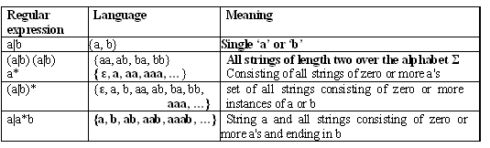

A language that can be defined by a regular expression is called a regular set. If two regular expressions r and s denote the same regular set, we say they are equivalent and write r = s. For instance, (a|b) = (b|a), (a|b)*= (a*b*)*, (b|a)*= (a|b)*, (a|b) (b|a) =aa|ab|ba|bb.

Algebraic laws

Algebraic laws that hold for arbitrary regular expressions r, s, and t:
LAW | DESCRIPTION
r|s = s|r | | is commutative
r(s|t) = (r|s)t | | is associative
r(st) = (rs)t | Concatenation is associative
r(s|t) = rs|rt; (s|t)r = sr|tr | Concatenation distributes over |
ε r = r ε = r | ε | ε is the identity for concatenation
r* = (r |ε)* | ε | ε is guaranteed in a closure
r** = r* | * is idempotent

REGULAR DEFINITIONS:
For notational convenience, we may wish to give names to regular expressions and to define
regular expressions using these names as if they were symbols.Identifiers are the set or string of letters and digits beginning with a letter. The following regular definition provides a precise specification for this class of string.
Example

Letter A | B | ......| Z |a | b |......| z|
Digits 0 | 1 | 2 | .... | 9
Id letter (letter / digit)*

Extensions of Regular Expressions

Few notational extensions that were first incorporated into Unix utilities such as Lex that are particularly useful in the specification lexical analyzers.

- One or more instances: The unary, postfix operator + represents the positive closure of a regular expression and its language. If r is a regular expression, then (r)+ denotes the language (L(r))⁺. The two useful algebraic laws, r* = r⁺|ε and r⁺ = rr* = r*r.
- Zero or one instance: The unary postfix operator ? means "zero or one occurrence."
That is, r? is equivalent to r|ε , L(r?) = L(r) U {ε}.

- Character classes: A regular expression a1|a2|…|an, where the ai's are each symbols of the alphabet, can be replaced by the shorthand [a1, a2, …an]. Thus, [abc] is shorthand for a|b|c, and [a-z] is shorthand for a|b|…|z.

Example: Regular definition for C identifier

Letter [A-Z a-z_]

digit [0-9]

id letter_ ( letter_ | digit )*

Example: Regular definition unsigned integer

digit [0-9]

digits digit⁺

number digits ( . digits)? ( E [+ -]? digits )?

Note: The operators *, +, and ? has the same precedence and associativity

RECOGNITION OF TOKENS

Consider the following grammar fragment:
stmt → if expr then stmt
| if expr then stmt else stmt | ε
expr → term relop term
| term
term → id | num
where the terminals if , then, else, relop, id and num generate sets of strings given by the following regular definitions:
if → if
then → then
else → else
relop → <|<=|=|<>|>|>=
id → letter(letter|digit)*
num → digit⁺ (.digit⁺)?(E(+|-)?digit⁺)?

We also want the lexer to remove whitespace so we define a new token
ws → ( blank | tab | newline ) +
where blank, tab, and newline are symbols used to represent the corresponding ascii characters.
Recall that the lexer will be called by the parser when the latter needs a new token. If the lexer then recognizes the token ws, it does not return it to the parser but instead goes on to recognize the next token, which is then returned.
Our goal for the lexical analyzer is to isolate each lexeme and produce as output a pair consisting of token name and attribute value Note that for the six relational operators, symbolic constants LT, LE, and so on are used as the attribute value, in order to indicate which instance of the token relop we have found

Lexeme | Token | Attribute
Whitespace | ws | —
if | if | —
then | then | —
else | else | —
An identifier | id | Pointer to table entry
A number | number | Pointer to table entry
< | relop | LT
<= | relop | LE
= | relop | EQ
<> | relop | NE
> | relop | GT
>= | relop | GE

For this language fragment the lexical analyzer will recognize the keywords if, then, else, as well as the lexemes denoted by relop, id, and num. To simplify matters, we assume keywords are reserved; that is, they cannot be used as identifiers.

Transition Diagrams
A transition diagram is similar to a flowchart for (a part of) the lexer. We draw one for each possible token. It shows the decisions that must be made based on the input seen. The two main components are circles representing states (think of them as decision points of the lexer) and arrows representing edges (think of them as the decisions made).

The transition diagram for relop is shown below
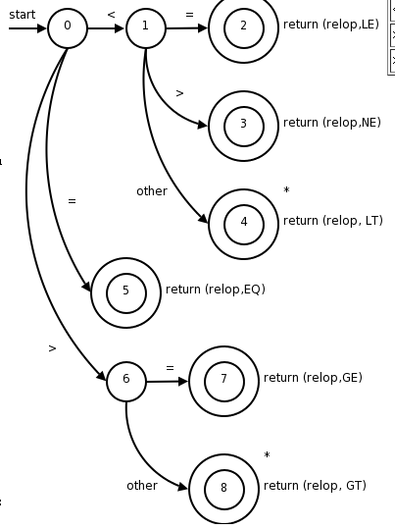
- The double circles represent accepting or finalstates at which point a lexeme has been found. There is often an action to be done (e.g., returning the token), which is written to the right of the double circle.
- If we have moved one (or more) characters too far in finding the token, one (or more) stars are drawn.
- An imaginary start state exists and has an arrow coming from it to indicate where to begin the process.
It is fairly clear how to write code corresponding to this diagram. You look at the first character, if it is <, you look at the next character. If that character is =, you return (relop,LE) to the parser. If instead that character is >, you return (relop,NE). If it is another character, return (relop,LT) and adjust the input buffer so that you will read this character again since you have not used it for the current lexeme. If the first character was =, you return (relop,EQ)

Recognition of Reserved Words and Identifiers
The transition diagram below corresponds to the regular definition given previously.
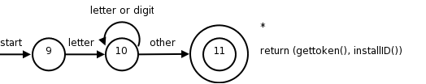
Keywords are installed into the identifier table prior to any invocation of the lexer. The table entry will indicate that the entry is a keyword.
installID() checks if the lexeme is already in the table. If it is not present, the lexeme is installed as an id token. In either case a pointer to the entry is returned.
gettoken() examines the lexeme and returns the token name, either id or a name corresponding to a reserved keyword.
The text also gives another method to distinguish between identifiers and keywords.

Recognizing Whitespace
The diagram itself is quite simple reflecting the simplicity of the corresponding regular expression.
- The delim in the diagram represents any of the whitespace characters, say space, tab, and newline.
- The final star is there because we needed to find a non-whitespace character in order to know when the whitespace ends and this character begins the next token.
- There is no action performed at the accepting state. Indeed the lexer does not return to the parser, but starts again from its beginning as it still must find the next token.
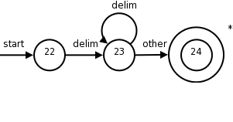

Recognizing Numbers
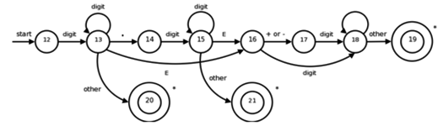
- Beginning in state 12, if we see a digit, we go to state 13. In that state, we can read any number of additional digits.
- However, if we see anything but a digit or a dot, we have seen a number in the form of an integer;
  - 123 is an example.
  - That case is handled by entering state 20, where we return token number and a pointer to a table of constants where the found lexeme is entered. These mechanics are not shown on the diagram but are analogous to the way we handled identifiers.
Architecture of a Transition-Diagram-Based Lexical Analyzer
Each state is represented by a piece of code. We may imagine a variable state holding the number of the current state for a transition diagram. A switch based on the value of state takes us to code for each of the possible states, where we find the action of that state. Often, the code for a state is itself a switch statement or multiway branch that determines the next state by reading and examining the next input character.
We could arrange for the transition diagrams for each token to be tried sequentially. Then, the function fail() resets the pointer forward and starts the next transition diagram, each time it is called
token nexttoken() {
while(1) { /* repeat character processing until
a return or failure occurs */
switch(state) {
case 0:
c = nextChar();
if(c =='<')state=1;
elseif(c =='=')state=5;
else if ( c == '>' ) state = 6;
/* lexeme is not a relop */
else fail() ;
break;
case 1: ...
...
case 8:
case 9:
c = nextChar();
if(isletter(c))state=10;
else fail() ;
break;
case 10:
c = nextChar();
if(isletter(c))state=10;
elseif(isdigit(c)) state=10;
else state=11;
break;
case 11:
retract(1);
install_id();
return(gettoken())
case 12:
c = nextChar();
if(isdigit(c)) state=13;
else fail();
break;

case 13: ...
...
case 18:
case 19:
retract(1);
install_num();
return(token num)

} // end switch
} // end while
}

Fail function
int state=0,start=0
int fail( )
{
forward=token_beginning;
switch(start)
{
case 0:
start=9;
break;
case 9:
start=12;
break;
default;
}
return start;
}

REVIEW OF FINITE AUTOMATA: REFER THEORY OF COMPUTATION NOTE.

