Python File I/O
File is a named location on disk to store related information. It is used to permanently store data in a non-volatile memory (e.g. hard disk). Since, random access memory (RAM) is volatile which loses its data when computer is turned off, we use files for future use of the data.
When we want to read from or write to a file we need to open it first. When we are done, it needs to be closed, so that resources that are tied with the file are freed. Hence, in Python, a file operation takes place in the following order.
- Open a file
- Read or write (perform operation)
- Close the file

Opening a File
Python has a built-in function open() to open a file. This function returns a file object, also called a handle, as it is used to read or modify the file accordingly.
Modes | Description
r | Opens a file for reading only. The file pointer is placed at the beginning of the file. This is the default mode.
rb | Opens a file for reading only in binary format. The file pointer is placed at the beginning of the file. This is the default mode.
r+ | Opens a file for both reading and writing. The file pointer placed at the beginning of the file.
rb+ | Opens a file for both reading and writing in binary format. The file pointer placed at the beginning of the file.
w | Opens a file for writing only. Overwrites the file if the file exists. If the file does not exist, creates a new file for writing.
wb | Opens a file for writing only in binary format. Overwrites the file if the file exists. If the file does not exist, creates a new file for writing.
w+ | Opens a file for both writing and reading. Overwrites the existing file if the file exists. If the file does not exist, creates a new file for reading and writing.
wb+ | Opens a file for both writing and reading in binary format. Overwrites the existing file if the file exists. If the file does not exist, creates a new file for reading and writing.
a | Opens a file for appending. The file pointer is at the end of the file if the file exists. That is, the file is in the append mode. If the file does not exist, it creates a new file for writing.
ab | Opens a file for appending in binary format. The file pointer is at the end of the file if the file exists. That is, the file is in the append mode. If the file does not exist, it creates a new file for writing.
a+ | Opens a file for both appending and reading. The file pointer is at the end of the file if the file exists. The file opens in the append mode. If the file does not exist, it creates a new file for reading and writing.
ab+ | Opens a file for both appending and reading in binary format. The file pointer is at the end of the file if the file exists. The file opens in the append mode. If the file does not exist, it creates a new file for reading and writing.

Closing a File
When we are done with operations to the file, we need to properly close it. Python has a garbage collector to clean up unreferenced objects. But we must not rely on it to close the file. Closing a file will free up the resources that were tied with the file and is done using the close() method.

f = open("test.txt",encoding = 'utf-8')
# perform file operations
f.close()
This method is not entirely safe. If an exception occurs when we are performing some operation with the file, the code exits without closing the file. A safer way is to use a try...finally block.

try:
f = open("test.txt",encoding = 'utf-8')
# perform file operations
finally:
f.close()
This way, we are guaranteed that the file is properly closed even if an exception is raised, causing program flow to stop.
The best way to do this is using the with statement. This ensures that the file is closed when the block inside with is exited. We don't need to explicitly call the close() method. It is done internally.

with open("test.txt",encoding = 'utf-8') as f:
# perform file operations

Python File Methods
There are various methods available with the file object. Some of them have been used in above examples. Here is the complete list of methods in text mode with a brief description.
Python File Methods
Method | Description
close() | Close an open file. It has no effect if the file is already closed.
detach() | Separate the underlying binary buffer from the TextIOBase and return it.
fileno() | Return an integer number (file descriptor) of the file.
flush() | Flush the write buffer of the file stream.
isatty() | Return True if the file stream is interactive.
read(n) | Read atmost n characters form the file. Reads till end of file if it is negative or None.
readable() | Returns True if the file stream can be read from.
readline(n=-1) | Read and return one line from the file. Reads in at most n bytes if specified.
readlines(n=-1) | Read and return a list of lines from the file. Reads in at most nbytes/characters if specified.
seek(offset,from=SEEK_SET) | Change the file position to offsetbytes, in reference to from (start, current, end).
seekable() | Returns True if the file stream supports random access.
tell() | Returns the current file location.
truncate(size=None) | Resize the file stream to size bytes. If size is not specified, resize to current location.
writable() | Returns True if the file stream can be written to.
write(s) | Write string s to the file and return the number of characters written.
writelines(lines) | Write a list of lines to the file.

Writing to a File
In order to write into a file we need to open it in write 'w', append 'a' or exclusive creation 'x' mode. We need to be careful with the 'w' mode as it will overwrite into the file if it already exists. All previous data are erased.
Writing a string or sequence of bytes (for binary files) is done using write() method. This method returns the number of characters written to the file.

with open("test.txt",'w',encoding = 'utf-8') as f:
f.write("my first file\n")
f.write("This file\n\n")
f.write("contains three lines\n")
This program will create a new file named 'test.txt' if it does not exist. If it does exist, it is overwritten. We must include the newline characters ourselves to distinguish different lines.

Reading From a File
To read the content of a file, we must open the file in reading mode. There are various methods available for this purpose. We can use the read(size) method to read in size number of data. Ifsize parameter is not specified, it reads and returns up to the end of the file.

>>> f = open("test.txt",'r',encoding = 'utf-8')
>>>f.read(4) # read the first 4 data
'This'

>>>f.read(4) # read the next 4 data
' is '

>>>f.read() # read in the rest till end of file
'my first file\nThis file\ncontains three lines\n'

>>>f.read() # further reading returns empty sting
''
We can see, that read() method returns newline as '\n'. Once the end of file is reached, we get empty string on further reading. We can change our current file cursor (position) using the seek()method. Similarly, the tell() method returns our current position (in number of bytes).

>>>f.tell() # get the current file position
56

>>>f.seek(0) # bring file cursor to initial position
0

>>>print(f.read()) # read the entire file
Thisismy first file
This file
contains three lines
We can read a file line-by-line using a for loop. This is both efficient and fast.

>>>for line in f:
... print(line, end = '')
...
Thisismy first file
This file
contains three lines
The lines in file itself has a newline character '\n'. Moreover,the print() function also appends a newline by default. Hence, we specify the end parameter to avoid two newlines when printing.
Alternately, we can use readline() method to read individual lines of a file. This method reads a file till the newline, including the newline character.

>>>f.readline()
'This is my first file\n'

>>>f.readline()
'This file\n'

>>>f.readline()
'contains three lines\n'

>>>f.readline()
''
Lastly, the readlines() method returns a list of remaining lines of the entire file. All these reading method return empty values when end of file (EOF) is reached.

>>>f.readlines()
['This is my first file\n', 'This file\n', 'contains three lines\n']

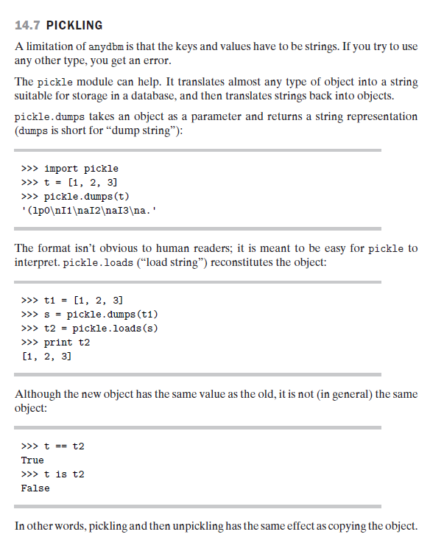

. Any object in python can be pickled so that it can be saved on disk. What pickle does is that it “serialises” the object first before writing it to file. Pickling is a way to convert a python object (list, dict, etc.) into a character stream. The idea is that this character stream contains all the information necessary to reconstruct the object in another python script.
So lets continue:
1. First of all you have to import it through this command:
import pickle
pickle has two main methods. The first one is dump, which dumps an object to a file object and the second one is load, which loads an object from a file object.
2. Prepare something to pickle:
Now you just have to get some data which you can pickle. For the sake of simplicity i will be pickling a python list. So just read the below code and you will be able to figure it out yourself.
import pickle
a = ['test value','test value 2','test value 3']
a
['test value','test value 2','test value 3']

file_Name = "testfile"
# open the file for writing
fileObject = open(file_Name,'wb')

# this writes the object a to the
# file named 'testfile'
pickle.dump(a,fileObject)

# here we close the fileObject
fileObject.close()
# we open the file for reading
fileObject = open(file_Name,'r')
# load the object from the file into var b
b = pickle.load(fileObject)
b
['test value','test value 2','test value 3']
a==b
True
The above code is self explanatory. It shows you how to import the pickled object and assign it to a variable. So now we need to know where we should use pickling. It is very useful when you want to dump some object while coding in the python shell. So after dumping whenever you restart the python shell you can import the pickled object and deserialize it. But there are other use cases as well which i found on stackoverflow. Let me list them below.
1) saving a program's state data to disk so that it can carry on where it left off when restarted (persistence)
2) sending python data over a TCP connection in a multi-core or distributed system (marshalling)
3) storing python objects in a database
4) converting an arbitrary python object to a string so that it can be used as a dictionary key (e.g. for caching & memoization).
One thing to note is that there is a brother of pickle as well with the name of cpickle. As the name suggests it is written in c which makes it 1000 times more faster than pickle. So why should we ever use pickle instead of cpickle ? Here’s the reason
>> Because pickle handles unicode objects.
>> Because pickle is written in pure Python, it's easier to debug.

Python Objects and Class
Python is an object oriented programming language. Unlike procedure oriented programming, in which the main emphasis is on functions, object oriented programming stress on objects. Object is simply a collection of data (variables) and methods (functions) that act on those data.
Class is a blueprint for the object. We can think of class like a sketch (prototype) of a house. It contains all the details about the floors, doors, windows etc. Based on these descriptions we build the house. House is the object. As, many houses can be made from a description, we can create many objects from a class. An object is also called an instance of a class and the process of creating this object is called instantiation.

Defining a Class in Python
Like function definitions begin with the keyword def, in Python, we define a class using the keywordclass. The first string is called docstring and has a brief description about the class. Although not mandatory, this is recommended. Here is a simple class definition.

classMyNewClass:
'''This is a docstring. I have created a new class'''
pass
A class creates a new local namespace where all its attributes are defines. Attributes may be data or functions. There are also special attributes in it that begins with double underscores (__). For example, __doc__ gives us the docstring of that class. As soon as we define a class, a new class object is created with the same name. This class object allows us to access the different attributes as well as to instantiate new objects of that class.

>>>classMyClass:
... "This is my second class"
... a = 10
... deffunc(self):
... print('Hello')
...
>>>MyClass.a
10

>>>MyClass.func
<functionMyClass.func at 0x0000000003079BF8>

>>>MyClass.__doc__
'This is my second class'

Creating an Object in Python
We saw that the class object could be used to access different attributes. It can also be used to create new object instances (instantiation) of that class. The procedure to create an object is similar to a function call.

>>>ob = MyClass()
This will create a new instance object named ob. We can access attributes of objects using the object name prefix. Attributes may be data or method. Method of an object are corresponding functions of that class. Any function object that is a class attribute defines a method for objects of that class. This means to say, since MyClass.func is a function object (attribute of class), ob.func will be a method object.

>>>ob = MyClass()
>>>MyClass.func
<functionMyClass.func at 0x000000000335B0D0>
>>>ob.func
<bound method MyClass.func of <__main__.MyClassobject at 0x000000000332DEF0>>

>>>ob.func()
Hello
You may have notices the self parameter in function definition inside the class. But we called the method simply as ob.func() without any arguments. It still worked. This is because, whenever an object calls its method, the object itself is pass as the first argument. So, ob.func() translates intoMyClass.func(ob). In general, calling a method with a list of n arguments is equivalent to calling the corresponding function with an argument list that is created by inserting the method's object before the first argument. For these reasons, the first argument of the function in class must be the object itself. This is conventionally called self. It can be named otherwise but we highly recommend to follow the convention.
Now you must be familiar with class object, instance object, function object, method object and their differences.

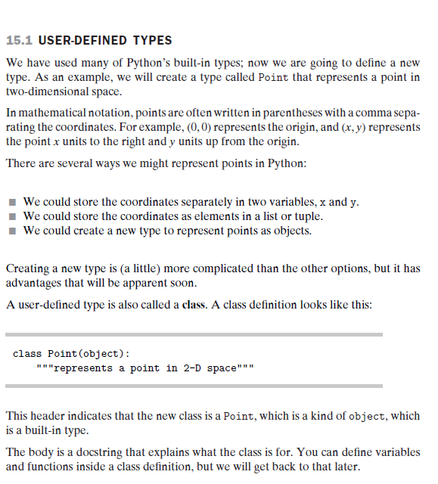

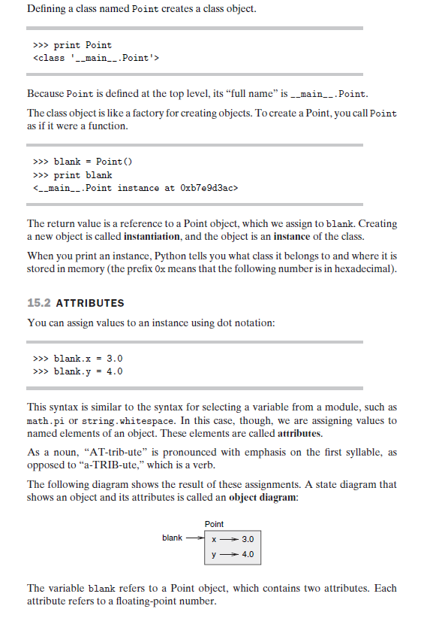

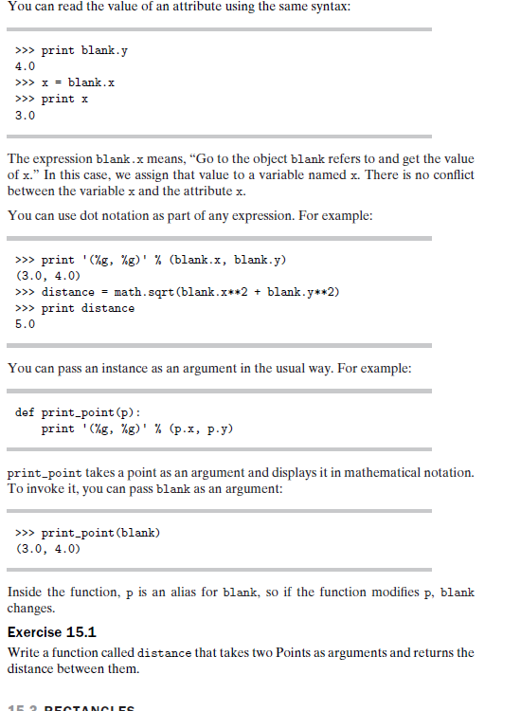

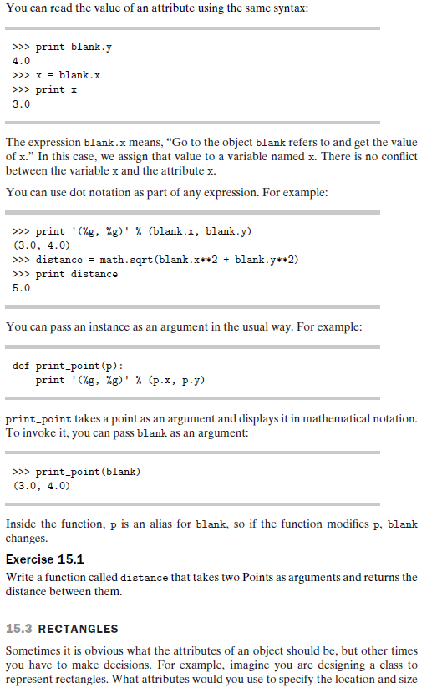

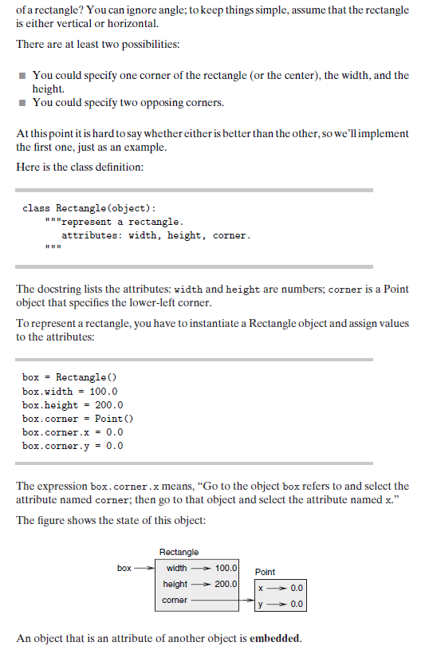

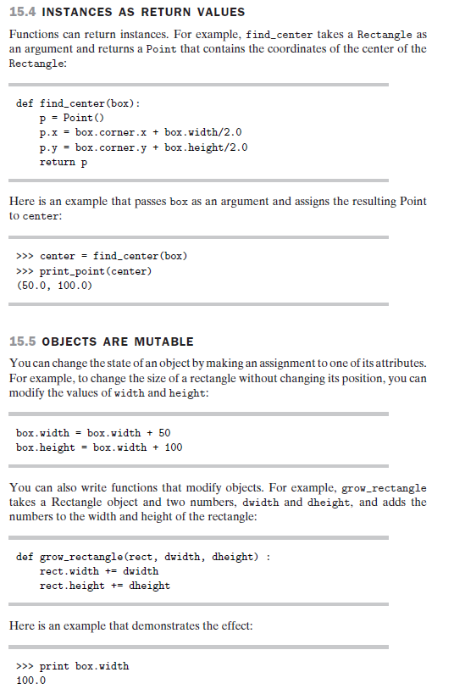

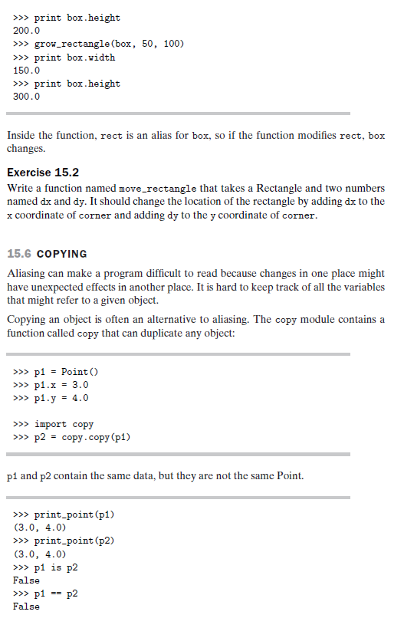

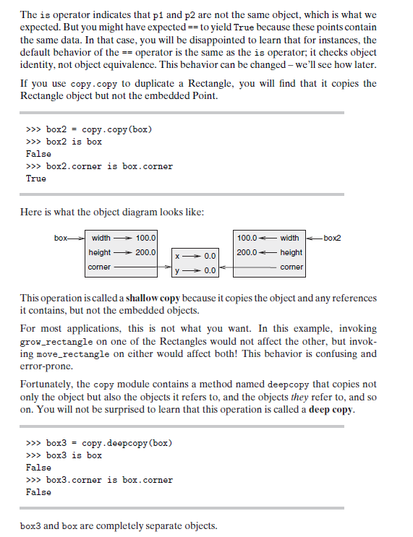

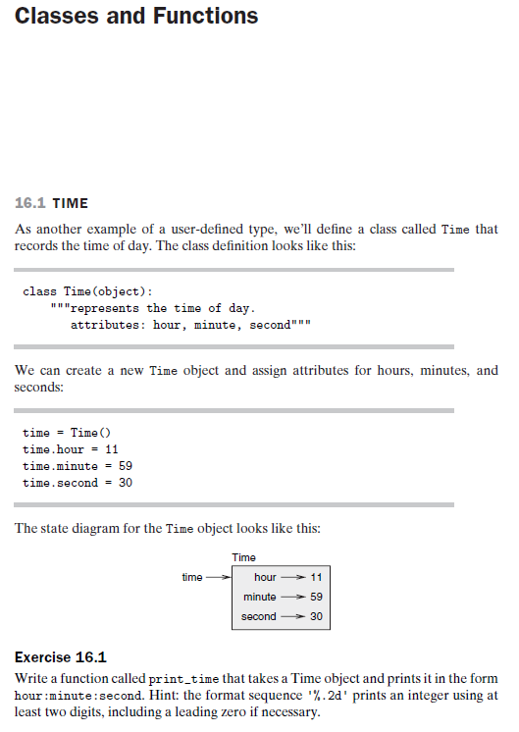

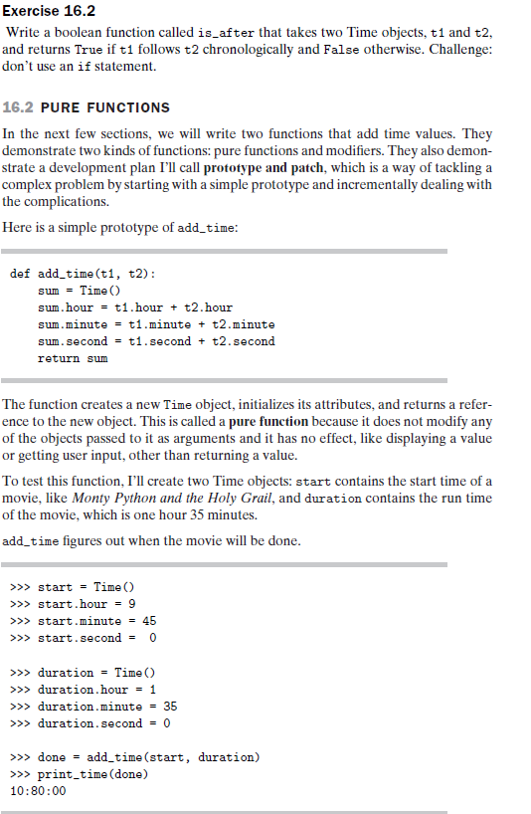

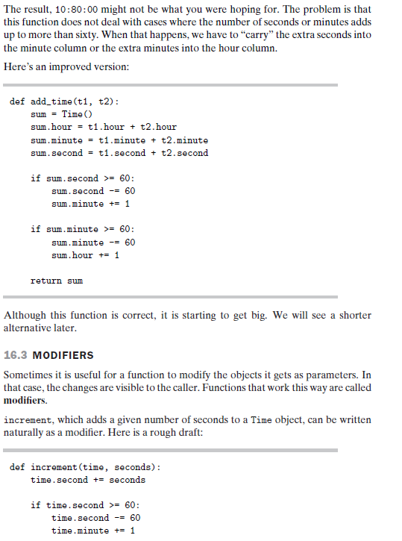

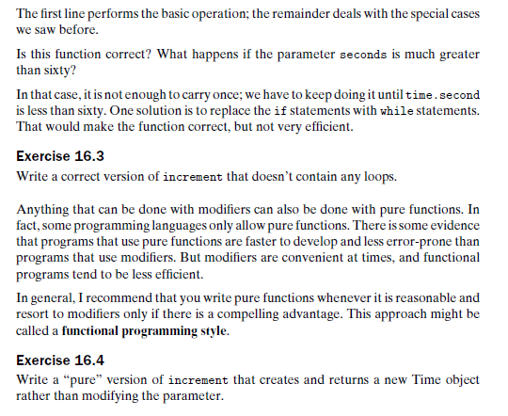

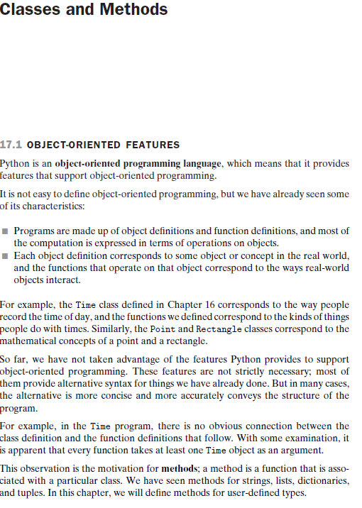

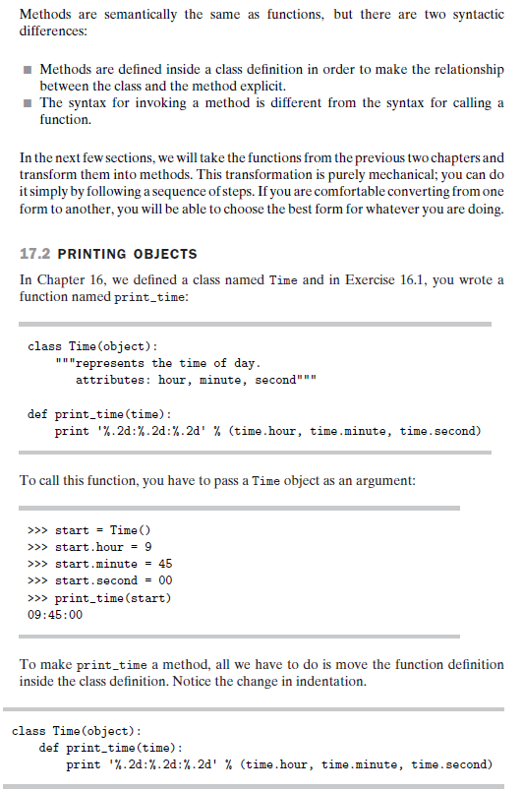

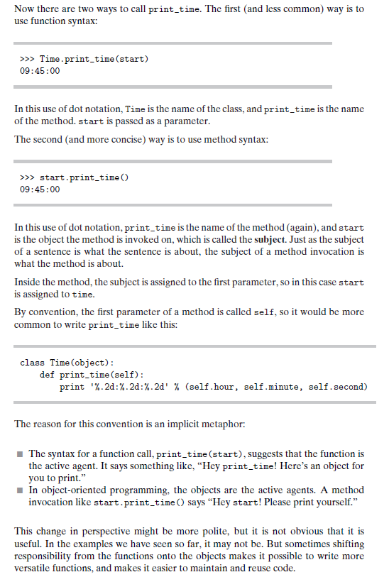

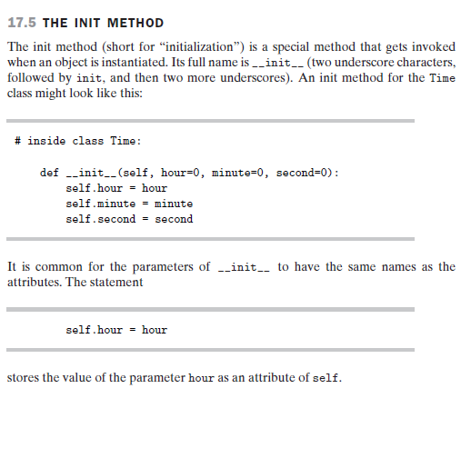

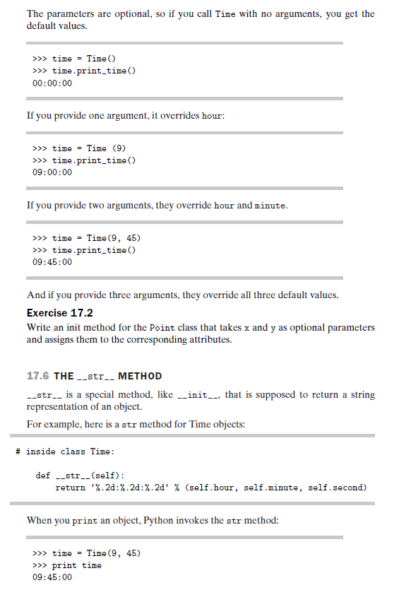

Constructors in Python
Class functions that begins with double underscore (__) are called special functions as they have special meaning. Of one particular interest is the __init__() function. This special function gets called whenever a new object of that class is instantiated. This type of function is also called constructors in Object Oriented Programming (OOP). We normally use it to initialize all the variables.

classComplexNumber:
def __init__(self,r = 0,i = 0):
self.real = r
self.imag = i

defgetData(self):
print("{0}+{1}j".format(self.real,self.imag))
In the above example, we define a new class to represent complex numbers. It has two functions,__init__() to initialize the variables (defaults to zero) and getData() to display the number properly. Here, are some sample runs.

>>> c1 = ComplexNumber(2,3)
>>>c1.getData()
2+3j

>>> c2 = ComplexNumber(5)
>>> c2.attr = 10
>>> (c2.real, c2.imag, c2.attr)
(5, 0, 10)
>>> c1.attr
Traceback (most recent call last):
...
AttributeError: 'ComplexNumber'object has no attribute 'attr'
An interesting thing to note in the above step is that attributes of an object can be created on the fly. We created a new attribute attr for object c2 and we read it as well. But this did not create that attribute for object c1.

Deleting Attributes and Objects
Any attribute of an object can be deleted anytime, using the del statement.

>>> c1 = ComplexNumber(2,3)
>>>del c1.imag
>>>c1.getData()
Traceback (most recent call last):
...
AttributeError: 'ComplexNumber'object has no attribute 'imag'

>>>delComplexNumber.getData
>>>c1.getData()
Traceback (most recent call last):
...
AttributeError: 'ComplexNumber'object has no attribute 'getData'
We can even delete the object itself, using the del statement.

>>> c1 = ComplexNumber(1,3)
>>>del c1
>>> c1
Traceback (most recent call last):
...
NameError: name 'c1'isnotdefined
Actually, it is more complicated than that. When we do c1 = ComplexNumber(1,3), a new instance object is created in memory and the name c1 binds with it. On the command del c1, this binding is removed and the name c1 is deleted from the corresponding namespace. The object however continues to exist in memory and if no other name is bound to it, it is later automatically destroyed. This automatic destruction of unreferenced objects in Python is also called garbage collection.

Detecting and Handling Exception
Exception can be detected by try statement.The try statement can be written in two forms try - except and try - finally.One try contain many except statements.
In try - except the exceptions,if any are handled in exception block.In try – finally ,finally block is always executed no matter the exception occurs or not
Syntax:
try:
statements
except<exception type1>:
statements
except<exception type2>:
statements
except<exception typen>:
statements

