Module 5
Dataflow Computers

Dataflow computers - Data driven computing and Languages - Data flow computers architectures - Static data flow computer -Dynamic data flow computer -Data flow design alternatives.
  - Data-Driven Computing and Languages

Data flow computers are based on the concept of data-driven computation, which is drastically different from the operation of a conventional von Neumann machine. The fundamental difference is that instruction execution in a conventional computer is under program-flow control, whereas that in a data flow computer is driven by the data (operand) availability. We characterize below these two types of computers.
Jack Dennis (1979) of MIT has identified three basic issues towards the development of an Ideal architecture for future computers. The first is to achieve a high performance/cost ratio; the second is to match the ratio with technological progress; and the third is to offer better programmability in application areas.

    - Control Flow vs Data Flow Computers
The concepts of control flow and data flow computing are distinguished by the control of computation sequences in two distinct program representations. The statement a = (b + 1)* (b - c) is specified by a series of instructions with an explicit flow of control. Shared memory cells are the means by which data is passed between instructions. Data (operands) are referenced by their memory addresses (variabIes).
In the traditional sequential control flow model (von Neumann), there is a single thread of control, as shown in Figure 5.1a, which is passed from instruction to instruction. Explicit control transfers are caused by using operators like GO TO. In the parallel control flow model (Figure 5.lb), special parallel control operators such as FORK and JOIN are used to explicitly specify parallelism; These operators allow more than one thread of control to be active at an instant and provide means for synchronizing these threads, as demonstrated in Figure 10.lb. All underlined variables refer to addresses of operands and instructions. Special features are identified below for either the sequential or parallel control flow model:
- Data is passed between instructions via references to shared memory cells.
- Flow of control is implicitly sequential, but special control operators can be used explicitly for parallelism.
- Program counters are used to sequence the execution of instruction in a centralized control environment.

Fig.5.1 Instruction execution in a control flow computer for the computation a=(b+1)*(b-c) using shared data memory
In a data flow computing environment, instructions are activated by the availability of data tokens as indicated by the ( ) in Figure 5.2. Data flow programs are represented by directed graphs, which show the flow of data between instructions. Each instruction consists of an operator, one or two operands, and one or more destinations to which the result (data token) will be sent. Three snapshots of the data flow graph for a = (b + 1)* (b - c) are shown in Figure 5.3. The dots correspond to data tokens being passed between instructions. Listed below are interesting features in the data flow model:
- Intermediate or final results are passed directly as data token between instructions.
- There is no concept of shared data storage as embodied in the traditional notion of a variable.
- Program sequencing is constrained only by data dependency among instructions.
Control flow computers have a control-driven organization. This means that the program has complete control over instruction sequencing. Synchronous computations are performed in control flow computers using centralized control. Data flow computers have a data-driven organization that is characterized by passive examine stage. Instructions are examined to reveal the operand availability, upon which they are executed immediately if the functional units are available.

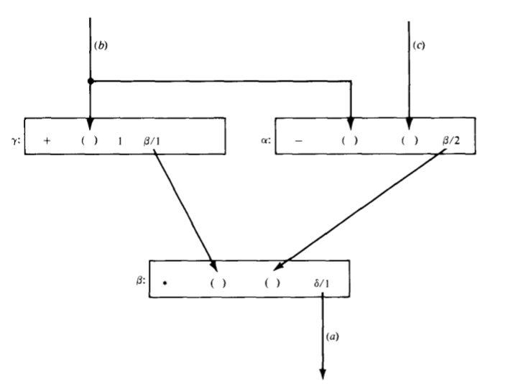
Fig.5.2. Instruction execution in a dataflow computer for the computation of a = (b+1)*(b-c) by direct data forwarding

This data-driven concept means asynchrony, which means that many instructions can be executed simultaneously and asynchronously. A high degree of implicit parallelism is expected in a data flow computer. Because there is no use of shared memory cells, data flow programs are free from side effects. In other words, a data flow operation is purely functional and produces no side effects such as the changes of a memory word. Operands are directly passed as “tokens” of values instead of as “address” variables.
Information items in a data flow computer appear as operation packets and data tokens. An operation packet is composed of the opcode, operands and destinations of its successor instructions as shown in Figure.5.2. A data token is formed with a result value and its destinations. Many of these packets or tokens are passed among various resource sections in a data flow machine. Therefore, the machine can assume packet communications architecture, which is a type of distributed multiprocessor organization.

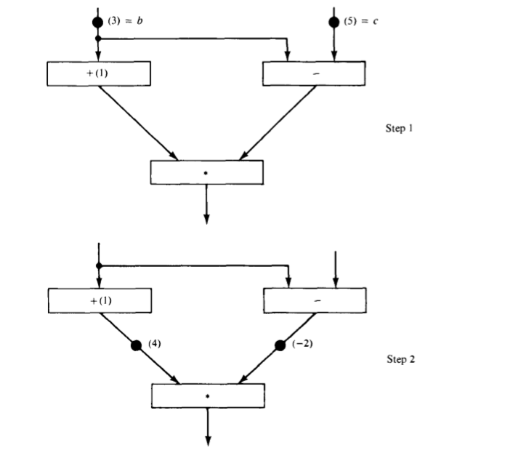
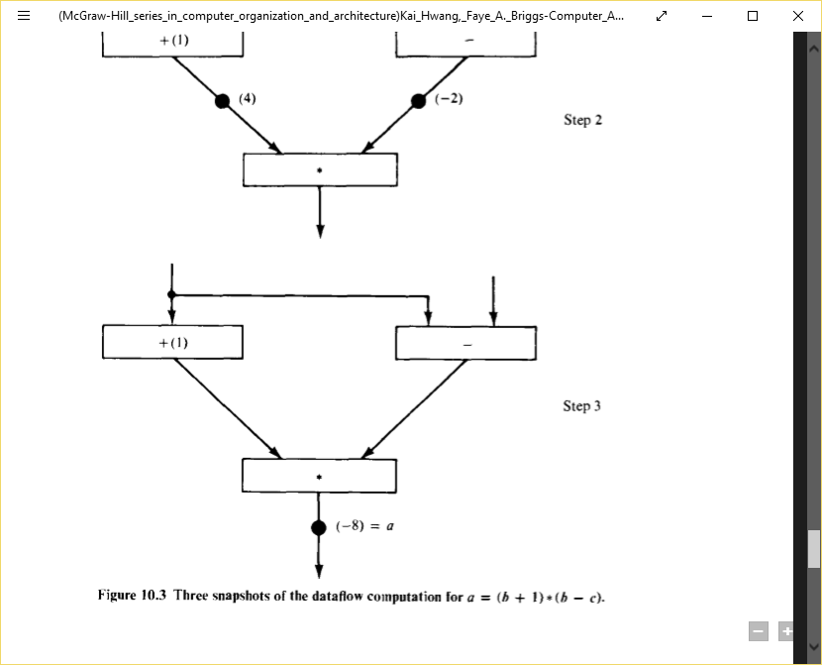
Fig.5.3.Three snapshots of the dataflow computation for a=(b+1)*(b-c)
Data flow machine architectures: Depending on the way of handling data tokens data flow computers are divided into static model and dynamic model. In a static data flow machine data tokens are assumed to move along the arcs of the data flow program graph to the operator nodes. The nodal operation gets executed when all its operand data are present at the input arcs. Only one token is allowed to exist on any arc at any given time, otherwise the successive sets of tokens cannot be distinguished. This architecture is considered static because tokens-are not labelled and control tokens must be used to acknowledge the proper timing in transferring data tokens from node to node. Jack Dennis and his research group at the MIT Laboratory for Computer Science are currently developing a static data flow computer.
Fig.5.4. Static dataflow computer organization

A dynamic data flow machine uses tagged tokens so that more than one token can exist in an arc. The tagging is achieved by attaching a label with each token which uniquely identifies the context of that particular token. This dynamically tagged data flow model suggests that maximum parallelism can be exploited from a program graph. If the graph is cyclic, the tagging allows dynamically unfolding of the iterative computations. Dynamic data flow computers include the Manchester machine developed by Watson and Gurd at the University of Manchester, England, and the Arvinds machine under development at MIT, which is evolved from an earlier data flow project at the University of California at Irvine.
Fig.5.5. Dynamic dataflow computer organization

The two packet-communication organizations are based on two different schemes for synchronizing instruction execution. A point of commonality in the two organizations is that multiple processing elements can independently and asynchronously evaluate the executable instruction packets. In Figure 5.4, the data tokens are in the input pool of the update unit. This update unit passes data tokens to their destination instructions in the memory unit. When an instruction receives all its required operand tokens, it is enabled and forwarded to the enabled queue. The fetch unit fetches these instructions when they become enabled.
In Figure.5.5, the system synchronization is based on a matching mechanism .Data tokens form the input pool of the matching unit .This matching unit arranges data tokens in to pairs or sets and temporarily stores token until all operands are compared, whereupon the matched token sets are released to the fetch-update unit. Each set of matched data tokens (usually two for binary operations) is needed for one instruction execution. The fetch-update unit forms the enabled instructions by merging the token sets with copies sent to their consumer instructions. The matching of the special tags attached to the data tokens can unfold iterative loops for parallel computations.
Both static and dynamic data flow architectures have a pipelined ring structure. If we include the I/O, a generalized architecture is shown in Figure 5.6, The ring contains four resource sections: the memories, the processors, the routing network, and the input-output unit. The memories are used to hold the instruction packets. The processing units form the task force for parallel execution of enabled instructions. The routing network is used to pass the result tokens to their destined instructions. The input-output unit serves as an interface between the data flow computer and the outside world. For dynamic machines, the token matching is performed by the I/O section.
Fig.5.6 A ring structured dataflow computer organization including the I/O functions
Major design issues:
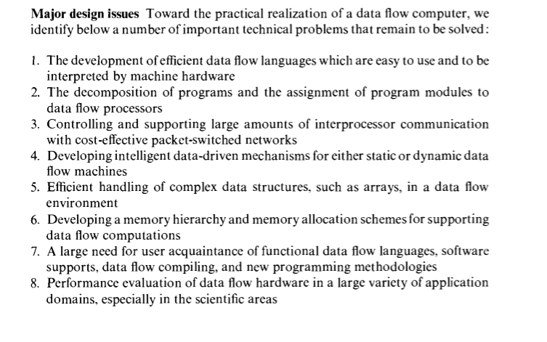
    - Data Flow graphs and languages
There is a need to provide a high-level language for data flow computers. The primary goal is to take advantage of implicit parallelism. Data flow computing is compatible with the use of dependence graphs In program analysis for computing a conventional computer. An efficient data flow language should be able to express parallelism in a program more naturally, to promote programming productivity, and to facilitate close interactions between algorithm constructs and hardware structures. Examples of data flow languages include the Irvine Data flow language and Value Arithmetic Language(VAL) among several single assignment and functional programming languages that have been proposed by computer researchers.
In a maximum parallel program, the sequencing of instructions should be constrained only by data dependencies and nothing else. Listed below are useful properties in a data flow language.
- Freedom from side effects based on functional programming.
- Locality of effect without far-reaching data dependencies
- Equivalence of instruction-sequencing constraints with data dependencies.
- Satisfying single-assignment rule with aliasing
- Unfolding of iterative computations into parallelism.
- Lack of “history sensitivity" in procedures calls
Data flow graphs: In a conventional computer, program analysis is often performed at compile time to yield better resource utilization and code optimization and at run time to reveal concurrent arithmetic logic activities for higher system throughput. Program analysis in dataflow computers can be represented by dataflow graph. Data flow graph is a directed graph whose nodes correspond to operators and arcs are pointers for forwarding data tokens. The graph demonstrates sequencing constraints among instructions. In a dataflow computer, the machine level program is represented by data flow graphs. The firing rule of instructions is based on the data availability.
For example:
- P=X+Y must wait for inputs X and Y
- Q=P/Y must wait for instruction 1 to complete
- R=X*P must wait for instruction 1to complete
- S=R-Q must wait for instructions 2 and 3 to complete
- T=R*Q must wait for instruction 3 to complete
- U=S/T must wait for instruction 4 and 5 to complete

Fig.5.7 A dataflow graph for the computation of U=f(X,Y)=(X*(X+Y)-(X+Y)/Y)/(X*X+Y)*(X+Y))
Two types of links on data flow graphs are depicted in figure 5.8. The purpose is to distinguish those for numerical data from those for boolean variables. Numerical data links transmit integer, real, or complex numbers and boolean links carry only boolean values for control purposes. Figure 5.8 presents various operator types for constructing data flow graphs. An identity operator is a special operator that has one input arc and transmits its input value unchanged. Deciders, gates and merge operators are used to represent conditional or iterative computation in data flow graphs. A decider requires a value from each input arc and produces the truth value resulting from applying the predicate P to the values received.
Control tokens bearing boolean values control the flow of data tokens by means of the T gates, the F gates, and the merge operators. A T gate passes a data token from its input arc to its output arc when it receives the true value on its control input arc. It will absorb a data token from its data input arc and place nothing on its output arc if it receives a false value. An F gate has similar behaviour, expect the sense of the control value is reversed. A merge operator has T and F data input arcs and a truth-value control arc. When a truth value is received, the merge actor places the token from the true input arc on its output arc. The token on the other unused input arc is discarded. Similarly, the false input is passed to the output, when the control arc is false.
Fig.5.8 Operators(nodes) and links(arcs) for the construction of dataflow graphs

Data flow graphs form the basis of data flow languages. Properties of data flow languages:
- Locality of effect - This means that instructions do not have unnecessary far-reaching data dependencies. This is achieved by assigning every variable a definite scope or region of the program in which it is active and carefully restricting the entry to and exit from the blocks that constitute scopes
- Freedom from side-effects - This property is necessary to ensure that the data dependencies are consistent with the sequencing constraints. Dataflow model of execution imposes a strict restriction by prohibiting any variables from being modified. This is done by using "call-by-value" rather than "call-by-reference" scheme. A call-by-value procedure copies rather than modifies its argument which avoids side-effects.
- Single assignment rule - This offers a method to promote parallelism in a program. The rule prohibits the use of the same variable name more than once on the left-hand side of any statement. The single assignment rule offers both clarity and ease of verification, which generally outweigh the convenience of reusing the same name.
- Unfolding iterations – A programming language cannot be considered as effective if it cannot be used to implement iterative computations efficiently. Iterative computations are represented by “cyclic” data flow graphs, which are inherently sequential. In order to achieve parallel processing, iterative computations must be unfolded. Techniques have been suggested to use tagged tokens to unfold activities embedded in a cyclic data flow graph.

    - Advantages and Potential Problems
Pros and cons of data flow computers are discussed in this section. Due to their strong appeal to parallelism, data flow techniques have attracted a great deal of attention in recent years. We assess first the advantages and then examine the opposition opinions. The development of data flow computers and languages is still in its infancy stage. The research community is currently divided in opinions. It is too early to draw a final conclusion because the success of data flow computing depends heavily on high technology and its matching with applications. However, it is commonly recognized that more research and development challenges should continue in this area. The idea of data-driven computation is rather old, but only in recent years have architectural models with anticipated performance been developed.
Most advantages are claimed by researchers in this area. The claimed advantages were only partially supported by performance analysis and simulation experiments. Operational statistics are not available from existing prototype data flow machines. Therefore, some of the claimed advantages are still subject to further verification. Data flow computers are advantageous in many respects over the traditional von Neumann machines. These aspects are elaborated below in terms of projected performance, matching technology, and programming productivity. .
- Highly concurrent operations
Parallelism can be easily exposed in a dataflow program graph. The data flow approach offers a possible solution to the problem of efficiently exploiting concurrency of computation on a large scale. It benefits not only regularly structured but also arbitrary parallelism in programs, direct use of values instead of names of value containers (addresses) enables purely functional programming without side effects. Asynchronous parallelism can exploited at the instruction level or at the procedure level. Inherently sequent computations can be unfolded to enable parallelism. The data flow approach has applied pipelining, array processing, and multiprocessing techniques discussed previous chapters for control flow computers.
The data flow language does not introduce instruction-sequencing constraiJ1 other than the ones imposed by data dependencies in the algorithm. In theory maximum parallelism can be achieved if sufficient resources are provided. This approach extends naturally to an arbitrary number of processors in the system. The speedup should be linearly proportional to the increase of processor number. The high concurrency in a data flow computer is supported by easier prograJ1 verification, better modularity and extendability of hardware, reduced protection problems, and superior confinement of software errors.
- Matching with VLSI technology
Recall the basic architecture of a data flow computer. The memory section contains instruction cells which can be uniformly structured in large-scale memory arrays. The pool of processing units and the network of packet switches can be each also regularly structured with modular cells. All this homogeneity and modularity in cellular structures contributes to the suitability of VLSI implementation of major components in a data flow computer. As introduced in Chapter I, the impressive progress in microelectronics technology has made it possible to challenge the fabrication of large arrays of processors, memories, and switches on VLSI chips.
The interconnection between chips can be built into highly densed packaging systems. It is fair to say that data flow machine architecture matches nicely with the technological supports that we anticipate to have. The potential of VLSI and VHSIC technologies can be fully exploited in the development of data flow machines. The operations in a data flow computer may be asynchronous. How- ever, the hardware components can be designed with synchronous functional pipes and clocked memory and switch arrays. With more lessons to be learned and the data flow hardware properly evaluated, it would be appropriate to consider VLSI implementation of some large-scale data flow systems.
- Programming productivity
In a control flow vector processor or a multiprocessor system, the percentage of code that can be vectorized ranges from 10 to 90 ' percent across a broad range of scientific applications. The nonvectorizable code (scalar operations) tends to become a bottleneck. Automatic vectorization requires sophisticated data flow analysis, which is difficult in Fortran because of the side effects caused by the global scope and aliasing of variables. A well-designed data flow computer should be able to overcome these difficulties and to remove the bottleneck caused by assorted scalar operations.
Shortcomings of data flow computing
Critics of the data flow approach have pointed out quite a number of potential problems in the development and application of data flow computers at the instruction level. It is instructional to learn n these reserved positions and to explore other alternatives to achieve high performance. In the conventional computer with centralized control hardware, an imperative language such as Fortran is used and an intelligent compiler is needed normalize the program and to generate the dependence graph, which guides vectorization and optimization processes we have studied in previous chapters. h-level use of the dependence graph is practiced here primarily at compile e. The major advantages of this high-level approach are summarized below:
- There is no need to use a new functional programming language, which ordinary programmers may be reluctant to learn.
- Existing software assets for vectorizing, compiling and dedicated application
software can continue to be utilized.
- Data flow analysis at the higher level of procedures and loops will result in less overhead when averaged over all instructions to be executed.
In the data flow approach, special functional programming languages must used which can be easily compiled into a dependence graph. The object code is generated to efficiently map the dependence graph onto the data flow machine h distributed control hardware. Some advantages of high-level data flow machines become potential shortcomings in the data flow computer, which exploits parallelism at the lowest level of instruction execution. Apparent disadvantages instructional-level data flow computers are summarized below:
- The data driven at instruction level causes excessive pipeline overhead per instruction, which may destroy the benefits of parallelism. The long pipeline filling problem is attributed to queueing all enabled instructions at the input ports of every subsystem in the data flow ring. The queue lengths absorb some of the parallelism in a program, thus, performance becomes weak for improper buffering and traffic congestion.
- Data flow programs tend to waste memory space for the increased code length due to the single assignment rule and the excessive copying of data arrays. The damaging effects of the memory access conflict problem are so far not well addressed by data flow researchers.
- When a data flow computer becomes large with high numbers of instruction cells and processing elements, the packet-switched network used becomes cost-prohibitive and a bottleneck to the entire system.

  - DATA FLOW COMPUTER ARCHITECTURE
Several interesting data flow computer architectures are studied in this section The intent is to identify related architectural concepts rather than to describe th implementation details. We shall start with static data flow computers represented by the Dennis machine at MIT. Then we describe several ring-structured, dynamic data flow computers, including the original Irvine machine and its successor machine at MIT. the EDDY system in Japan, and the Manchester machine il1 England. Several specially designed data flow systems will be briefly examined, including the Utah machine, the French LAU system, and the Newcastle data. control flow computer. Design alternatives of data flow computers will also be discussed to inspire future development. .
    - Static Data Flow Computers
Jack Dennis and his associates at MIT have pioneered the area of data flow research. They have developed a static data flow computing model and the associated language supports. There are two interesting data flow projects at MIT. For identification purpose, we distinguish them by calling them the Dennis machine and the Arvind machine. The Dennis machine has a static architecture, whereas the Arvind machine is dynamic, using tagged tokens and colored activities.
Data flow graphs used in the Dennis machine must follow a static execution rule that only one data token can occupy an arc at an instant. This leads to a static firing rule that an instruction is enabled if a data token is present on each of its input arcs and no token is present on any of its output arcs. Thus. the program graph contains control tokens as well as data tokens, both contributing to the enabling of an instruction. These control tokens act as acknowledge signals when data tokens are removed from output arcs.
The Dennis machine is designed to exploit the concurrency in programs represented by static data flow graphs. The structure of this data flow computer it consists of five major sections connected by channels through which information is sent in the form of discrete tokens (packets):
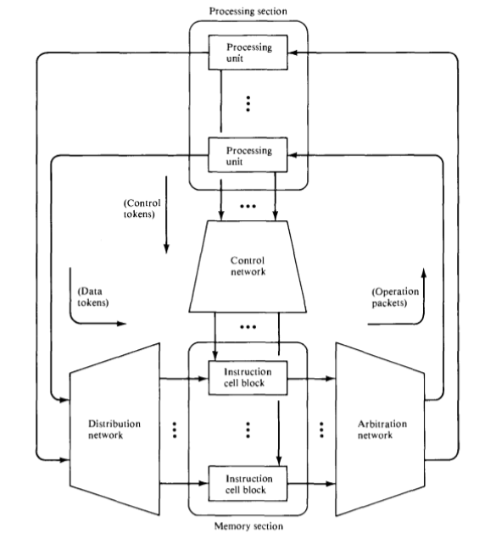
Fig 5.9. The static dataflow computer architecture proposed at MIT
- Memory section consists of instruction cells which hold instructions and their operands.
- Processing section consists of processing units that perform functional operations on data tokens.
- Arbitration network delivers operation packets from the memory section to the processing section.
- Control network delivers a control token from the processing section to the memory section.
- Distribution network delivers data tokens from the processing section to the memory section.
Instruction held in the memory section are enabled for executing by the arrival of their operands in data tokens from the distribution network and control tokens from the control network. Enabled instructions, together with their operands, are sent as operation packets to the processing section through the arbitration network. The results of instruction execution are sent through the distribution network and the control network to the memory section, where they become operands of other instructions. Each instruction cell has a unique address, the cell identifier. An occupied cell holds an instruction consisting a destination address, which is a cell identifier, and additional control information used by processing units to generate result tokens.
Each instruction cell contains receivers which await the arrival of token values for use as operands by the instruction. Once an instruction cell has received the necessary operand tokens and acknowledges signals, the cell becomes enabled and sends an operation packets consisting of instruction and the operand values to the appropriate processing unit through the arbitration network.
The arbitration network provides a path from each instruction cell to each processing unit and sorts the operation packets among its output ports according to the operation codes of the instruction they contain. Each operation packet receive, a processing unit performs the operation specified by the instruction using the operand values in the packet and produces one or more result tokens, which are sends to instruction cells through the control and distribution network. Each result token consist of result value and a destination address derived from the instruction being processed by the processing unit. There are control tokens containing boolean values or acknowledge signals, which are send through the control network, and data packets containing integer or complex values, which are send through the distribution network.
The two networks deliver result tokens to receivers of instruction cells as specified by the destination address fields; that is, data packets are routed according to the destination address. The arrival of a result token at an instruction cell provides one of the receivers of cell with an operand value or delivers an acknowledge signal; if all result tokens required by the instruction in the cell has been receives, the instruction cell becomes enables and dispatches its content to the arbitration network as new operation packet.
The functions performed by the processing unit are distributed among several sections of the data flow processor. The operation specified by instruction are carried out in the processing section, but control of instruction sequencing is a function of control network, and the decoding of operation code is partially done within the arbitration network. The network address fields (destination address) of instruction specified where the results should be send instead of addressing a shared memory cell. Instead of instruction fetching their operands, the operand values are send to the instructions.
Fig 5.10. The concept of grouping instruction cells into cell blocks

When the number of instruction becomes large the networks may become exceedingly large and thus cost prohibitive. One approach that has been suggested to overcome this difficulty is to use the concept of cell blocks. A cell block is a collection of instruction cells which share the same set of input and output ports from the distribution, control and arbitration network. The cell block implementation and the uses in machine architecture are demonstrated in figure 5.10. By using shared input ports, the arbitration networks can be partitioned into sub networks of significantly smaller sizes so can the other networks in the system.
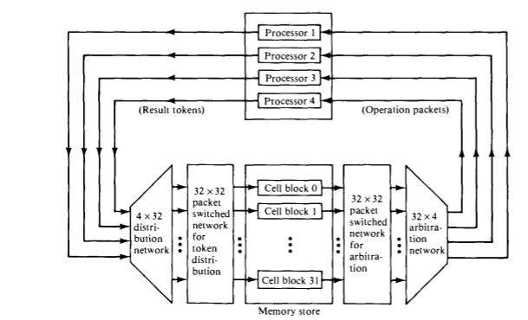

    - Dynamic Data Flow Computers

Three dynamic data flow projects are introduced below. In dynamic machines, data tokens are tagged (labelled or colored) to allow multiple tokens to appear simultaneously on any input arc of an operator node. No control tokens are needed to acknowledge the transfer of data tokens among instructions. Instead, the matching of token tags (labels or colors) is performed to merge them for instructions requiring more than one operand token. Therefore, additional hardware is needed to attach tags onto data tokens and to perform tag matching. We shall first present the Arvind machine, followed by the EDDY system and the Manchester data flow machine.
The development of the Irvine data flow machine was motivated by the desire to exploit the potential of VLSI and to provide a high-level, highly concurrent program organization. This project originated at the University of California at Irvine and now continues at the Massachusetts Institute of Technology by Arvind and his associates. The architecture of the original Irvine machine is conceptually shown in figure.
The Irvine machine was proposed to consist of multiple PE clusters. All PE clusters (physical domains) can operate concurrently. The physical domains are interconnected by two system buses. The token bus is a pair of bidirectional shift-register rings. Each ring is partitioned into as many slots as there are PEs and each slot is either empty or holds one data token. Obviously, the token rings are used to transfer tagged tokens among the PEs.
Each cluster of PEs(four PEs per cluster, as shown in figure.5.11) shares a local memory through a local bus and a memory controller. A global bus is used to transfer data structures among the local memories. Each PE must accept all tokens that are sent to it and sort those tokens into groups by activity name. When all input tokens for an activity has arrived , the PE must execute that activity.
Fig.5.11. The Irvine dataflow computer
The Arvind machine at MIT is modified from the Irvine machine, but still based on the ID language. The Arvind machine has chosen to use an NxN packet switch network for inter-PE communications as demonstrated in figure 5.12(a). The machine consists of N PEs, where each PE is a complete computer instruction set, a memory, tag-matching hardware etc. Activities are divided among the PEs according to a mapping from tags to PE numbers.
Fig.5.12. Arvinds dataflow machine organization and instruction format
A general format instructions is shown in figure 5.12(b), where op is the opcode, nc is the number of constants stored in the instruction, and nd is the number of destinations for the result token. Each destination is identified by four fields(s,p,nt,af); where s is the destination address, p indicates the input port at the destination instruction, nt indicates the number of tokens needed to enable the destination instruction, and af indicates the assignment function to be used in selecting the PE for the execution of the destination instruction.
The functional structure of each PE is shown in figure 5.13. The input section has a register which if empty can accept a token either from the communication system or from the output section of the same PE. Each activity requires either one or two tokens, as indicated by the nt field of a token. If the activity corresponding to the input token requires another token, the waiting-matching section is informed. The latter has a buffer to hold those tokens for which another token with a matching tag has not yet arrived. Whenever the tags of two tokens match, both tokens are moved to the instruction-fetch buffer.
If a match for the tag of the input token is not found and the waiting-matching buffer is full a refusal to accept the token will cause a deadlock. Therefore, if the buffer-full condition exists, the token has to be stored somewhere else and retrieved at a later time. After the instruction has been fetched, an operation packet containing the operation code, the operands, and the destinations is formed and sent to the service section. The service section contains a floating point ALU and the hardware to calculate new activity names and destination PE numbers.
Fig.5.13. The processing element(PE) in Arvinds dataflow machine at MIT
EDDY dataflow computer hardware consist of 4x4 PEs and two broadcast control units(BCUs), as in figure 5.14. Each PE is composed of two microprocessors(Z8001) and is connected directly with eight neighboring PEs. The broadcast control can load or unload programs and data to or from all PEs, in column or row, at the same time.
Fig.5.14. The EDDY dataflow machine in Japan
The Manchester machine also assumes a ring structure, as demonstrated in figure 5.15. Five functional blocks communicate in clockwise direction around a ring. A token package is the main unit of information and comprises a data value, label, and destination node pointer. The matching unit group tokens. When sufficient tokens arrive to fire a node, an appropriate group package finds a destination node description in the node store. An executable package is sent to the processing unit for execution. The switch handles external input/output. The token queue saves excess tokens generated at about the same time.
Fig.5.15. The Manchester dataflow computer organization

  - Data Flow Design Alternatives
There are several data flow projects that have special architectural approaches different from the static or dynamic machines described in previous sections. In fact the first operational dataflow machine in the USA is the Data driven machine. The program and machine organization are based on the concept of recursion, markedly different from the previous data flow systems we have examined. The computer is composed of a hierarchy of comput1ng elements (processor-memory pairs), where each element is logically recursive and consists of further offspring elements.
Logically the .DDM architecture is tree structured, with each computing element being connected to a parent element and up to eight offspring elements (below), which it supervises. The DDM project is currently located at the University of Utah. It is operational and communicates with a DEC-20j40, which is used for software support of compilers, simulators, and performance measurement programs.
In Toulouse, France, a data flow system called LAU has been constructed with 32 bit-slice microprocessors interconnected by multiple buses. The LAU programming language is based on single assignment rule, but the computer's program organization is based on control flow concepts. In the computer, data are passed via sharable memory cells that are accessed through addresses embedded in instructions. Separate control signals are used to enable instructions.
Dependence-driven approach
This approach was independently proposed by Gajski et al. (1982), and by Motooka et al. (1981). The idea is to raise the level of parallelism to compound-function (procedure) level at run time. A compound function is a collection of computational tasks that are suitable for parallel processing by multiprocessors: Listed below are six compound functions investigated by the research group at the University of Illinois:
- . array operations
- . Linear recurrence
- . For all loops
- . Pipeline loops
- . Blocks of assignment statements
- . Compound conditional statements
A program is a dependence graph connecting the compound-function nodes. Dependence-driven refers to the application of data flow principles over multiple compound-function nodes. In a sense, it is procedure driven. Instead of using data flow languages, traditional high-level language programs can be used in this dependence-driven approach(Figure.5.16).Additional program transformation packages should be developed to convert ordinary language programs to dependence graphs.

Fig.5.16. Comparison between data-driven and dependence-driven computing models
A hardware organization needed for dependence-driven computations is illustrated in Figure 5.17. Such a dependence-driven machine has a global controller for multiple processor clusters and shared memory and other resources, instead of decentralized control as emphasized in a data-driven machine.
Fig.5.17. The hardware structure suggested for high-level data flow computing
Multilevel event-driven approach
The dependence-driven was generalized to an event-driven approach by Hwang and Su (1983c). An event is a logical activity which can be defined at the job (program) level, the procedure level, the task level, or at the instruction level after proper abstraction or engrossment, as illustrated in figure.5.18. Hierarchical scheduling is needed in this event-driven approach. A mechanism for program abstraction needs to be developed. Such a mechanism must not require high system overhead. It could be implemented partially at compile time and partially at run time. The choice depends on the performance criteria to be used in promoting parallel processing at various levels. Hierarchical scheduling of resources is the most challenging part of research in this approach.
Fig.5.18. Multilevel program abstraction in the event-driven data flow computing model
Heuristic algorithms are needed for scheduling multiple events to the available resources in an event-driven computer. Instead of using the first-in, first-out (FIFO) scheduling policy on all enabled activities, as in a data-driven computer, this approach considers the use of priority queues in the event scheduling. The priority is determined by pre-run-time estimating of the time-space complexities of all enabled events.

