Module-3
Array Processors
Array processors - SIMD array processors - Interconnection networks - Static vs dynamic networks - mesh connected networks - Cube interconnection networks - Parallel algorithms for array processors - SIMD matrix multiplication-Parallel sorting on array processors - Associative array processing - Memory organization.
3.1. SIMD Array Processors
A synchronous array of parallel processors is called array processor, which consists of multiple processing element(PEs) under the supervision of one control unit (CU). An array processor can handle single instruction and multiple data (SIMD) streams. Array processors are also known as SIMD computers. SIMD machines are especially designed to perform vector computations over matrices or array of data.
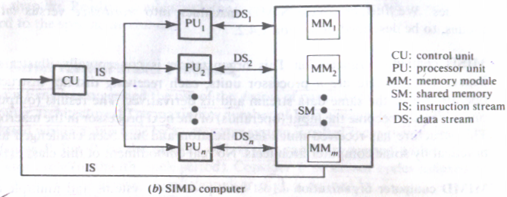
3.1.1 SIMD Computer organizations
Array processor has two different configurations. Configuration I has been implemented in the Illiac-IV computer. Configuration 1 is structured with N synchronized PEs,all of which are under the control of one CU. Each PE_{i} is essentially an ALU with attached working registers and local memory PEM_{i} for the storage of distributed data. The CU also has its own main memory for storage of programs. The function of CU is to decode all instruction and determine where the decoded instructions should be executed. Scalar or control type instructions are directly executed inside the CU. Vector instructions are broadcasted to the PEs for distributed execution.
All the PEs perform the same function synchronously in a lock-step fashion under the command of the CU. Vector operands are distributed to the PEMs before parallel execution in the array of PEs. The distributed data can be loaded into the PEMs from an external source via the system data bus or via the CU in a broadcast mode using the control bus. Masking schemes are used to control the status of each PE during the execution of a vector instruction. Each PE may be either active or disabled during an instruction cycle. A masking vector is used to control the status of all PEs. Only enabled PEs perform computation. Data exchanges among the PEs are done via an inter-PE communication network, which performs all necessary data routing and manipulation functions. This interconnection network is under the control of the control unit.
Fig.3.1. Architectural configuration of SIMD array processors
An array processor is normally interfaced to a host computer through the control unit. The host computer is a general purpose machine which serves as the operating manager of the entire system. The functions of the host computer include resource management and peripheral and I/O supervisions. The control unit of the processor array directly supervises the execution of programs, whereas the host machine performs the execution and I/O functions with the outside world.
Configuration II differs from configuration I in two aspects.First the local memories attached to the PEs are replaced by parallel memory modules shared by all the PEs through an alignment network. Second the inter PE permutation network is replaced by inter PE memory alignment network. A good example of configuration II SIMD machine is Burroughs scientific processor.
Formally an SIMD computer is characterized by following set of parameters.
C=<N, F, I, M>
Where N=Number of PEs in the system.
F=A set of data routing functions.
I=Set of machine instructions
M=Set of masking schemes.
3.1.2 Masking and data routing mechanisms
Consider configuration I of an SIMD computer. Each PE_{i} is a processor with its own memory PEM_{i}: a set of working registers and flags, namely A_{i}, Bi, C_{i} and S_{i}: an arithmetic logic unit; a local index register Ii; an address register D_{i}; and a data routing register R_{i}. The R_{i} of each PEi is connected to the R_{j} of other PEs via the interconnection network. When data transfer among PEs occurs, it is the contents of the R_{i} registers that are being transferred. N PEs is denoted as PEi for i=0, 1, 2 ...N-1, where the index i is the address of PE_{i}. We assume N=2^{m} or m=log₂N binary digits are needed to encode the address of a PE. The address register Di is used to hold the m-bit address of a PE.
Some array processors may use two routing registers, one for input and the other for output. The use of one Ri per PEi in which the inputs and outputs of Ri are totally isolated by using master-slave flip flops. Each PEi is either in the active or in the inactive mode during each instruction cycle. If a PEi is active, it executes the instruction broadcast to it by the CU. If a PE_{i} is inactive, it will not execute the instruction broadcast to it. The masking schemes are used to specify the status flag Si of PEi. The convention S_{i}=1 is chosen for an active PEi and S_{i}=0 for an inactive PE_{i}. In the CU, there is a global index register I and a masking register M. The M register has N bits. The ith bit of M will be denoted as M_{i}. The collection of S_{i} flags for i=0, 1, 2... N-1 forms a status register S for all the PEs.
Fig.3.2.Components in a Processing Element(PE_{i})
3.1.3 Inter- PE communications
There are fundamental decisions in designing appropriate architecture of an interconnection network for an SIMD machine. The decisions are made between operation modes, control strategies, switching methodologies, and network topologies.
Operation Mode
The types of communication can be identified :Synchronous and asynchronous.
Synchronous communication is needed for establishing communication paths synchronously for either a data manipulating function or for a data instruction broadcast. Asynchronous communication is needed for multiprocessing in which connection requests are issued dynamically. A system may also be designed to facilitate both synchronous and asynchronous processing. Typical operation modes of interconnection networks are synchronous, asynchronous, and combined. All existing SIMD machines choose the synchronous operation mode
Control strategy
A typical interconnection network consists of a number of switching elements and interconnecting links.
- Distributed control -Interconnection functions are realized by properly setting control of the switching elements.
- Centralized control -The control-setting function can be managed by a centralized controller or by the individual switching element.
- Most existing SIMD interconnection networks choose the centralized control on all switch elements by the control unit.
Switching Methodology
The two major switching methodologies are circuit switching and packet switching.
- In Circuit switching a physical path is established between source and destination.
- In packet switching, data is put in a packet and routed through the interconnection network, without establishing a physical connection path.
SIMD uses circuit switching operations.
Network topology
The topologies can be grouped into two categories: static and dynamic.
- In a static topology, links between two processors are passive and dedicated buses cannot be reconfigured for direct connections to other processors.
- In the dynamic category links can be reconfigured by setting the network's active switching elements.
- The space of the interconnection networks can be represented by the cartesian product of the above four sets of design features: {operation mode} x {control strategy} x {switching methodology) x {network topology).
3.2.SIMD Interconnection Networks

Various interconnection networks have been suggested for SIMD computers. The classification includes static versus dynamic networks, Mesh-connected Illiac network, Cube interconnection networks, Barrel shifter and data manipulator, Shuffle exchange and omega networks. Here we will discuss the first three networks.
3.2.1 Static versus dynamic networks
The SIMD interconnection networks are classified into two categories based on network topologies: static networks and dynamic networks.
Static networks
In static network the interconnection network is fixed and permanent interconnection path between two processing elements and data communication has to follow a fixed route to reach the destination processing element. Topologies in the static networks can be classified according to the dimensions required for layout. Examples of one-dimensional topologies include the linear array . Two-dimensional topologies include the ring, star, tree, mesh, and systolic array. Three dimensional topologies include completely connected chordal ring, 3 cube, and 3 cube connected cycle networks.

Fig.3.3. Static interconnection network topologies

Dynamic networks
Two classes of dynamic networks are there. Single stage versus multistage.
Single stage networks
A single stage network is a switching network with N input selectors (IS) and N output selectors (OS).Each IS is essentially a 1 to D demultiplexer and each OS is an M to 1 multiplexer where 1<D<N and 1<M<N.A single stage network with D=M=N is a crossbar switching network. To establish a desired connecting path different path control signals will be applied to all IS and OS selectors.
A single stage network is also called a recirculating network. Data items may have to recirculate through the single stage several times before reaching the final destination.The number of recirculation’s needed depend on the connectivity in the single stage network. In general, higher is the hardware connectivity, the less is the number of recirculation’s.

Fig.3.4.Conceptual view of a single-stage interconnection network

Multi stage networks
Many stages of interconnected switches from the multistage network. They are described by three characterizing features: switch box, network topology and control structure. Many switch boxes are used in multistage networks. Each box is essentially an interchange device with two inputs and outputs. The four states of a switch box: straight,exchange,upper broadcast and lower broadcast.
A multistage network is capable of connecting an arbitrary input terminal to an arbitrary output terminal. Multistage networks can be one-sided or two-sided. The one-sided networks, sometimes called full switches, have input-output ports on the same side. The two-sided multistage networks, which usually have an input side and an output side, can be divided into three classes: blocking, rearrangeable, and nonblocking.

Fig.3.5.A two-by-two switching box and its four interconnection states

In blocking networks, simultaneous connections of more than one terminal pair may result in conflicts in the use of network communications links. Examples of a blocking network are the data manipulator, Omega, flip, and baseline. A network is called a rearrangeable network if it can perform all possible connections between inputs and outputs by rearranging its existing connections so that a connection path for a new input-output pair can always be established. Example of rearrangeable network is Benes network. A network which can handle all possible connections without blocking is called a nonblocking network. Example of nonblocking network is Clos network.

Fig.3.6. Several multistage interconnection networks

3.2.2Mesh-Connected Illiac Network

A single stage recirculating network has been implemented in the Illiac IV array processor with 64 PEs. Each PE_{i} is allowed to send data to PE _{i+1},PE_{i-1},PE,_{i+r}PE_{i-r} where r=√N (for the case of the Illiac-IV, r=√64=8). Formally Illiac network is characterized by following four routing functions.
R₊₁(i)=(i+1)mod N
R₋₁(i)=(i-1)mod N
R_{+r}(i)=(i+r)mod N
R_{-r}(i)=(i-r)mod N
A reduced Illiac network is illustrated in Fig with N=16 and r=4.Each PEi is directly connected to its four nearest neighbours in the mesh network. Horizontally, all the PEs of all rows form a linear circular list is governed by the two permutations, each with a single cycle of order N.
R₊₁=(0 1 2 ……N-1)
R₋₁=(N-1………2 1 0)
Vertically, the distance r shifting operations are characterized by the following two permutations, each with r cycles of order r each:
r-s
R_{+r}= ∏ (i+r i+2r....i+N-r)
i=0

r-s
R_{+r}= ∏ (i+N-r ..... i+2r i+ri)
i=0

For the example network of N=16 and r=√16=4, the shift by a distance of four is specified by the following two permutations, each with four cycles of order four each:

R₊₄=(0 4 8 12)(1 5 9 13)(2 6 10 14 )(3 7 11 15)
R₋₄=(12 8 4 0)(13 9 5 1)(14 10 6 2 )(15 11 7 3)
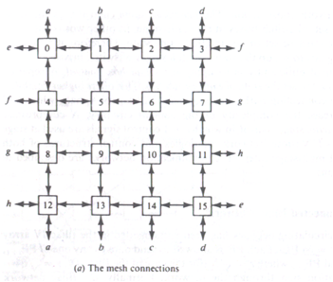
This fig shows four PEs can be reached from any PE in one step,seven PEs in two steps,and eleven PEs in three steps.In general it take I steps to route data from PE_{i} to any other PE_{j} in an Illiac network of size N where I is upper bounded by
I<√N-1
Fig.3.7.An Illiac network with N=16 PEs
Fig.3.7.An Illiac network with N=16 PEs
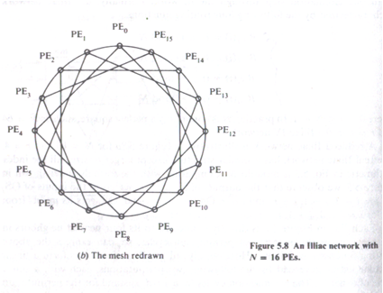
Fig.3.7.An Illiac network with N=16 PEs

3.2.3 Cube Interconnection Networks
The cube network can be implemented as either a recirculating network or as a multi stage network for SIMD machines.Vertical lines connect vertices whose address differs in the most significant bit position.Vertices at both ends of the diagonal lines differ in the middle bit position.Horizontal lines differ in the least significant bit position.
The interconnections of the PE’s corresponding to the 3 routing functions C0,C1 and C3.
If one assembles all three connecting patterns togethr , the 3 cube shown in Fig 5.9a should be the result.
Formally an n dimensional network of N PEs is specified by following n routing functions.
C_{i}(a_{n-1……}a_{i+1}a_{i} a_{i-1………..}a₀) for i=0,1,2……..n-1.
Two-function {straight and exchange) switch boxes are used in constructing multistage cube networks.
The stages are numbered as 0 at the input end and increased to n-1 at the output end.
Stage i implements the Ci routing function
for i = 0,1,2……n-1.

Fig.3.8. The cube interconnection network
The same set of cube- routing functions C0,C1 and C2 can also be implemented by three stage cube network with N=8. In the n cube, each PE located at a corner is directly connected to n neighbors. The neighboring PEs differ in exactly one bit position.
Fig.3.9. A multistage cube network for N=8

3.3. PARALLEL ALGORITHMS FOR ARRAY PROCESSORS
The original motivation for developing SIMD array processors was to perform parallel computations on vector or matrix types of data. Parallel processing algorithms have been developed by many computer scientists for SIMD computers. Important SIMD algorithms can be used to perform matrix multiplication, fast Fourier transform (FFT), matrix transposition, summation of vector elements, matrix inversion, parallel sorting, linear recurrence, boolean matrix operations, and to solve partial differential equations. We study below several representative SIMD algorithms for matrix multiplication, parallel sorting, and parallel FFT. We shall analyze the speedups of these parallel algorithms over the sequential algorithms on SISD computers.
SIMD Matrix Multiplication
We present below two parallel algorithms for matrix multiplication. The differences between SISD and SIMD matrix algorithms are pointed out in their program structures and speed performances. In general, the inner loop of a multilevel SISD program can be replaced by one or more SIMD vector instructions.
Let A = [a_{ik}] and B = [b_{kj}] be n x n matrices. The multiplication of A and B generates a product matrix C = Ax B = [C_{ij}] of dimension n x n. The elements of the product matrix C is related to the elements of A and B by:
Cij₌∑a_{ik} x b_{kj}
There are n³ cumulative multiplications to be performed in the above equation. A cumulative multiplication refers to the linked multiply-add operation c= c + a x b. The addition is merged into the multiplication because the multiply is equivalent to multioperand addition. Therefore, we can consider the unit time as the time required to perform one cumulative multiplication, since add and multiply are performed simultaneously.
In a conventional SISD uniprocessor system, the n3 cumulative multiplications are carried out by a serially coded program with three levels of DO loops corresponding to three indices to be used. The time complexity of this sequential program is proportional to n3, as specified in the following SISD algorithm for matrix multiplication.
An O(n3) algorithm for SISD matrix multiplication
For i= 1to n Do
For j = 1to n Do
Cij= 0 (initialization)
For k = 1to n Do
C_{ij}=C_{ij}+a_{ik.}b_{kj} (scalar additive multiply)
End of k loop
End of j loop
End of i loop
Now, we want to implement the matrix multiplication on an SIMD computer with n PEs. The algorithm construct depends heavily on the memory allocations of the A, B, and C matrices in the PEMs. Column vectors are then stored within the same PEM. This memory allocation scheme allows parallel access of all the elements in each row vector of the matrices. Based in this data -distribution, we obtain the following parallel algorithm. The two parallel do operations correspond to vector load for initialization and vector multiply for the inner loop of additive multiplications. The time complexity has been reduced to O(n2).
Therefore, the SIMD algorithm is n times faster than the SISD algorithm for matrix multiplication.
An O(n) algorithm for SIMD matrix multiplication
For i= 1 to n Do
Par for k = 1 to n Do
C_{ik}= 0 (rector load)
For j = 1 to n Do
Par for k = 1 to n Do
C_{ik}= C_{ik}+ a_{ij}.b_{jk} (vector multiply)
End of j loop
End of i loop
It should be noted that the vector load operation is performed to initialize the row vectors of matrix C one row at a time. In the vector multiply operation, the same multiplier aijis broadcast from the CU to all PEs to multiply all n elements {b_{ik}for k = 1,2, ..., n} of the ith row vector of B. In total, n2 vector multiply operations are needed in the double loops.

Fig.3.10. Memory allocation for SIMD matrix multiplication
4 cube construction from two 3 cube networks
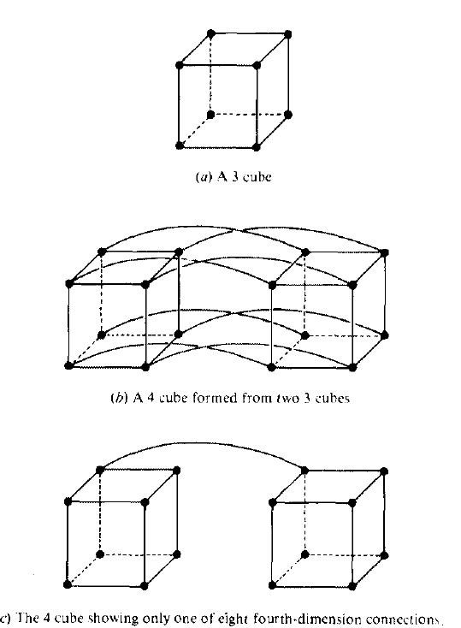
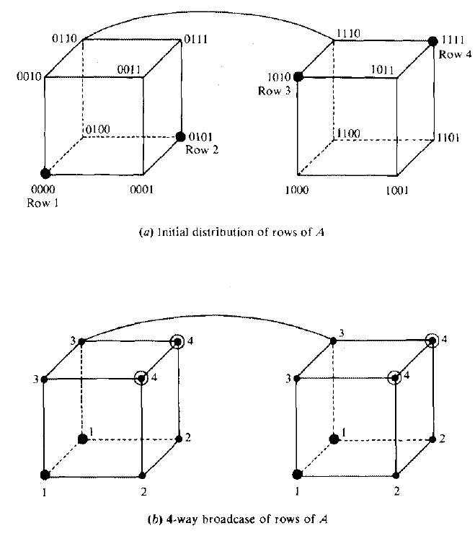
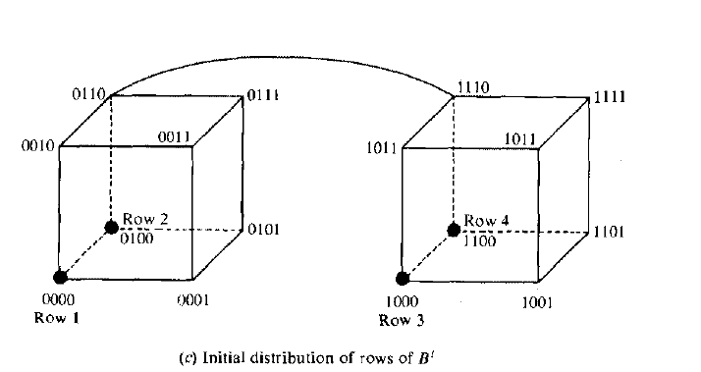
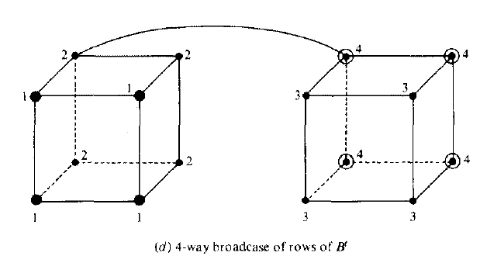
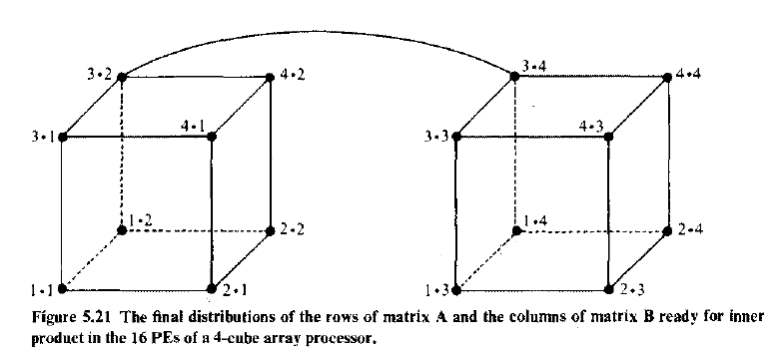

Parallel Sorting on Array Processors
An SIMD algorithm is to be presented for sorting n² elements on a mesh-connected (llIiac-lV-Iike) processor array in O(n) routing and comparison steps. This shows a speedup of O(log2 n) over the best sorting algorithm, which takes O(n log2 n) steps on a uniprocessor system. We assume an array processor with N = n² identical PEs interconnected by a mesh network similar to llIiac-IV except that the PEs at the perimeter have two or three rather than four neighbours. In other words, there are no wraparound connections in this simplified mesh network.
Eliminating the wraparound connections simplifies the array-sorting algorithm. The time complexity of the array-sorting algorithm would be affected by, at most, a factor of two if the wraparound connections were included.
Fig.3.11. A mesh connection of PEs without boundary wraparound connections for SIMD sorting
Two time measures are needed to estimate the time complexity of the parallel sorting algorithm. Let t R be the routing time required to move one item from a PE to one of its neighbours, and tc be the comparison time required for one comparison step. Concurrent data routing is allowed. Up to N comparisons may be performed simultaneously. This means that a comparison-interchange step between two items in adjacent PEs can be done in 2tR + tc time units (route left, compare, and. route right). A mixture of horizontal and vertical comparison interchanges requires at least 4tR + tc time units.
The sorting problem depends on the indexing schemes on the PEs. Illustrated in Figure are three indexing patterns formed after sorting the given array in part a with respect to three different ways for indexing the PEs. The pattern in part b corresponds to a row-majored indexing, part c corresponds to a shuffled row-major indexing, and is based on a snake-like row-major indexing. The choice of a particular indexing scheme depends upon how the sorted elements will be used. We are interested in designing sorting algorithms which minimize the total routing and comparison steps.
Fig.3.12. Sorting patterns with respect to three ways of indexing the PEs
The longest routing path on the mesh in a sorting process is the transposition of two elements initially loaded at opposite corner PEs.
Fig.3.13. The transposition of two elements at opposite corner PEs
This transposition needs at least 4(n - 1) routing steps. This means that no algorithm can sort n²elements in a time of less than O(n). In other words, an O(n) sorting algorithm is considered optimal on a mesh of n² PEs. Before we show one such optimal sorting algorithm on the mesh-connected PEs, let us review Batcher's odd-even merge sort of two sorted sequences on a set of linearly connected PEs shown in Figure. The shuffle and unshuffle operations can each be implemented with a sequence of interchange operations (marked by the double-arrows in Figure). Both the perfect shuffle and its inverse (unshuffle) can be done in k - 1 interchanges or 2(k - 1) routing steps on a linear array of 2k PEs.
Fig.3.14. Batchers odd-even merge of two sorted sequences on a linear array of PEs
Batcher's odd-even merge sort on a linear array has been generalized by Thompson and Kung to a square array of PEs. Let M(j, k) be a sorting algorithm for merging two sorted j-by-k/2 subarrays to form a sorted j-by-k array, where j and k are powers of 2 and k > 1. The snakelike row-major ordering is assumed in all the arrays. In the degenerate case of M(l, 2), a single comparison-interchange step is sufficient to sort two unit subarrays. Given two sorted columns of length j ~ 2, the M(j, 2) algorithm consists of the following steps:
The M(j, 2) sorting algorithm
J1: .Move all odds to the left column and all evens to the right in 2tk time.
J2: Use the odd-even transposition sort to sort each column in 2jtk + jtctime.
J3: Interchange on even row in 2tk time.
J4: Perform one comparison-interchange in 2tk + tc time
Fig.3.15. Data routing,comparison, and interchange operations performed in the M(4,2) sorting algorithm

The M(j,k) algorithm
M1: Perform single interchange step on even rows
M2: Unshuffle each row.
M3: Merge by calling algorithm M(j,k/2)
M4: Shuffle each row
M5: Interchange on even row
M6: Comparison interchange

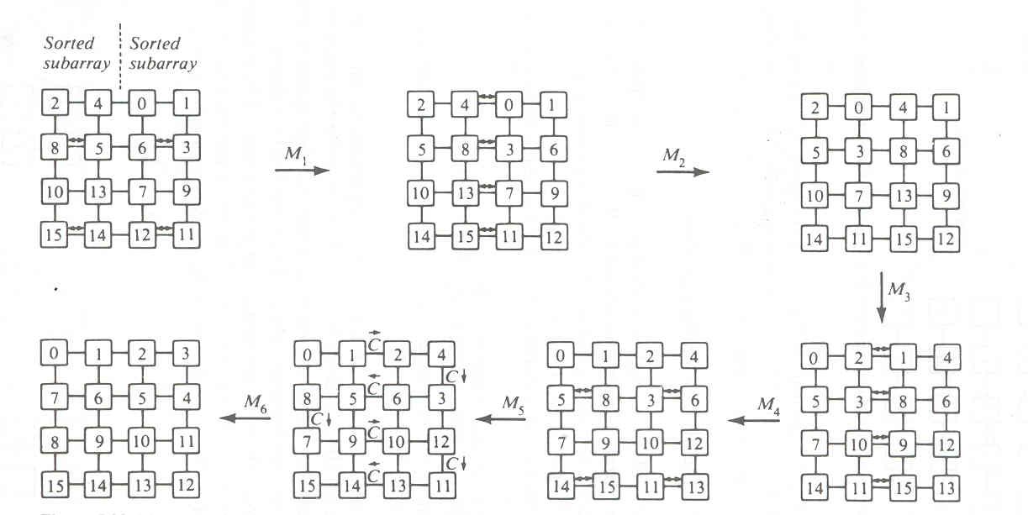
Fig.3.16. Merge sorting steps in the M (4,4) sorting algorithm
3.4. Associative array processing
In this section, we describe the functional organization of an associative array processor and various parallel processing functions that can be performed on an associative processor. We classify associative processors based on associative- memory organizations. Finally, we identify the major searching applications of associative memories and associative processors. Associative processors have been built only as special-purpose computers for dedicated applications in the past. Two SIMD computers, STARAN and the Parallel Element Processing Ensemble(PEPE), have been built around an associative memory(AM) instead of using the conventional random-access memory(RAM). The fundamental distinction between AM and RAM is that AM is content addressable allowing parallel access of multiple memory words, whereas the RAM must be sequentially accessed by specifying the word addresses.
Associative Memory Organizations
Data stored in an associative memory are addressed by their contents. In this sense, associative memories have been known as Content.-addressable memory, Parallel search memory and multiaccess memory. The major advantage of associative memory over RAM is its capability of performing parallel search and parallel search and parallel comparison operations. These are frequently needed-in-many-important applications., such as the storage and retrieval of rapidly changing databases, radar- signal tracking, image processing, computer vision, and artificial intelligence. The major shortcoming of associative memory is its much increased hardware cost. Recently, the cost of associative memory is much higher than that of RAMs.
The structure of AM is modelled in fig. The associative memory array consists of n words with mbits per word. Each cell in the array consists of a flip flop associated with some comparison logic gates for pattern match and read write control. A bit slice is a vertical column of bit cells of all the words at the same position.
Each bit cell B_{ij} can be written in,read out,or compared with an external interrogating signal. The comparand register C=(C_{1,}C_{2,}…………..C_{m}) is used to hold the key operand being searched for .The masking register M=(M_{1,}M₂,………..M_{m}) is used to enable the bit slices to be involved in the parallel comparison operations across all the word in the associative memory. The indicator register I and one or more temporary registers T are used to hold the current and previous match patterns. The counters are used to keep track of the i and j index values. The search key in the C register is first masked by the bit pattern in the M register. This masking operation selects the effective fields of bit slices to be involved. Parallel comparisons of the masked key word with all words in the associative memory are performed by sending the proper interrogating signals to all the bit slices involved .

Fig.3.17. An associative memory array and working registers

In practice, most associative memories have the capability of word parallel operations; that is, all words in the associative memory array are involved in the parallel search operations. This differs drastically from the word serial operations encountered in RAMs. Based on how bit slices are involved in the operation, we consider below two different associative memory organizations:
The bit parallel organization: In a bit parallel organization, the comparison process is performed in a parallel-by-word and parallel-by-bit fashion. All bit slices which are not masked off by the masking pattern are involved in the comparison process. In this organization, word-match tags for all words are used (Figure 5.34a). Each cross point in the array is a bit cell. Essentially, the entire array of cells is involved in a search operation.
Bit serial organization: The memory organization in Figure 5.34b operates with one bit slice at a time across all the words. The particular bit slice is selected by an extra logic and control unit. The bit-cell readouts will be used in subsequent bit-slice operations. The associative processor STARAN has the bit serial memory organization and the PEPE has been installed with the bit parallel organization.
The associative memories are used mainly for search and retrieval of non- numeric information. The bit serial organization requires less hardware but is slower in speed. The bit parallel organization requires additional word-match detection logic but is faster inspeed.

Fig.3.18. Associative memory organizations
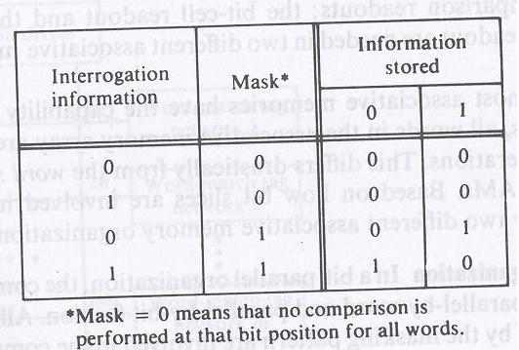
Interrogating signal are associated with each bit slice, and the read write drives are associated with each word. There are 2 types of comparison readouts: the bit-cell readout and the word readout. 2 types of readout are needed in 2 different AM organizations.
Consider a student-file search in a bit parallel associative "memory”.Search all students whose age is not younger than 21 but is younger than 31. Performing the not-less-than search and the less-than search on the age field of the file. Two matching patterns are used in the two subsequent searches. masking pattern selects the age field. The lower-bound 21 is loaded into the C register as the first key word. Parallel comparisons are performed on all student records (words) in the file. Initially, the indicator register is cleared to be zero.
After the first search, those students who are not younger than 21 are marked with a 1 in the indicator register, one bit per each student word. This matching vector is then transferred to one of the T registers. Then the upper-bound 31 is loaded into C as the second matching key. After the second search, a new matching vector is sent to the I register. A bitwise AND ing operation is then performed between the I and T registers with the resulting vector residing in the I register as the final output of the search process. The whole search process requires only two accesses of the associative memory.

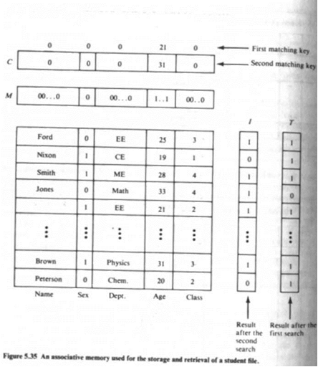
Associative processors (PEPE and STARAN)
Associative processor is a SIMD machine with the capabilities:
Stored data items are content addressable. Arithmetic and logic operations are performed over many sets of arguments in a single instruction. Because of the content addressable and parallel processing capabilities, associative processors form a special subclass of SIMD computers.
Classification of Associative processors into 2 classes:
fully parallel versus the bit serial organizations depending on AM used.
The PEPE architecture:
There are 2 types of fully parallel associative processors: word- organized and distributed logic.
Word organized associative processor:
Comparison logic is associated with each bit cell of every word and the logical decision is available at the o/p of every word.
Distributed logic associative processor:
Comparison logic is associated with each character cell of a fixed no. of bits or with a group of character cells.
PEPE is based on this.
--less complex
--less expensive
Schematic block diagram of PEPE
is attached to general purpose machine CDC7600
- a special purpose computer
- commercial model not available.
- performs real-time radar tracking in the antiballistic missile (ABM) environment.
The bit-serial STARAN organization
Full parallel structure requires expensive logic in each memory cell and complicated communications among the cells.
Bit serial associative processor is less expensive than the fully parallel structure because only one bit slice is involved in the parallel comparison at a time.
Bit serial associative processing is realized in the computer STARAN
I STARAN for digital image processing (1975)
-Interface unit involves interface with sensors, conventional computers, signal processors, interactive displays and mass storage devices.
- A variety of I/O option are implemented in the custom-interface unit including the DMA, buffered I/O channels, external function channels and parallel I/O.It consists of 32 associative array modules
- Each associative array module contains a 256 word 256 bit multidimensional access (MDA) memory, 256 PEs, a flip n/w, a selector.
- The 256 i/p and 256 o/p (used to increase the speed of inter array data communication that allow STARAN to communicate with high bandwidth I/O device) of each associative array module are into the custom interface unit.
- Each PE operates serially bit by bit on the data in all MDA memory words

