Module-2
Principles of pipelining and vector Processing
Principles of pipelining and vector processing- Linear pipelining - Classification of pipeline processors - General pipelines - Instruction and Arithmetic pipelines –Design of Pipelined instruction unit-Principles of Designing Pipeline Processors- Instruction prefetch and branch handling- Data Buffering and Busing Structure-Internal forwarding and register tagging-Hazard detection and Resolution, Dynamic pipelines and Reconfigurability.

We have already seen those parallel computers are classified into pipeline computers, array processors, multiprocessor systems and dataflow computers. This module deals with pipeline computers. Pipelining offers an economical way to realize temporal parallelism in digital computers. To achieve pipelining, one must subdivide the input task into a sequence of subtasks, each of which can be executed by a specialized hardware stage that operates concurrently with other stages in the pipeline.

2.1 PRINCIPLES OF LINEAR PIPELINING
Pipelining offers temporal parallelism in digital computers.The concept of pipeline processing is similar to assembly lines in an industrial plant. To achieve pipelining, one must subdivide the input task (process) into a sequence of subtasks, each of the task can be executed by a specialized hardware stage that operates concurrently with other stages in the Pipeline .Successive tasks get executed in an overlapped fashion at the subtask level. The subdivision of the input tasks into a proper sequence of subtasks becomes a crucial factor in determining the performance of the pipeline.

A basic linear pipeline processor is depicted in figure. The pipeline consists of a cascade of processing stages. The stages are pure combinational circuits performing arithmetic or logic operations over the data stream flowing through the pipe. The stages are separated by high speed interface latches. The latches are fast registers for holding the intermediate results between the stages. Information flows between adjacent stages are under the control of a common clock applied to all the latches simultaneously.

Fig: 2.1 Linear pipeline processor for overlapped processing of multiple tasks

Clock period:-
The logic circuitry in each stage si has a time delay denoted by τ_{i}. Let τ_{i} be the time delay of each interface latch. The clock period of a linear pipeline is defined by
τ=max { τ_{i}.}^{k}1 + τ_{i}= τ_{m+} τ_{i}.
The reciprocal of the clock period is called the frequency f=1/ τ of a pipeline processor.

- In space time diagram ,once the pipe is filled up ,it will output one result per clock period independent of the number of stages of the pipe
- Ideally a linear pipeline with k stages can process n tasks in Tk=k+(n-1) clock periods,where k cycles are used to fill up the pipeline or complete the execution of the first task and (n-1) cycles are needed to complete the remaining n-1 tasks.
- The same number of tasks can be executed in a non pipeline processor with an equivalent function in T1=n.k time delay.
Speedup:-
We define the speedup of a K stage linear pipeline processor over an equivalent nonpipeline processor as
S_{k}=T₁ = n.k
T_{k} k+(n-1)

Maximum speed up that a linear pipeline can provide is k, where k is the number of stages in the pipe. This maximum speed up is never fully achievable because of data dependencies between instructions. Interrupts, program branches, and other factors to be revealed in later sections.
Design of a pipeline floating-point adder
To understand the operational principles of pipeline computation, we illustrate the design of a pipeline floating point adder in figure. This pipeline is linearly constructed with four functional stges.The inputs to this pipeline are two normalized floating point numbers:
A=a x 2^{p}
B=b x 2^{q}
Where a and b are two fractions and p and q are their exponents, respectively. Our purpose is to compute the sum
C=A+B=c x 2^{r}=d x 2^{s}
Where r=max (p.q) and .5<d<1
Operations performed in the 4 pipeline stages are specified below:
1. Compare the two exponents p and q to reveal the larger exponent r=max (p, q) and to determine their difference t=|p-q|. Shift right the fraction associated with the smaller exponent by t bits to equalize the two exponents before fraction addition.
2. Add the preshifted fraction with the other fraction to produce the intermediate sum fraction c, where 0<c<1
3. Count the number of leading zeros, say u, in fraction c and shift left c by u bits to produce the normalized fraction sum d=c x 2^{u},with a leading bit 1.
- Update the large exponent s by subtracting s=r-u to produce the o/p exponent.

Fig 2.2. A pipelined floating-point adder with four processing stages
Efficiency:-
The efficiency of a linear pipeline is measured by the percentage of busy time space spans over the total time space span, which equals the sum of all busy and idle time space spans.
η = n.k.τ = n
k.[kτ+(n-1)τ] k+(n-1)

Throughput:-
The number of tasks that can be completed by a pipeline per unit time is called its throughput. This rate reflects the computing power of a pipeline.
w = n = η
kτ+(n-1)τ τ

Pipelined structure of CPU
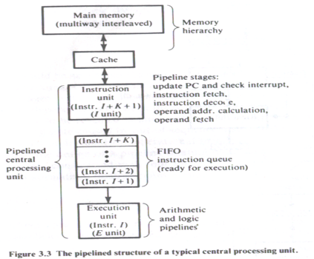

The central processing unit (CPU) of a modern digital computer can be partitioned into three sections: the instruction unit, the instruction queue, and the execution unit.Programs and data reside in the main memory; which usually consists of interleaved memory modules. The cache is a faster storage of copies of programs and data which are ready for execution. The cache is used to close up the speed gap between main memory and the CPU.
The instruction unit consists of pipeline stages
-instruction fetch,
- instruction decode,
- operand address calculation, and
-operand fetches (if needed).
The instruction queue is a first-in, first-out (FIFO) storage area for decoded instructions (ready for execution), and fetched operands. The execution unit may contain multiple functional pipelines for arithmetic logic functions. While the instruction unit is fetching instruction I+ K + 1, the instruction queue holds instructions I + 1, I + 2. ..., I + K, and the execution unit execute instruction I.

2.2. CLASSIFICATION OF PIPELINE PROCESSORS

According to the levels of processing, Handler has proposed the following classification scheme for pipeline processors, They are Arithmetic pielining, Instruction pipelining, Processor pipelining.
- Arithmetic pipelining
The arithmetic logic units of a computer can be segmentized for pipeline operations in various data formats. Pipelining techniques can be applied to speed up numerical arithmetic computations. Well known arithmetic pipe line examples are the upto 14 pipeline stages used in the Cray-1 and the upto 26 stages per pipe in the Cyber-205.
- Instruction pipelining
The execution of a stream of instructions can be pipelined by overlapping the execution of the current instruction with the fetch, decode and operand fetch of subsequent instructions. This technique is also known as instruction lookahead. Almost all high-performance computers are now equipped with instruction pipelines.

- Processor pipelining
This refers to the pipeline processing of the same data stream by a cascade of processors, each of which processes a specific task. The data stream passes the first processor with the result stored in memory block which is also accessible by the second processor. The second processor then passes the refined results to the third and so on. The pipelining of multiple processors is not yet well accepted as a common practice

Fig.2.3. Handler’s classification of pipelined processors
Based on configuration they are classified into following pipelines(According to Ramamoorthi and Li).
- Static Vs dynamic pipelines
A static pipeline may assume only one functional configuration at a time. Static pipelines can be either unifunctional or multifunctional. A dynamic pipeline processor permits several functional configurations to exist simultaneously. In this sense a dynamic pipeline must be multifunctional. On the other hand a unifunctional pipe must be static.
- Unifunction Vs multifunction pipelines
A pipeline unit with a fixed and dedicated function is called unifunctional. A multifunction pipe may perform different functions, either at different times or at the same timely interconnecting different subsets of stages in the pipeline.

- Scalar Vs vector pipelines
Scalar pipeline processes a sequence of scalar operands under the control of a DO loop. Instructions in a small DO loop are often prefetched into the instruction buffer. The required scalar operands for repeated scalar instructions are moved into a data cache in order to continuously supply the pipeline with operands.
Vector pipelines are specially designed to handle vector instructions over vector operands. Computers having vector instructions are often called vector processors.

2.3 GENERAL PIPELINES AND RESERVATION TABLES
In some computations like linear recurrence the outputs of the pipeline are feedback as future inputs. In other words the inputs may depend on previous outputs. Pipelines with feedback may have a nonlinear flow of data. The timing of the feedback inputs becomes crucial to the nonlinear data flow.
Consider a sample pipeline that has a structure with both feed forward or feedback connections, in addition to the cascaded connection in linear pipeline. We use a two dimensional chart known as reservation table which is borrowed from the Gantt charts used in operation research to show how successive pipeline stages are utilized for a specific function evaluation in successive pipeline cycles.
The two reservation tables shown in figure correspond to the two functions of the sample pipeline. The rows correspond to pipeline stages and the columns to clock time units. The total number of clock units in the table is called the evaluation time for the given function.
The rows correspond to pipeline stages and the columns to clock time units. A feed forward connection connects a stage Si to a stage Sj such that j >= i + 2 and . A feedback connection connects a stage Si to a stage Sj such that j < =i. The crossed circles refer to data multiplexers used for selecting among multiple connection paths in evaluating different functions.
In reservation table , multiple marks in a row or in a column is possible . multiple marks in a column correspond to the simultaneous usage of multiple pipeline stages. Multiple marks in a row correspond to the repeated usage (for marks distant columns) or prolonged usage (for marks in adjacent columns) of a given stage .

Fig.2.4. A sample pipeline and reservation tables for two of its function

Snapshot evaluating function A in sample pipeline
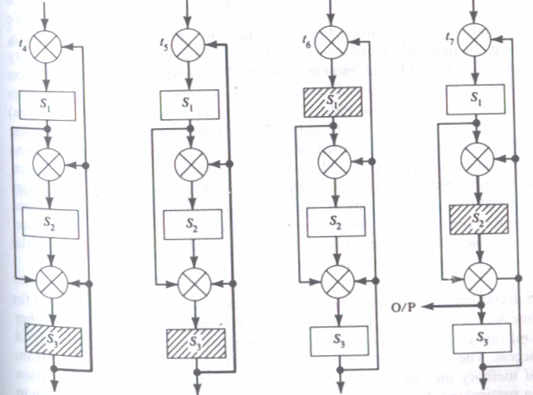

Before studying various pipeline design techniques and examining vector processing requirements ,we need to understand how instructions can be overlapped ,executed and how repeated arithmetic computations can be done with pipelining. Instruction pipelining is illustrated with the designs in the IBM 360/91.Arithmetic pipelining will be studied in detail with multiple number addition, floating point addition, multiplication, and division.

2.4 INSTRUCTION AND ARITHMETIC PIPELINES
Design of pipelined instruction units
The IBM 360/91 incorporates a high degree of pipelining in both instruction preprocessing and instruction execution. It is a 32 bit machine specially designed for scientific computations in either fixed point or floating point data formats.
A block diagram of the CPU in the IBM 360\91 is depicted in figure. It consists of 4 major parts. The main storage control unit, the instruction unit, the fixed point execution unit, and the floating point execution unit. The instruction unit is pipelined with a clock period of 60 ns. The cpu is designed to issue instructions at burst rate of one instruction per clock cycle, and the performance of two execution units should support this rate. The storage control unit supervises information exchange between the cpu and main memory major functions of I unit, including instruction fetch, decode, and delivery to appropriate E unit, operand address calculation and operand fetch. The two E units are responsible for the fixed point and floating point arithmetic logic operations needed in the execution phase.
Concurrent arithmetic executions are facilitated in the model 91 by using two separate units for fixed point execution and floating point execution.
This permits instructions of two classes to be executed in parallel. As long as no cross unit data dependencies exist, the execution does not necessarily flow in the sequence in which the instructions are programmed. Within the floating point E unit are an add unit and multiply/divide unit which can operate in parallel.
Fig.2.5 The central processing unit of IBM System 360/Model 91
The I unit in model 91 is specially designed to support the pipeline operations buffer is used to prefetch up to eight double words of instructions. A special controller is designed to handle instruction fetch, branch and interrupt conditions. There are two target buffers for branch handling. Sequential instruction fetch branch and interrupt handling are all built in hardware features. After decoding the I unit will dispatch the instructions to the fixed point E unit, the floating point E unit. For memory reference instructions the operand address is generated by an address adder. This adder is also used for branch address generation.
Fig.2.6.a. The instruction unit in IBM 360/91 CPU

2.5 PRINCIPLES OF DESIGNING PIPELINE PROCESSORS
1. Instruction prefetch and branch handling
From the viewpoint of overlapped instruction execution sequencing for pipelined processing, the instruction mixes in typical computer programs can be classified into four types, as shown in Table. The arithmetic load operations constitute 60 percent of a typical computer program. These are mainly data manipulation operations which require one or two operand fetches. The execution of different arithmetic operations requires a different number of pipeline cycles. The store type operation (15%) does not require a fetch operand, but memory access is needed to store the data. The branch type (5%) operations correspond to an unconditional jump. There are two paths for a conditional operation .The yes path (12%) requires the calculation of the new address being branched to, whereas the no path (8%) proceeds to the next sequential instruction in the program.
Interrupt and branch, produce damaging effects on the performance of pipeline computers. When instruction I is being executed, the occurrence of an interrupt postpones the execution of instruction I+1 until the interrupting request has been serviced.
There are two types of interrupts.
1.Precise interrupts are caused by illegal operation codes found in instructions, which can be detected during the decoding stage.
2.imprecise interrupts, is caused by defaults from storage, address, and execution functions.
Since the precise interrupts are detected in the decoding stage, an interrupt on instruction I prohibits instruction I + I from entering the pipeline. Then the interrupt routine is serviced.
Imprecise interrupt occurs when the instruction is halfway through the pipeline and subsequent instructions are already admitted into pipeline. When an interrupt of this kind occurs, no new instructions are allowed enter the pipeline and all the incomplete instructions inside the pipeline, whether they precede or follow the interrupted instruction, will be completed before the processor unit is switched to service the interrupt.
Star-1OO system
The pipelines are dedicated to vector-oriented arithmetic operations. To handle interrupts during the execution of a vector instruction special interrupt buffer areas are needed .Interrupt buffer areas hold addresses, delimiters, field lengths. etc, which are needed to restart the vector instructions after an interrupt.
The effect of branching on pipeline performance is described below by a linear instruction pipeline consisting of five segments: instruction fetch, decode, operand fetch, execute, and store results. Possible memory conflicts between overlapped fetches are ignored and a sufficiently large cache memory is used in the following analysis.
As illustrated in figure the instruction pipeline executes a stream of instructions continuously in an overlapped fashion if branch type instructions do not appear. Under such circumstances once the pipeline is filled up with sequential instructions the pipeline completes the execution of one instruction per a fixed latency.
On the other hand a branch instruction entering the pipeline may be halfway down the pipe before a branch decision is made. This will cause the program counter to be loaded with the new address to which the program should be directed, making all prefetched instructions useless. The next instruction cannot be initiated until the completion of the current branch instruction cycle. The overlapped action is suspended and the pipeline must be drained at the end of the branch cycle. The continuous flow of instructions into the pipeline is thus temporarily interrupted because of the presence of a branch instruction.

Fig.2.6.b. The effect of branching on the performance of an instruction pipeline
The damaging effects of branch instructions can be restricted by different mechanisms like instruction prefetch. A prefetching strategy is as follows:
Instruction words ahead of the one currently being decoded are fetched from the memory before the instruction-decoding unit requests them. All requests require T cycles to return from memory. There are two prefetch buffers of sizes s and t instruction words.
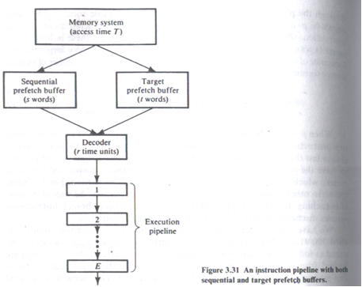
The s-size buffer(sequential prefetch buffer) holds instructions fetched during the sequential part of a run. When a branch is successful, the entire sequential buffer is invalidated. The Target prefetch buffer holds instructions fetched from the target of a conditional branch. When a conditional branch is resolved and determined to be unsuccessful, the contents of the target buffer are invalidated
The instruction requested by the decoder is available in the Sequential buffer for sequential instructions, or is in the target buffer if a conditional branch has just been resolved and is successful, it enters the decoder with zero delay. Otherwise, the decoder is idle until the instruction returns from memory.
Except for jump instructions, all decoded instructions enter the execution Pipeline, where E units are required to complete execution.
If the decoded instruction is an unconditional branch, the instruction word at the target of the jump is requested immediately by the decoder .Decoding ceases until the target instruction returns from the memory. In unconditional branch operation, no opportunity for target prefetching.

2. Data Buffering and Busing Structure
The processing speeds of pipeline segments are usually unequal. Consider the example pipeline with three segments having delays T₁,T₂, andT₃ respectively. If T₁=T₃=T and T₂ = 3T, obviously segment S₂ is the bottleneck. The throughput of the pipeline is inversely proportional to the bottleneck. Therefore, it is desirable to remove the bottleneck which causes the unnecessary congestion. One obvious method is to subdivide the bottleneck. The below figure shows two different subdivisions of segment S₂. The throughput is increased in either case. If the bottleneck is not subdivisible, using duplication the bottleneck in parallel is another way to smooth congestion as shown in figure.
Fig. Subdivision or replication to alleviate the bottleneck in a pipeline
Data and instruction buffers
Another method to smooth the traffic flow in a pipeline is to use buffers to close up the speed gap between the memory accesses for either instructions or operands and the arithmetic logic executions in the functional pipes. The IBM System 360 Model 91 uses three buffer types for various instruction and data types. Instructions are first fetched to the instruction-fetch buffers before sending them to the instruction unit. After decoding, fixed-point and floating-point instructions and data are sent to their dedicated buffers. The stored address and data buffers are used for continuously storing results back to the main memory.
In the STAR-100 system, a 64 word buffer is used to temporarily hold the input data stream until operands are properly aligned. In addition there is an instruction buffer which provides for the storage of thirty-two 64 bit instructions. In the TI-ASC system,two eight-word buffers are utilized to balance the stream of instructions from the memory to the execution unit.A memory buffer unit has three double buffers,X,Y,and and Z. Two buffers(X and Y) are used to hold the input operands and the third(Z buffer) is used for the output results.
Busing structures
The subfunction being executed by one stage should be independent of the other subfunctions being executed by the remaining stages; otherwise, some processes in the pipeline must be halted until the dependency is removed. For example, when one instruction waiting to be executed is first to be modified by a future instruction, the execution of this instruction must be suspended until the dependency is released. Another example is the conflicting use of some registers or memory locations by different segments of a pipeline. These problems cause additional time delays. An efficient internal busing structure is desired to route results to the requesting stations with minimum time delays.Example : TI ASC,STAR-100. In STAR-100 system, direct routes are established from the output transmit segment to the input receive segment.
3. Internal forwarding and register tagging
Internal forwarding refers to a short-circuit technique for replacing unnecessary memory accesses by register-to-register transfers in a sequence of fetch-arithmetic-store operations. Memory access is slower than register-to-register operations.Performance can be enhanced by eliminating unnecessary memory accesses. Register tagging refers to the use of tagged registers, buffers, and reservation stations for exploiting concurrent activities among multiple arithmetic units. We use the symbols Mi and R_{j} to represent the ith word in the memory and the jth register in the CPU.<- arrow is used to specify data moving operations such as fetch, store and register-to-register transfer. The contents of M_{i} and R_{j} are represented by (M_{i}) and (R_{j}) respectively.
Internal Forwarding
This concept can be explored in 3 directions:
- Store – Fetch Forwarding
- Fetch – Fetch Forwarding
- Store – Store Forwarding
Store-fetch forwarding
The following sequence of the two operations store-then-fetch can be replaced by two parallel operations, one store and one register transfer. Fetch equals Load operation.

M_{i}<-(R₁) (store)
Two memory accesses
R₂<-(M_{i}) (fetch)

being replaced by

M_{i}<-(R₁) (store)
Only one memory access
R₂<-(R₁) (register transfer)

Fetch-fetch forwarding
The following two fetch operations can be replaced by one fetch and one register transfer.
R₁<-(M_{i}) (fetch)
Two memory accesses
R₂<-(M_{i}) (fetch)

being replaced by

R₁<-(M_{i}) (store)
Only one memory access
R₂<-(R₁) (register transfer)

Store-store forwarding
The following two memory updates of the same word can be combined into one, since the second store overwrites the first.
M_{i}<-(R₁) (store)
Two memory accesses
M_{i}<-(R₂) (store)

being replaced by

M_{i}<-(R₂) (store) Only one memory access

Fig.2.8. Internal forwarding examples
Register Tagging
Register tagging refers to the use of tagged registers, buffers and reservation stations for exploiting concurrent activities among multiple arithmetic logic units.
Example : IBM Model 91 : Floating Point Execution Unit
- The floating point execution unit consists of :
  - Data registers
  - Transfer paths
  - Floating Point Adder Unit
  - Multiply-Divide Unit
  - Reservation stations
  - Common Data Bus
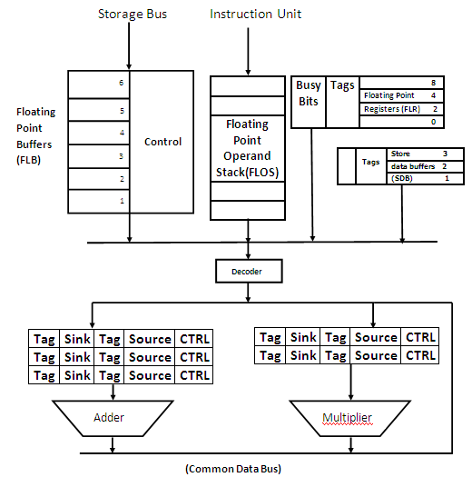
- 3 store data buffers(SDBs) and 4 floating point registers (FLRs) are tagged
- Busy bits in FLR indicates the dependence of instructions in subsequent execution
- Common Data Bus(CDB) is to transfer operands
- There are 11 units to supply information to CDB: 6 FLBs, 3 adders & 2 multiply/divide unit
Tags for these stations are :
Unit | Tag | Unit | Tag
FLB1 | 0001 | ADD1 | 1010
FLB2 | 0010 | ADD2 | 1011
FLB3 | 0011 | ADD3 | 1100
FLB4 | 0100 | M1 | 1000
FLB5 | 0101 | M2 | 1001
FLB6 | 0110
Example:
- Let F refers to FLR and FLB_{i} stands for i^{th} FLB and their contents be (F) and (FLB_{i})
- Consider instruction sequence
ADD F,FLB1 F (F) + (FLB₁)
MPY F,FLB2 F (F) x (FLB₂)
- During addition :
  - Busy bit of F is set to 1
  - Contents of F and FLB1 is sent to adder A1
  - Tag of F is set to 1010 (tag of adder)
Busy Bit = 1 | Tag=1010
F
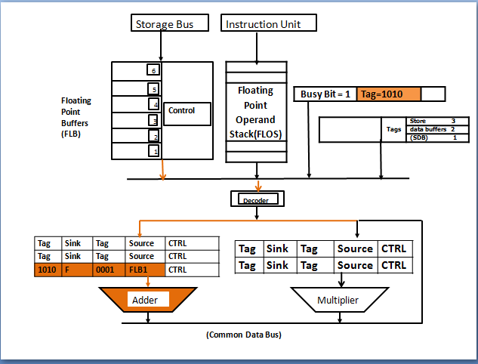
Meantime, the decode of MPY reveals F is busy, then
  - F should set tag of M1 as 1010 (Tag of adder)
  - F should change its tag to 1000 (Tag of Multiplier)
  - Send content of FLB2 to M1
F
Busy Bit = 1 | Tag=1000

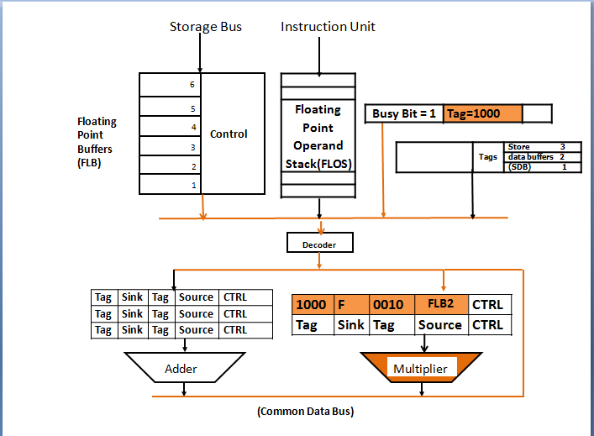
When addition is done, CDB finds that the result should be sent to M1.
Multiplication is done when both operands are available.
4. Hazard detection and Resolution
Pipeline hazards are caused by resource usage conflicts among various instructions in the pipeline. Such hazards are triggered by interinstruction dependencies. Hazards is also known data dependent hazards.Eg: an instruction may depend on the result of a previous instruction. In other instances, two stages of a pipeline may need to update the same memory location.
Terminologies:
Resource Objects: set of working registers, memory locations and special flags.
Data Objects: Content of resource objects
Each Instruction can be considered as a mapping from a set of data objects to a set of data objects.
Domain D(I) : set of resource objects whose data objects may affect the execution of instruction I.
Range R(I): set of resource objects whose data objects may be modified by the execution of instruction I
Instruction reads from its domain and writes in its range. I.e. the operands to be used in an instruction execution are retrieved(read) from its domain, and the results will be stored (written)in its range.
There are three classes of data-dependent hazards, according to various data update patterns: write after read (WAR) hazards, read after write (RAW) hazards, and write after write (WAW) hazards.
RAW (Read After Write)
A read after write (RAW) data hazard refers to a situation where an instruction refers to a result that has not yet been calculated or retrieved. (i2 tries to read a source before i1 writes to it).
For example:
i1. R2 <-R1+R3
i2. R4 <- R2 + R3
The first instruction is calculating a value to be saved in register R2, and the second is going to use this value to compute a result for register R4. However, in a pipeline, when operands are fetched for the 2nd operation, the results from the first will not yet have been saved, and hence a data dependency occurs.A data dependency occurs with instruction i2, as it is dependent on the completion of instruction i1.
WAW(Write After Write)
A write after write (WAW) data hazard may occur in a concurrent execution environment. (i2 tries to write an operand before it is written by i1)
i1. R2 <-R4+R7
i2. R2 <- R1 + R3
We must delay the WB (Write Back) of i2 until the execution of i1.
Example
I1 : MUL r1, r2
I2 : ADD r1,r4
Here I1 and I2 writes to same destination and hence they are said to be WAW dependent.
WAR(Write After Read)
A write after read (WAR) data hazard represents a problem with concurrent execution. (i2 tries to write a destination before it is read by i1)
i1.R4<-R1+ R5
i2. R5 <- R1 + R2
Example:
I1 : MUL r1,r2
I2 : ADD r2,r3
Here I2 has r2 as destination while I1 uses it as source and hence they are WAR dependent.

A RAW hazard between the two instructions I and J may occur when J attempts to read some data object that has been modified by I. A WAR hazard may occur when J attempts to modify some data object that is read by I. A WAW hazard may occur if both I and J attempt to modify the same data object.
R(I)ᴖD(J) ≠ ɸ for RAW
R(I)ᴖR(J) ≠ ɸ for WAW
D(I)ᴖR(J) ≠ ɸ for WAR

Fig.2.9. Illustration of RAW, WAW, and WAR hazard conditions

Hazard Detection and Resolution
- Hazards can be detected in fetch stage by comparing domain and range.
- Once detected, there are two methods:
- Generate a warning signal to prevent hazard
- Allow incoming instruction through pipe and distribute detection to all pipeline stages.
5. Dynamic pipelines and Reconfigurability
A dynamic pipeline may initiate tasks from different reservation tables simultaneously to allow multiple numbers of initiations of different functions in the same pipeline. The reservation of a pipeline can be modified with the insertion of noncompute delays or with the use of internal buffers at each stage. The utilization of the stages and hence the throughput of the pipe can be greatly enhanced with a modified reservation table yielding a more desirable latency pattern.
The task arrivals in a pipeline processor may be periodic for a program with inner loops. If we assume that each task can only occupy one stage at a time, no parallel computation can be done within a single task. Such an assumption stems from the practical difficulties encountered in implementing a priority scheme involving parallel computations of a task. Once some buffers are provided internally the task scheduling problem can be greatly simplified. Whenever two or more tasks trying to use the same stage only one of the tasks allow using the stage, while the rest wait in the buffers according to some priority schemes.
There are two different implementations of internal buffers in a pipeline. The first use one buffer for each stage (Fig.2.10.a). And the second uses one buffer per computation step (Fig.2.10.b). For one buffer per stage two priority schemes FIFO global can be used. In the FIFI global scheme a task has priority overall tasks initiated later. In the LIFO global scheme a task has priority over all tasks initiated earlier. For one buffer per computation step multiple buffers may be used in each segment with the following priorites:MPF:most processed first;LPF:least processed first;LWRF:least work remaining first; and MWRF:most work remaining first.
Fig.2.10. Inserting buffers to improve the pipeline utilization rate
A dynamic pipeline would allow several configurations to be simultaneously present. For example a dynamic pipeline arithmetic unit could perform addition and multiplication at the same time. Tremendous control overhead and increased interconnection complexity would be expected. None of the existing pipeline processors has achieved this dynamic capability. Most commercial pipelines are static. In T1-ASC the desired control allows different instructions to assume different data paths through the arithmetic pipeline at different times. All path control information is stored in a read only memory, which can be accessed at the initiation of an instruction.

