Module-1
Introduction to Parallel Processing
Introduction to parallel processing - Trends towards parallel processing - Parallelism in uniprocessor - Parallel computer structures-Architecture classification schemes –Amdahl’s law- Indian contribution to parallel processing.

Basic concepts of parallel processing on high performance computers are introduced in this chapter. We will review the architectural evolution, examine various forms of concurrent activities in modern computer systems, and assess advanced applications of parallel processing computers.
Introduction to parallel Processing
- Efficient form of Information processing
- Emphasizes the exploitation of concurrent events in the computing process
- Concurrency implies
-Parallelism
-Simultaneity
-Pipelining
- Parallel events may occur in multiple resources during the same time interval;
- simultaneous events may occur at the same time instant; and
- pipelined events may occur in overlapped time spans.
Parallel processing demands concurrent execution of many programs in the computer and thereby improving the system performance
1.1 Evolution of Computer Systems
To design a powerful and cost effective computer system and to devise efficient programs to solve a computational problem, one must understand the underlying hardware and software system structures and the computing algorithms to be implemented on the machine with some user oriented programming languages. These disciplines constitute the technical scope of computer architecture. In this section we review the generations of computer systems and indicate the general trends in the development of high performance computers.
First Generation - 1938-1953: Vacuum Tubes
The first computers used vacuum tubes for circuitry and magnetic drums for memory, and were often enormous, taking up entire rooms. They were very expensive to operate and in addition to using a great deal of electricity, generated a lot of heat, which was often the cause of malfunctions. First generation computers relied on machine language to perform operations, and they could only solve one problem at a time. Input was based on punched cards and paper tape, and output was displayed on printouts.
The EDVAC(Electronic Descrete Variable Automatic Computer)and ENIAC (Electronic Numerical Integrator &Computer) are examples of first-generation computing devices.
Second Generation - 1952-1963: Transistors
Transistors replaced vacuum tubes and ushered in the second generation of computers. The transistor was invented in 1948 but did not see widespread use in computers until the late 50s. The transistor was far superior to the vacuum tube, allowing computers to become smaller, faster, cheaper, more energy-efficient and more reliable than their first-generation predecessors. Though the transistor still generated a great deal of heat that subjected the computer to damage, it was a vast improvement over the vacuum tube. The first transistorized digital computer TRADIAC was built by Bell Laboratories in 1954.Batch processing of job is used.
Second-generation computers moved from cryptic binary machine language to symbolic, or assembly, languages, which allowed programmers to specify instructions in words. High-level programming languages were also being developed at this time, such as early versions of ALGOL and FORTRAN. By this time magnetic core memory was developed, which moved from a magnetic drum to magnetic core technology in memory.
Third Generation - 1962-1975: Integrated Circuits
The development of the integrated circuit was the hallmark of the third generation of computers. small-scale integrated (SSI) &medium-scale integrated (MSI) circuits are the basic building blocks of third generation computers. Core memory was still used in CDC-6600 and other machines .By 1968, many fast computers, like CDC-7600, began to replace cores with solid-state memories.
Multiprogramming and Timesharing operating systems concepts are used in third generation computers. High-performance computers like IBM 360/91, lIliac IV, T1-ASC etc developed in the early seventies. Virtual memory was developed by using hierarchically structured memory systems.
Fourth Generation - 1972-Present: Microprocessors
The microprocessor brought the fourth generation of computers, as thousands of integrated circuits were built onto a single silicon chip. What in the first generation filled an entire room could now fit in the palm of the hand. In 1981 IBM introduced its first computer for the home user, and in 1984 Apple introduced the Macintosh.
As these small computers became more powerful, they could be linked together to form networks, which eventually led to the development of the Internet. Fourth generation computers also saw the development of GUIs, the mouse and handheld devices. Other examples of fourth generation computers are Cray-I(1976),Cyber-205(1982)
Fifth Generation - Present and Beyond: Artificial Intelligence
Fifth generation computing devices, based on artificial intelligence, are still in development, though there are some applications, such as voice recognition, that are being used today.The goal of fifth-generation computing is to develop devices that respond to natural language input and are capable of learning and self-organization.

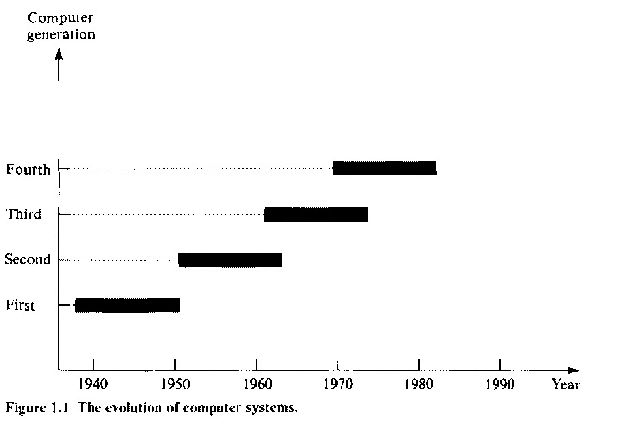
Figure 1.1 The evolution of computer systems
1.2 Trends towards parallel processing
- Trends towards parallel processingin 2 ways:
  - From an application point of view
  - From an operating system point of view
From an application point of view
- Main stream usage of computer –described in 4 ascending levels
- Data processing
Computer usage started with data processing, which is still a major task of today’s computers. Data space is the largest, including numeric numbers in various formats, character symbols, and multidimensional measures
- Information processing
An information item is a collection of data objects that are related by some syntactic structure. Therfore information items form a subspace of data space.
- Knowledge processing
Knowledge consists of information items plus some semantic meanings. Thus knowledge items form a sequence of the information space.
- Intelligence processing
Intelligence is derived from a collection of knowledge items. The intelligence space is represented by the innermost and highest triangle in the Venn diagram.
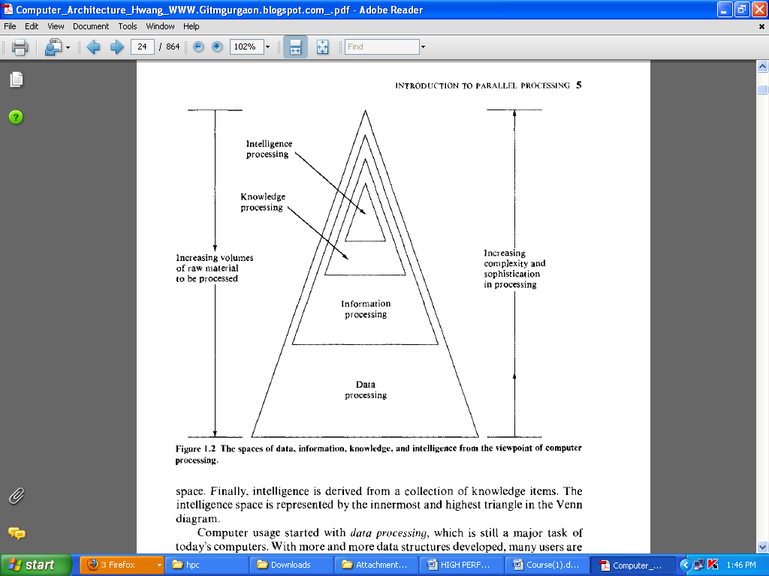
Figure 1.2 The spaces of data, information, knowledge, and intelligence from the viewpoint of computer processing
From an operating system point of view
- computer systems usage described in 4 phases:
• Batch processing,
• Multiprogramming
• Time sharing
• Multiprocessing
In these four operating modes, the degree of parallelism increases sharply from phase to phase.
Definition for parallel processing
Parallel processing is an efficient form of information processing which emphasizes the exploitation of concurrent events in the computing process. Concurrently implies parallelism, simultaneity, and pipelining. Parallel events may occur in multiple resources during the same time interval; simultaneous events may occur at the same time instant; and pipelined events may occur in overlapped time spans.
Parallel processing can be challenged in four programmatic levels:
- Job or program level
- Task or procedure level
- Interinstruction level
- Intrainstruction level
- Job or program level
-The highest level of parallel processing is conducted among multiple jobs or programs through multiprogramming,time sharing, and multiprocessing.
- Task or procedure level
- The next highest level of parallel processing is among procedures or task within the same program.
- decomposition of a program into multiple tasks.
- Inter instruction level
-The third level is to exploit concurrency among multiple instructions.
- Intra instruction level
-Data dependency analysis is often performed to reveal parallelism among instructions.
- Finally, faster and concurrent operations within each instruction.

What is Parallel Computing?
- Traditionally, software has been written for serial computation:
  - To be run on a single computer having a single Central Processing Unit (CPU).
  - A problem is broken into a discrete series of instructions.
  - Instructions are executed one after another.
  - Only one instruction may execute at any moment in time.
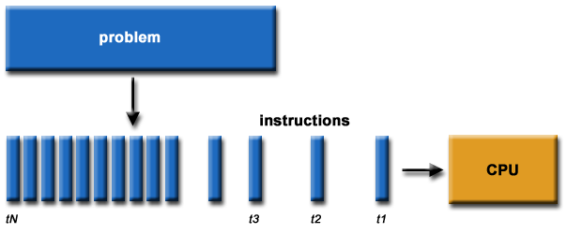
- In the simplest sense, parallel computing is the simultaneous use of multiple compute resources to solve a computational problem:
  - To be run using multiple CPUs
  - A problem is broken into discrete parts that can be solved concurrently
  - Each part is further broken down to a series of instructions
  - Instructions from each part execute simultaneously on different CPUs
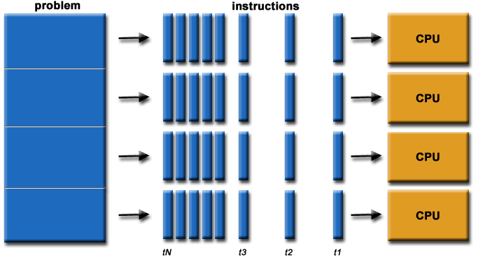
General trend is being shifted away from conventional uniprocessor array processor multiprocessor system
1.3 Parallelism in uniprocessor
Most general purpose uniprocessor systems have the same basic structure. In this section we will briefly review the architecture of uniprocessor systems.
1.3.1 Basic uniprocessor architecture
A typical uniprocessor computer consists of three major components: The main memory, CPU, I/O subsystem. Figure shows the architectural components of the super minicomputer VAX-11/780, manufactured by Digital Equipment Company. The CPU contains the master controller of the VAX system. There are 16 32 bit general purpose registers, one of which serves as program counter. The CPU contains an ALU with an optional floating point accelerator, and some local cache memory with an optional diagnostic memory. The CPU can be intervened by the operator through the console connected to floppy disk. The CPU, the main memory, and the I/O subsystems are all connected to a common bus, the synchronous backplane interconnect(SBI).Through this bus, all I/O devices can communicate with each other, with the CPU, or with the memory. Peripheral storage or I/O devices can be connected directly to the SBI through the unibus and its controller (which can be connected to PDP-l I series minicomputers), or through a massbus and its controller.
Figure 1.3 The system architecture of the supermini VAX-11/780 uniprocessor system
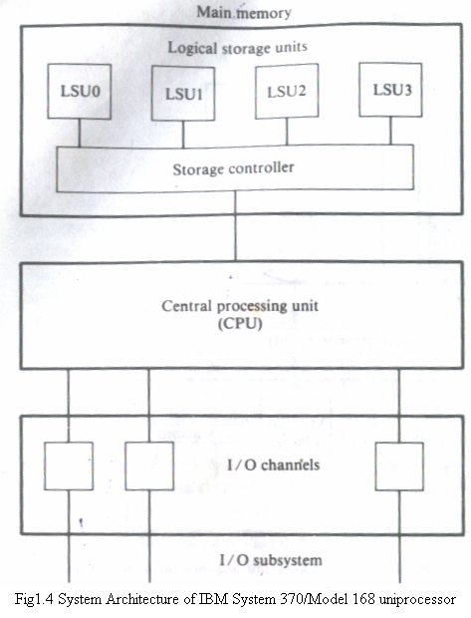
- The CPU contains the instruction decoding and execution units as well as a cache.
- Main memory is divided into four units, referred to as logical storage unit (LSU), that are four-way interleaved.
- The storage controller provides multiport connections between the CPU and the four LSUs.
- Peripherals are connected to the system via high-speed I/ 0 channels which operate asynchronously with the CPU.
- Hardware and software means to promote parallelism in uniprocessor systems are introduced in the next three subsections
1.3.2 Parallel Processing Mechanisms
Six categories of parallel processing Mechanisms
- Multiplicity of functional units
- Parallelism and pipelining within the CPU
- Overlapped CPU and I/O operations
- Use of a hierarchical memory system
- Balancing of subsystem bandwidths
- Multiprogramming and time sharing

Multiplicity of functional units:-
The early computer had only one ALU in its CPU.ALU could only perform one function at a time, a rather slow process for executing a long sequence of arithmetic logic instructions. In practice, many of the functions of ALU can be distributed to multiple and specialized functional units which can operate in parallel. The CDC-6600 has 10 functional units built in to its CPU .These 10 units are independent of each other and may operate simultaneously. A scoreboard is used to keep track of the availability of the functional units and registers being demanded.

Figure 1.4 The system architecture of the CDC-6600 computer

Parallelism and pipelining within the CPU:-
- Parallel adders, using such techniques as carry-look ahead and carry save are now built into almost all ALUs. High speed multiplier recoding and convergence division are techniques for exploring parallelism and sharing of hardware resources for functions of multiply and divide. Instruction executions are now pipelined, including instruction fetch, operand fetch, arithmetic logic execution, and store result.
Overlapped CPU and I/O operations
I/O operations can be performed simultaneously with the CPU computations by using separate I/O controllers, channels or I/O processors. The DMA channel can be used to provide direct information transfer between I/O devices and main memory. The DMA is conducted on a cycle stealing basis, which is apparent to the CPU.
Use of a hierarchical memory system:-
In computer memory hierarchy the innermost level is the register files directly addressable by ALU. Cache memory can be used to serve as a buffer between the CPU and the main memory. Block access of main memory can be achieved through multiway interleaving across parallel memory modules. Virtual memory space can be established with the use of disks and tape units at the outer levels.
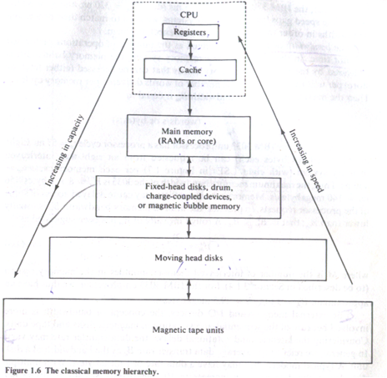

1.3.3 Balancing of subsystem bandwidths:-
- The CPU is the fastest unit in a computer,
- If processor cycle, t_{p}, of tens of nanoseconds,
main memory has a cycle time t_{m} of hundreds of nanoseconds ;
and I/O devices are the slowest with an average access time t_{d} of a few milliseconds.
It is thus observed that t_{d}>t_{m}>t_{p} .
- The bandwidth of a system is defined as the number of operations performed per unit time.
- In the case of a main memory system, the memory bandwidth is measured by the number of memory words that can be accessed per unit time.
- Let W be the number of words delivered per memory cycle tm . Then the maximum memory bandwidth Bm, is equal to .
- In practice the utilized memory bandwidth B_{m}^{u} is usually lower than B_{m} ; that is, B_{m}^{u} < B_{m}
- .A rough measure of B^{u}_{m}, has been suggested as
.
- where M is the number of interleaved memory modules in the memory system

- Based on current technology the following relationships have been observed between the bandwidths of the major subsystems in a high-performance uniprocessor:
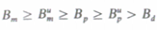
- This implies that the main memory has the highest bandwidth, since it must be updated by both the CPU and the I/0 devices
- Due to the unbalanced speeds, we need to match the processing power of the three subsystems
1.3.3.1Bandwidth balancing between CPU and memory
- The speed a between the CPU and main memory can be closed up by using fast cache memory between them.
- The cache should have an access time t_{c}=t_{p}.
- A block of memory words is moved from the main memory into the cache . The cache serves as a data/instruction buffer.
- 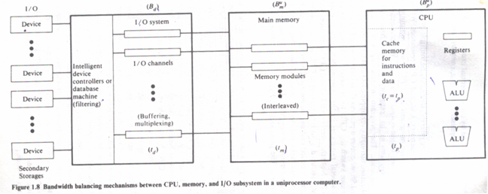

1.3.3.2Bandwidth balancing between memory and I/0 devices
- Input/output channels with different speeds can be used between the slow I/0 devices and the main memory.
- The buffering, multiplexing and filtering operations by the I/O channels thus can provide a faster , more effective data transfer rate, matching that of the memory
Totally balanced system
- To achieve a totally balanced system, in which the entire memory bandwidth matches the bandwidth sum of the processor and I/O devices;
Where B^{u}_{p}=B_{p} and B^{u}_{m}=B_{m} are maximised
1.3.4Multiprogramming and time sharing:-

Multiprogramming:
Within the same time interval there may be multiple processes active in a computer. Competing for memory, I/O, and CPU resources. We are aware of the fact that some computer programs are cpu bound and some are I/O bound .We can mix the execution of various types of programs in the computer to balance bandwidths among the various functional units. Whenever a process P1 is tied up with I/O operations ,the system scheduler can switch the cpu to process p2.When p2 is done cpu can be switched to p3.This interleaving of CPU and I/O operations among several programs is called multiprogramming.
Time sharing:-Sometimes a high priority program may occupy the cpu for too long to allow others to share. This problem can be overcome by using a timesharing operating system. Equal opportunity are given to all programs competing for the use of the CPU. Time sharing is particularly effective when applied to a computer system connected to many interactive terminals.Each user at a terminal can interact with the computer on an instantaneous basis.
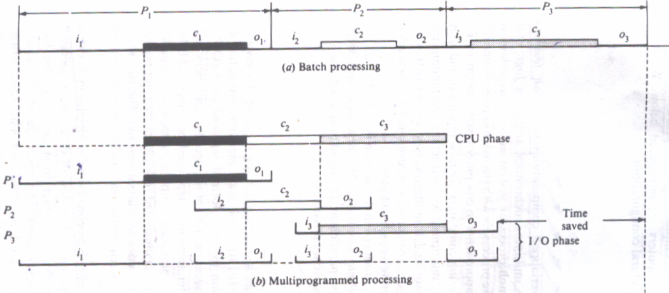
1.4 Parallel computer structures
Parallel computers are those systems that emphasize parallel processing. We divide parallel computers three architectural configurations:
- Pipeline computers
- Array processors
- Multiprocessor systems
- Dataflow computers

- Pipeline computers

A pipeline processor performs overlapped computations to exploit temporal parallelism.
- Array processors
An array processor uses multiple synchronized arithmetic logic units to achieve spatial parallelism.
- Multiprocessor systems
A multiprocessor system achieves asynchronous parallelism through a set of interactive processors with shared resources (memories, database etc.)
- Dataflow Computers
- The conventional von Neumann machines are called control flow computers because instructions are executed sequentially as controlled by a program counter.
- Sequential program execution is inherently slow.
- To exploit maximal parallelism in a program, data flow computers were suggested
- The basic concept is to enable the execution of an instruction whenever it’s available.
- No program counters are needed in initiation depends on data availability, independent of the physical location of an instruction in the program.
- Instructions in a program are not ordered.
The execution follows the data dependency constraints
- Programs for data-driven computations can be represented by data flow graphs.
- An example data flow graph for the expression z=(x+y)*2
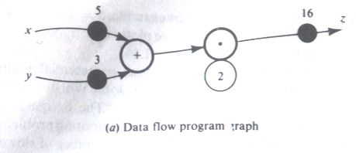
- Each instruction in a data flow computer is implemented as a template, which consists of the operator, operand receivers, and result destinations.
- Operands are marked on the incoming arcs and results on the outgoing arcs
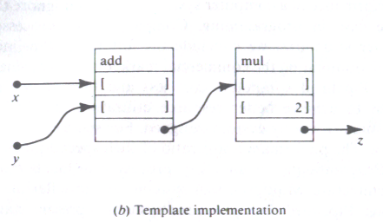
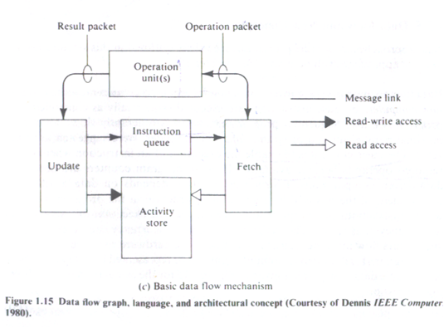
- Activity templates are stored in the activity store.
- Each activity template has a unique address which is entered in the instruction queue when the instruction is ready for execution.
- Instruction fetch and data access are handled by the fetch and update units.
- The operation unit performs the specified operation and generates the result to be delivered to each destination field in the template.
1.4.1 Pipeline Computers
In computing, a pipeline is a set of data processing elements connected in series, so that the output of one element is the input of the next one. Process of executing an instruction in a digital computer involves four major steps:
- instruction fetch (IF) from the main memory;
- instruction decoding (ID), identifying the operation to be performed:
- operand fetch (OF), if needed in the execution
- execution (EX)of the decoded ALU operation.
- In the Pipelined computer, these four steps must be completed before the next instruction can be issued
- In a pipelined computer, successive instructions are executed in an overlapped fashion
- four pipeline stage IF,ID,OF,EX are arranged- into a linear cascade.
- The instruction cycle consists of multiple pipeline cycles.
- The flow of data (input, operand, intermediate results and output results) from stage to stage is triggered by a common clock of the pipeline.
- Interface latches are used between adjacent segments to hold the intermediate results.
- For nonpipelined computer it takes four pipeline cycles to complete one instruction.
- Once a pipeline is filled up an output result is produced from the pipeline on each cycle.

Figure 1.5 Basic concepts of pipelined processor and overlapped instruction execution
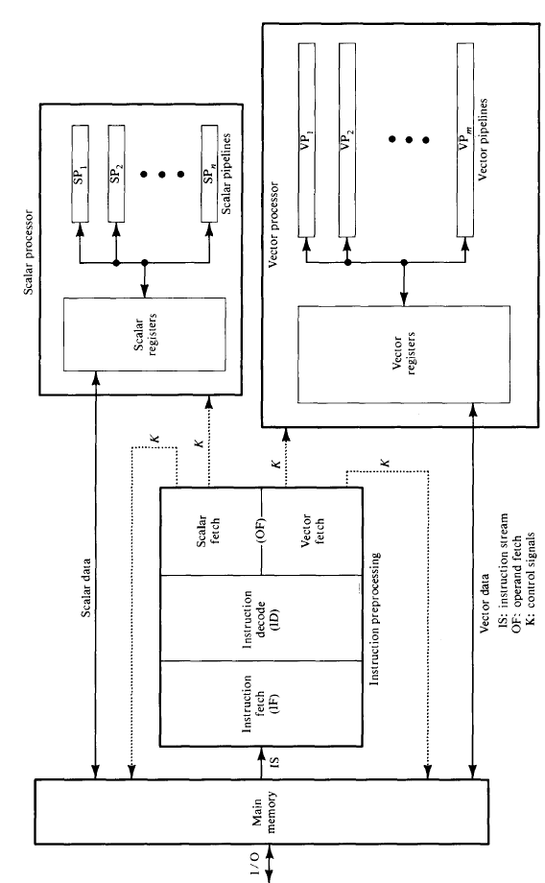
Figure 1.6 Functional structure of a modern pipeline computer with scalar and vector capabilities
- It includes both scalar and vector arithmetic pipelines for processing scalar and vector instructions.
- The instruction preprocessing unit is pipelined with three stages
- The OF stage consists of two independent stages, one for vector operand fetch.
- The scalar registers are fewer in quantity than the vector registers because each vector register implies a whole set of component registers
- Both scalar and vector data could appear in fixed-point or floating-point format.
- Different pipelines be dedicated to different arithmetic logic functions with different data formats.

1.4.2 Array Processors
- Array processor is a synchronous parallel computer with multiple arithmetic units, called processing elements
- By replication of ALUs, one can achieve the spatial parallelism.
- The PE’s are synchronized to perform the same function at the same time.
- An appropriate data-routing mechanism must be established among the PE.
- Scalar and Control-type instructions are directly executed in the control unit (CU).
- Each PE consists of an ALU with registers and a local memory.
- The PEs are interconnected by a data-routing network.
- The interconnection pattern is under program control from the CU.
- Vector instructions are broadcast to the PEs for distributed execution over different component operands fetched directly from the local memories.
- Instruction fetch (from local memories or from the control memory) and decode is done by the control unit.

Figure 1.7 Functional structure of an SIMD array processor with concurrent scalar processing in the control unit

1.4.3 Multiprocessor systems
Figure 1.8 Functional design of an MIMD multiprocessor system

A multiprocessor system contains two or more processors of approximately comparable capabilities. All processors share access to common sets of memory modules, I/O channels and peripheral devices. Besides the shared memories and I/O devices each processor has its own local memory and private devices. Interprocessor communications can be done through the shared memories .Multiprocessor hardware system organization is determined primarily by the interconnection structure to be used between the memories and processors.
1.5 Architecture classification schemes

- Three computer architectural classification schemes
- Flynn’s classification (1966)
Based on the multiplicity of instruction streams and data streams in a computer system.
- Feng’s classification ( 1972)
Based on serial Vs parallel processing..
- Handlers classification (1977)
Based on degree of parallelism and pipelining in various subsystem levels.
1.5.1 Multiplicity of Instruction-Data Streams(Flynn’s classification)
Digital computers may be classified in to 4 categories, according to the multiplicity of instruction and data streams. This scheme for classifying computer organizations was introduced by Michael J Flynn. The essential computing process is the execution of a sequence of instructions on a set of data. An instruction stream is a sequence of instructions as executed by the machine; a data stream is a sequence of data including input, partial, or temporary results, called for by the instruction team.
- Flynn’s taxonomy distinguishes multi-processor computer architectures according to how they can be classified along the two independent dimensions of Instruction and Data. Each of these dimensions can have only one of two possible states: Single or Multiple.
- The matrix below defines the 4 possible classifications according to Flynn:

S I S D  Single Instruction, Single Data | S I M D  Single Instruction, Multiple Data
M I S D  Multiple Instruction, Single Data | M I M D  Multiple Instruction, Multiple Data

Figure 1.9 Flynns classification of various computer organizations

a) Single Instruction, Single Data (SISD) computer organization
This organization represents most serial computers available today. Instructions are executed sequentially but may be overlapped in their execution stages. Most SISD uniprocesor systems are pipelined. A SISD computer may have more than one functional unit in it. All the functional units are under supervision of one control unit.

- A serial (non-parallel) computer
- Single Instruction: Only one instruction stream is being acted on by the CPU during any one clock cycle
- Single Data: Only one data stream is being used as input during any one clock cycle
- This is the oldest and even today, the most common type of computer
- Examples: older generation mainframes, minicomputers and workstations; most modern day PCs.
b) Single Instruction, Multiple Data (SIMD) computer organization
This corresponds to array processors. Here multiple processing elements supervised by the same control unit. All PEs receive the same instruction broadcast from the control unit but operate on different data sets from distinct data streams.
- A type of parallel computer
- Single Instruction: All processing units execute the same instruction at any given clock cycle
- Multiple Data: Each processing unit can operate on a different data element
- Best suited for specialized problems characterized by a high degree of regularity, such as graphics/image processing.
- Synchronous (lockstep) and deterministic execution
- Two varieties: Processor Arrays and Vector Pipelines
- Examples:
  - Processor Arrays: Connection Machine CM-2, MasPar MP-1 & MP-2, ILLIAC IV
  - Vector Pipelines: IBM 9000, Cray X-MP, Y-MP & C90, Fujitsu VP, NEC SX-2, Hitachi S820, ETA10
- Most modern computers, particularly those with graphics processor units (GPUs) employ SIMD instructions and execution units.
c) Multiple Instruction, Single Data (MISD) computer organization
There are n processor units, each receiving distinct instructions operating over the same data stream and its derivatives. The results of one processor become the input of the next processor in the macropipe.This structure has received much less attention and has been challenged as impractical by some computer architects.
- A type of parallel computer
- Multiple Instructions: Each processing unit operates on the data independently via separate instruction streams.
- Single Data: A single data stream is fed into multiple processing units.
- Few actual examples of this class of parallel computer have ever existed. One is the experimental Carnegie-Mellon C.mmp computer (1971).
- Some conceivable uses might be:
- multiple frequency filters operating on a single signal stream
- multiple cryptography algorithms attempting to crack a single coded message

d) Multiple Instruction, Multiple Data (MIMD) computer organization
Most multiprocessor systems and multiple computer systems can be classified in this category. An intrinsic MIMD computer implies interactions among the n processors because all memory streams are derived from the same data space shared by all processors. If the n data streams were derived from disjointed subspaces of the shared memories, then we would have the so called multiple SISD operation, which is nothing but a set of n independent SISD uniprocesor systems.
- A type of parallel computer
- Multiple Instruction: Every processor may be executing a different instruction stream
- Multiple Data: Every processor may be working with a different data stream
- Execution can be synchronous or asynchronous, deterministic or non-deterministic
- Currently, the most common type of parallel computer - most modern supercomputers fall into this category.
- Examples: most current supercomputers, networked parallel computer clusters and "grids", multi-processor SMP computers, multi-core PCs.
- Note: many MIMD architectures also include SIMD execution sub-components

1.5.2 Serial versus Parallel Processing
The maximum number of binary digits that can be processed within a unit time by a computer system is called the maximum parallelism degree P. The maximum parallelism degree P(C) of a given computer system C is represented by the product of the word length n and the bit slice length m;that is p(c)=n.m
There are 4 types of processing methods.
- WSBS
- WPBS
- WSBP
- WPBP

WSBS has been called bit serial processing because one bit (n=m=1) is processed at a time, a rather slow process. This was done only in the first generation computers.WPBS (n=1, m>1) has been called bis processing because an m bit slice is processed at a time.WSBP (n>1.m=1) as found in most existing computers, has been called word slice processing because one word of n bits is processed at a time. Finally WPBP (n>1,m>1)is known as fully parallel processing, in which an array of n.m bits is processed at one time, the fastest processing mode of the four.
Figure 1.10 Fengs computer systems classification
1.5.3 Parallelism versus pipelining
Wolfgang Handler has proposed a classification scheme for identifying the parallelism degree and pipelining degree built into the hardware structures of a computer system. He considers parallel pipeline processing at three subsystem levels
Processor Control unit (PCU)
Arithmetic logic unit (ALU)
Bit level circuit (BLC)
Functions of PCU ,ALU ,BLC:
- Each PCU corresponds to one processor or one CPU.
- The ALU is equivalent to the processing element PE) we specified for SIMD array processors.
The BLC corresponds to the combinational circuitry needed to perform 1-bit operations in the ALU.
- A computer system C,can be charactertized by a triple containing six independent entities, as defined below
T(C) = <K x K’,D x D’, W x W’>
here K = the number of processors (PCUs) within the computer
D = the number of ALUs (or PEs) under the control of one PCU
W- the word length of an ALU or of a PE
W’ = the number of pipeline stages in all ALUs or in a PE
D’ = the number of ALUs that can be pipelined
K’ = the number of PCUs that can be pipelined
- Advanced Scientific Comp(TI-ASC) has one controller controlling four arithmetic pipelines, each has 64-bit word lengths and eight stages. Thus, we have
T(ASC)=(lxl,4x1,64x8>=<l,4,64x8>
Whenever the second entity, K’, D’, or W’, equals 1, we drop it, since pipelining of one stage or of one unit is meaningless.
1.6 Amdahl’s Law
- Used to find the maximum expected improvement to an overall system when only part of the system is improved.It is often used in parallel computing to predict the theoretical maximum speed up using multiple processors.
- The performance gain that can be obtained by improving some portion of a computer can be obtained by improving some portion of a computer can be calculated using Amdhal’s Law
- Amdahl’s law states that the performance improvement to be gained from using some faster mode of execution is limited by the fraction of the time the faster mode can be used.
- Amdahl’s Law can serve as a guide to how much an enhancement will improve performance and how to distribute resources to improve cost performance.
- Amdhal’s Law defines the speedup that can be gained by using a particular feature .
- Speedup is the ratio
- Speed up= Performance for entire task using the enhancement when possible
Performance for entire task without using enhancement.
Alternatively
- Speed up= Execution time for entire task without using the enhancement.
Execution time for entire task using the enhancement.
- Speed up tells how much faster a task will run using the computer with the enhancement as opposed to the original computer.

1.7 Indian contributions to parallel processing
India has made significant strides in developing high-performance parallel computers .Many Indians feel that the presence of these systems has helped create a high-performance computing culture in India, and has brought down the cost of equivalent international machines in the Indian marketplace. However, questions remain about the cost-effectiveness of the government funding for these systems, and about their commercial viability.India’s government decided to support the development of indigenous parallel processing technology. In August 1988 it set up the Center for Development of Advanced Computing (C-DAC).
The C-DAC’s First Mission was to deliver a 1 -Gflop parallel supercomputer by 1991. Simultaneously, the Bhabha Atomic Research Center (BARC), the Advanced Numerical Research & Analysis Group (Anurag) of the Defense Research and Development Organization, the National Aerospace Laboratory WAL) of the Council of Scientific and Industrial Research, and the Center for Development of Telematics (C-DOT) initiated complementary projects to develop high-performance parallel computers. Delivery of India’s firstgeneration parallel computers started in 1991.
- Param

The C-DAC’s computers are named Pairam (parallel machine), which means “supreme” in Sanskrit. The first Param systems, called the 8000 series, used Innios 800 and 805 Transputers as computing nodes.Although the theoretical peak-performance of a 256-node Param was 1 Gflop (a singlenode T805 performs at 4.25 Mflops), its sustained performance in an actual application turned out to be between 100 and 200 Mflops. The C-DAC named the programming environment Pavas, after the mythical stone that can turn iron into gold by mere touch.
Early in 1992, the C-DAC realized that the Param 8000’s basic compute node was underpowered, so it integrated Intel’s i860 chip into the Param architecture. The objective was to preserve the same application programming environment and provide straightforward hardware upgrades by just replacing the Param 8000’s compute- node boards. This resulted in the Param 8600, architecture with the i860 as a main processor and four Transputers as communication processors, each with four built-in links. The CDAC extended Paras to the Param 8600 to give a user view identical to that of the Param 8000. Param 8000 applications could easily port to the new machine.
The C-DAC claimed that the sustained performance of the 16-node Param 8600 ranged from 100 to 200 Mflops, depending on the application. Both the C-DAC and the Indian government considered that the First Mission was accomplished and embarked on the Second Wssion, to deliver a teraflopsrange parallel system capable of addressing grand challenge problems. This machine, the Param 9000, was announced in 1994 and exhibited at Supercomputing ’94. The C-DAC plans to scale it to teraflops- level performance.
The Param 9000’s multistage interconnect network uses a packet-switching wormhole router as the basic switching element. Each switch can establish 32 simultaneous non blocking connections to provide a sustainable bandwidth of 320 Mbytes per second. The communication links conform to the IEEE P13 55 standards for point-to-point links. The Param 9000 architecture emphasizes flexibility. The C-DAC hopes that, as new technologies in processors, memory, and communication links become available, those elements can be upgraded in the field. The first system is the Param 9000/SS, which is based on SuperSparc processors. A complete node is a 75-MHz Supersparc I1 processor with 1 Mbyte of external cache, 16 to 12 8 Mbytes of memory, one to four communication links, and related I/O devices. When new MBus modules with higher frequencies become available, the computers can be field-upgraded. Users can integrate Sparc workstations into the Param 9000/SS by adding a Sbus-based network interface card. Each card supports one, two, or four communication links. The C-DAC also provides the necessary software drivers.
- Anupam

The BARC, founded by Homi Bhabha and located in Bombay, is India’s major center for nuclear science and is at the forefront of India’s Atomic Energy Program. Through 1991 and 1992, BARC computer facility members started interacting with the C-DAC to develop a high-performance computing facility. The BARC estimated that it needed a machine of 200 Mflops sustained computing power to solve its problems. Because of the importance of the BARC’s program, it decided to build its own parallel computer. In 1992, the BARC developed the Anupam (Sanskrit for “unparalleled”) computer, based on the standard Multibus I1 i860 hardware. Initially, it announced an eight-node machine, which it expanded to 16, 24, and 32 nodes. Subsequently, the BARC transferred Anupam to the Electronics Corporation of India, which manufactures electronic systems under the umbrella of India’s Department of Atomic Energy.
System Architecture
Anupam has a multiple-instruction, multiple- data (MIMD) architecture realized through off-the-shelf Multibus I1 i860 cards and crates. Each node is a 64-bit i860 processor with a 64-Kbyte cache and a local memory of 16 to 64 Mbytes. A node’s peak computing power is 100 Mflops, although the sustained power is much less. The first version of the machine had eight nodes in a single cluster (or Multibus I1 crate). There is no need for a separate host. Anupam scales to 64 nodes. The intercluster message-passing bus is a 32-bit Multibus II backplane bus operating at 40 Mbytesls peak. Eight nodes in a cluster share this bus. Communication between clusters travels through two 16-bit-wide SCSI buses that form a 2D mesh. Standard topologies such as a mesh, ring, or hypercube can easily map to the mesh.

- PACE

Anurag, located in Hyderabad, focuses on R&D in parallel computing; VLSIs; and applications of high-performance computing in computational fluid dynamics, medical imaging, and other areas. Anurag has developed the Proces- SOT for Aevodynamzc Computations and Evaluatzon, a loosely-coupled, messagepassing parallel processing system. The PACE program began in August 1988. The initial prototypes used the 16.67-MHz Motorola MC 68020 processor. The first prototype had four nodes and used a VME bus for communication. The VME backplane works well with Motorola processors and provided the necessary bandwidth and operational flexibility. Later, Anurag developed an eight-node prototype based on the 2s-MHz MC 68030. This cluster forms the backbone of the PACE architecture. The 128-node prototype is based on the 33-MHz MC 68030. To enhance the floating-point speed, Anurag has developed a floating-point processor, Anuco. The processor board has been specially designed to accommodate the MC 68881, MC 68882, or the Anuco floating-point accelerators. PACE+, the latest version, uses a 66- MHz HyperSparc node. The memory per node can expand to 256 MBytes.

- FLOSOLVER

In 1986, the NAL, located in Bangalore, started a project to design, develop, and fabricate suitable parallel processing systems to solve fluid dynamics and aerodynamics problems. The project was motivated by the need for a powerful computer in the laboratory and was influenced by similar international developments Flosolver, the NAL’s parallel computer, was the first operational Indian parallel computer. Since then, the NAL has built a series of updated versions, including Flosolver Mkl and MklA, four-processor systems based on 16-bit Intel 8086 and 8087 processors, Flosolver MklB, an eight-processor system, Flosolver Mk2, based on Intel’s 32-bit 80386 and 80387 processors, and the latest version, Flosolver Mk3, based on Intel’s 1860 RISC processor.

- Chipps

The Indian government launched the CDOT to develop indigenous digital switching technology. The C-DOT, located in Bangalore, completed its First Mission in 1989 by delivering technologies for rural exchanges and secondary switching areas. In February 1988, the C-DOT signed a contract with the Department of Science and Technology to design and build a 640-Mflop, 1,000- MIPS-peak parallel computer. The CDOT set a target of 200 Mflops for sustained performance.
System Architecture
C-DOTS High Performance Parallel Processing System (Chipps) is based on the single-algorithm, multiple-data architecture. Such architecture provides coarse-grain parallelism with barrier synchronization, and uniform startup and simultaneous data distribution across all configurations. It also employs off-the-shelf hardware and software. Chipps supports large, medium, and small applications. The system has three versions: a 192-node, a 64-node, and a 16-node machine.
In terms of performance and software support, the Indian high-performance computers hardly compare to the best commercial machines. For example, the C-DAC’s 16-node Param 9000/SS has a peak performance of 0.96 Gflops, whereas Silicon Graphics’ 16-processor Power Challenge has a peak performance of 5.96 Gflops, and IBM’s 16- processor Para2 model 590 has a peak performance of 4.22 Gflops. However, the C-DAC hopes that a future Param based on DEC Alpha processors will match such performance.

Applications of parallel processing

i) Predictive Modeling and Simulations
Predictive modelling is done through extensive computer simulation experiments which often involve large scale computations to achieve the desired accuracy and turnaround time.
- Numerical Weather forecasting :
Weather modelling is necessary for short range forecasts and long range hazard predictions, such as flood, drought, and environmental pollutions.
- Oceanography and astrophysics:
A good understanding of the ocean will help in the following areas:

*Climate predictive analysis

*Fishery management

*Ocean resource exploration

*Coastal dynamics and tides

- Socioeconomics and government use:
Large computers are in great demand in the areas of econometrics, government causes, crime control, and the modelling of the world economy.

ii) Engineering design and automation
Useful in solving many engineering problems such as the finite element analysis needed for the structural designs and wind tunnel experiments for the aerodynamic studies.
- Finite element analysis
The design of dams, bridges, ships, supersonic jets, high buildings, and space vehicles require the resolution of a large system of algebraic equations or partial differential equations. Many researchers and engineers have attempted to build more efficient computers to perform finite element analysis or to seek finite difference solutions.
- Computational aerodynamics
Large scale computers have made significant contributions in providing new technological capabilities and economies in pressing ahead with aircraft and spacecraft lift and turbulent studies.
- Artificial Intelligence and automation
Listed below are intelligence functions which demand parallel processing
*Image processing
*Pattern recognition
*Computer vision
*Speech understanding
*Machine inference
*CAD/CAM/CAI/OA
*Intelligence robotics
*Expert computer system
*Knowledge engineering
- Remote sensing applications
Computer analysis of remotely sensed earth resource data has many potential applications in agriculture, forestry, geology, and water resources. Explosive amounts of pictorial information need to be processed in this area.

iii) Energy Resource Exploration
Computers can play an important role in the discovery of oil and gas and the management of their recovery, in the development of workable plasma fusion energy, and in ensuring nuclear reactor safety.
- Seismic Exploration
Many oil companies are investing in the use of attached array processors or vector supercomputers for seismic data processing, which accounts for about 10 percent of the oil finding costs.
- Reservoir modeling
Supercomputers are used to perform 3-D modeling of oil fields. The reservoir problem is solved by using the finite difference method on the 3-D representation of the field.
- Plasma fusion power
Nuclear fusion researchers are pushing to use a computer 00 times more powerful than any existing one to model the plasma dynamics.
- Nuclear reactor safety
Nuclear reactor design and safety control can both be aided by computer simulation studies. These studies attempt to provide for
*online analysis of reactor conditions
*automatic control for normal and abnormal operations
*simulation of operator training
*Quick assessment of potential accident mitigation procedures

iv) Medical, military and basic research
In the medical area, fast computers are needed in computer assisted tomography, artificial heart design, liver diagnosis, brain damage estimation, and genetic engineering studies.
- Computer assisted tomography
The human body can be modeled by computer assisted tomography
- Genetic engineering
Biological systems can be simulated on supercomputers. There is a growing need for large scale computations to study molecular biology for the synthesis of complex organic molecules.
- Weapon research and defense
Listed below are several defense related military applications of supercomputers
*Multiwarhead nuclear weapon design
*Simulation of atomic weapon effects by solving hydrodynamics and radiation problems
*Intelligence gathering such as radar signal processing on the associative processor for the antiballistic missile program
*Cartographic data processing for automatic map generation
*Sea surveillance for anti submarine warfare
- Basic research problems

Below are several additional areas that demand the use of supercomputers
*Computational chemists solve problems on quantum mechanics, statistical mechanics, polymer chemistry, and crystal growth.
*Computational physicists analyze practical tracks generated in spark chambers, study fluid dynamics, examine quantum field theory, and investigate molecular dynamics.
*Electronic engineers solve large scale circuit equations using the multilevel Newton algorithm, and lay out VLSI connections on semiconductor chips.

