MODULE 5
Introduction – Fuzzy Set
Natural languages are vague. In real world concepts do not have sharply defined boundaries
Eg- many ,tall,much larger than, young
These concepts are true to some degree &false to some degree as well. These concepts/facts are called Fuzzy or vague or gray concepts. Human brain will work with fuzzy concepts, while computers may not do it. Natural languages are fuzzy, where as programming languages are not.
Classical set
The classical set or crisp set is defined by means of the definite or crisp boundaries. The crisp sets are sets without ambiguity in their membership.
Eg-The clock speeds of computers CPUs.The integers 1–100.
Operations on Classical Sets
Consider two sets A and B defined on the universe X. The definitions of the operation for classical sets are based on the two sets A and B defined on the universe X.The operations that can be performed on the classical sets are
The Union of two classical sets A and B is denoted by A ∪ B. It represents all the elements in the universe that reside in either the set A, the set B or both sets A and B. This operation is called the logical OR.In set theoretic form it is represented as A ∪ B = {x/x ∈ A or x ∈ B}
The intersection of two sets A and B is denoted A∩B. It represents all those elements in the universe X that simultaneously reside in (or belongs to) both sets A and B.In set theoretic form it is represented as A ∩ B = {x/x ∈ A and x ∈ B} .
The complement of set A denoted A, is defined as the collection of all elements in the universe that do not reside in the set A.In set theoretic form it is represented as A = {x/x ∈ A, x ∈ X} .
The difference of a set A with respect to B, denoted A|B is defined as collection of all elements in the universe that reside in A and that do not reside in B simultaneously.In set theoretic form it is represented as A|B = {x/x ∈ A and x ∈ B}
Properties of classical Set
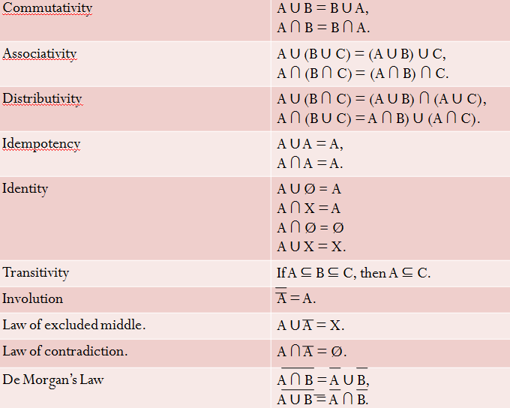
Membership function of classical set
In classical set membership fn, assigns a value 1 or 0 to each individual element in universal set, there by discriminating b/w members and non members under consideration.
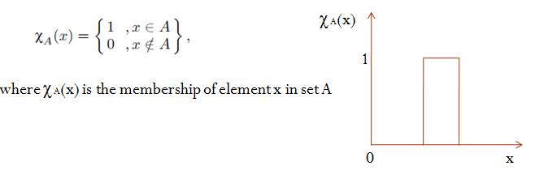
Mapping of Classical Sets to a Function
Union
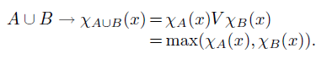
Here V indicates the maximum operator.
Intersection
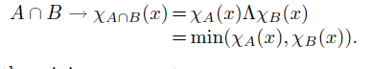
Here Λ indicates the minimum operator.
Complement
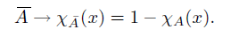
Containment
The two sets A and B in universe, if one set (A) is contained in another set B, then
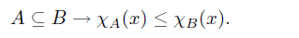
Fuzzy sets
Fuzzy sets provide means to model the uncertainty associated with vagueness, imprecision, and lack of information regarding a problem.A fuzzy set is a set containing elements that have varying degree of membership in the set
In crisp sets, characteristic fn or membership fn is given by
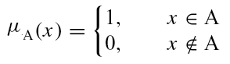
In fuzzy sets, membership function is a function in [0,1] that represents the degree of belonging.
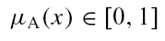
Formal definition of fuzzy set
For any fuzzy set A, the function µ_{A} represents the membership function for which µ_{A}(x) indicates the degree of membership that x, of the universal set X, belongs to set A and is, usually, expressed as a number between 0 and 1.
µ_{A}(x) : X [0,1]
The translation from x to µA(x) is known as fuzzification . Fuzzy sets can be either discrete or continuous.
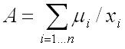A Discrete set, A is defined as:
A = µ₁ /x₁+µ₂/x₂+…..+µ_{n}/x_{n} or
Where, x₁ ,x₂ , ….. x_{n} : members of the set A,µ₁, µ₂,…..µ_{n} are x₁ , x₂ ….. x_{n} ’s degree of membership.
A continuous fuzzy set, A can be defined as:
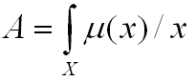
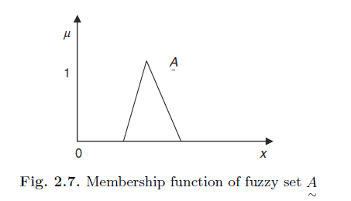
. Fuzzy Set Operations
Considering three fuzzy sets A,B,C on the universe X. For a given element x of the universe, the following theoretic operations are defined
Union
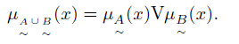
Intersection
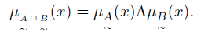
Complement
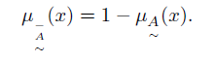
Difference
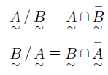
Properties of Fuzzy Set

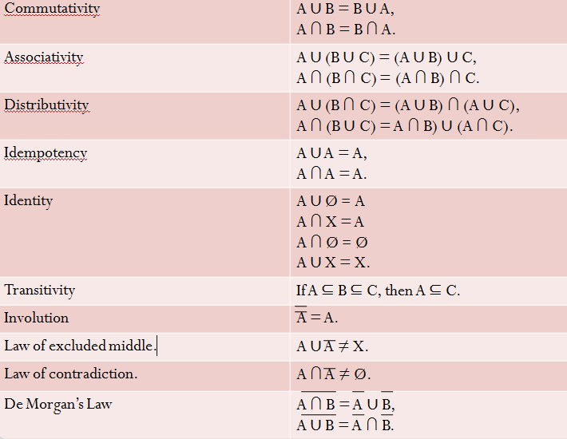
Membership Functions
The feature of the membership function is defined by three properties. They are:
1.Core
If the region of universe is characterized by full membership (1) in the set A then this gives the core of the membership function of fuzzy at A.The elements, which have the membership function as 1, are the elements of the core, i.e μA(x) = 1.
2.Support
If the region of universe is characterized by nonzero membership in the set A this defines the support of a membership function for fuzzy set A.The support has the elements whose membership is greater than 0. μA(x) ) > 0.
3. Boundary
If the region of universe has a nonzero membership but not full membership,this defines the boundary of a membership; this defines the boundary of a membership function for fuzzy set A.The boundary has the elements whose membership is between 0 and 1, 0 <μA(x) < 1.
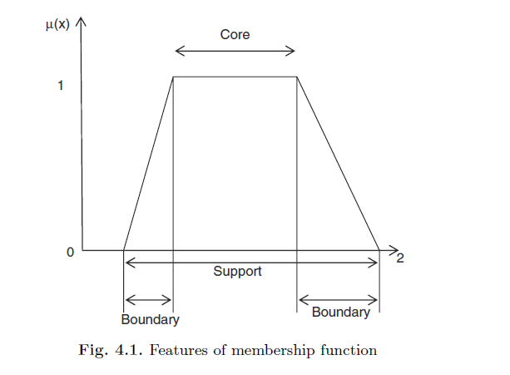
Crossover point-The crossover point of a membership function is the elements in universe whose membership value is equal to 0.5, μA(x) = 0.5.
Height-The height of the fuzzy set A is the maximum value of the membership function, max (μA(x))
Classification of Fuzzy Sets
Normal fuzzy set. -If the membership function has at least one element in the universe whose value is equal to 1, then that set is called as normal fuzzy set.
Subnormal fuzzy set. -If the membership function has the membership values less than 1, then that set is called as subnormal fuzzy set.
Convex fuzzy set. -If the membership function has membership values those are monotonically increasing, or, monotonically decreasing, or they are monotonically increasing and decreasing with the increasing values for elements in the universe, those fuzzy set A is called convex fuzzy set.
Non convex fuzzy set.-If the membership function has membership values which are not strictly monotonically increasing or monotonically decreasing or both monotonically increasing and decreasing with increasing values for elements in the universe, then this is called as nonconvex fuzzy set

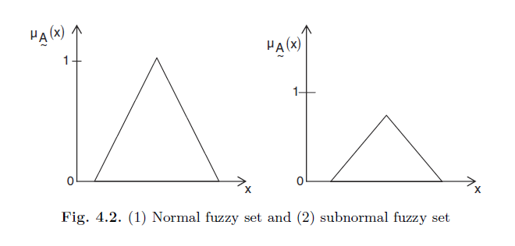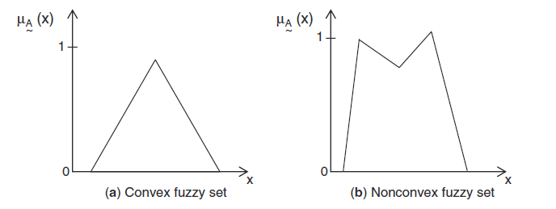
Some membership functions
Triangular function:
defined by a lower limit a, an upper limit b, and a value m, where a < m < b.
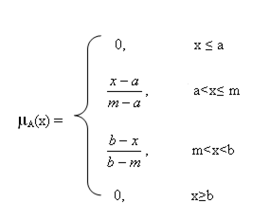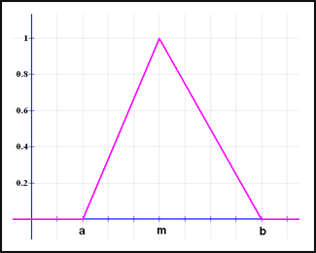
Trapezoidal function:
defined by a lower limit a, an upper limit d, a lower support limit b, and an upper support limit c, wherea < b < c < d.
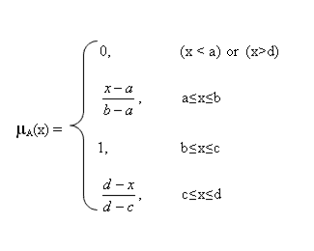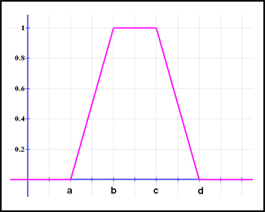
Gaussian function:
defined by a central value m and a standard deviation k > 0. The smaller k is, the narrower the “bell” is
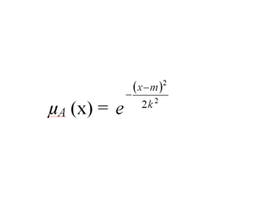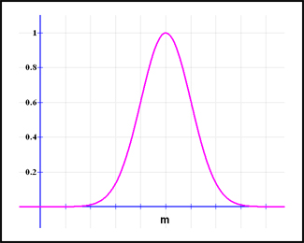

Introduction – Expert Systems
Expert system solve problems normally solved by human experts.These are highly domain specific.To solve expert level problems, expert system need
- Access to substantial knowledge base
- Use of one or more reasoning mechanisms
- Mechanism for explanation
Architecture of expert system
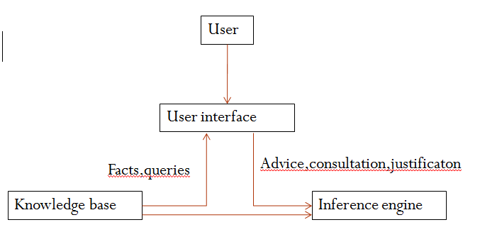
User interface-Allows user to enter rules and facts about a particular situation and ask questions to the system. Provide responses to user requests. It supports all other communication between system and user.
Knowledge base - Developed by experts in the area. Data is in the form of rules.it is updated regularly so that system provides most relevant and complete assistance to the user – knowledge acquisition module.
Inference Engine-Uses rules provided by Knowledge base and the user to infer new facts.
Representing and Using Domain Knowledge.
Most widely used way for representing knowledge is a Set of production rules of the form if-then, which is often coupled with a frame system that defines the object that occur in the rules
Reasoning with the Knowledge
Expert System represent knowledge in a rule format. Hence also known as Rule-Based Expert System.Some reasoning mechanisms:
- Forward chaining (R1)
- backward chaining(MYCIN)
- justification-based truth maintenance system(DESIGN ADVISOR ).

Some Expert Systems
MYCIN
Developed by Edward Shortliffe,Bruce G Buchanan and Stanley N Cohen in LISP Its an early expert system to identify bacteria causing severe infections and to recommend antibiotics, with dosage adjusted for patient’s body weight.MYCIN attempts to recommend appropriate therapies for patients with bacterial infections.It is never used in practice,but has an acceptance in 69% of cases. It interacts with physician to acquire clinical data it needs.
MYCIN represents most of its diagnostic knowledge as a set of rules.Rule has a certainty factor associated with it, which is a measure of the extent to which the evidence that is described by the antecedent of the rule supports the conclusion that is given in the rule’s consequent. Certainty factor has a value between 0 and 1.MYCIN use rules to reason backward to clinical data available to find the disease causing organism and then it attempts to select therapy to treat the disease
R1 or XCON
R1(XCON or eXpert CONfigurer ) is written in OPS5 by john Mcdermott .It is used in design domain.Used to select the computer system components based on the customer's requirements.It assist in the ordering of DEC’s VAX computer systems by automatically selecting the computer system components based on customer requirements.It has an accuracy of 95-98%.Before XCON, every cable, connection had to be ordered separately. The sales people were not always very technically expert, so customers would find that components were often didnt match. XCON interact with the sales person, asking critical questions and prepare a coherent and workable system specification/order slip.
Unlike MYCIN, there is no measure of certainty in rules of RI.In R1’s domain it is possible to state exactly what it has to do for each situation. Good human expertise is involved in this area .As it is design task alternatives need not be considered
PROSPECTOR
It is developed by P E Hart and R O Duda in LISP.It provides advice on mineral exploration.It provide active consultation on problems of mineral exploration and resource evaluation.
Here, each rule contains two confidence estimates.The first estimate indicates the extent to which the presence of evidence described in the condition part of rule suggests the validity of rule’s conclusion.The second estimate indicates the extent to which the lack of evidence indicates that the conclusion is not valid.
DESIGN ADVISOR
Developed by robin L Steele, Scott A Richardson and Michel A Winchell .Its an expert system that critics chip designs. It give advice to chip designer, who can accept or reject the advice.If designer rejects an advice ,system can use aa justification-based truth maintenance to revise its model of circuit
Expert system shells
Expert System is usually built from scratch in LISP.But several systems has a lot of common things.Most systems have a set of rules combined with interpreter. It is possible to separate interpreter from domain specific knowledge. The resulting interpreter is called shell.New expert system can be built by adding new knowledge corresponding to problem domain.A single expert system shell can be used to build a number of different expert systems..Expert system shells must provide mechanisms for knowledge representation, reasoning, explanation and knowledge acquisition.Shells must be easy to integrate and must provide easy to use interface
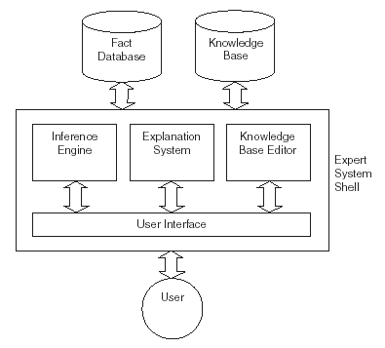
EMYCIN or Empty MYCIN or Essential MYCIN is a shell derived from MYCIN.Its a domain-independent version of MYCIN that contains all of MYCIN except its knowledge. EMYCIN facilitated the development of other expert systems, such as PUFF, an application for the diagnosis of pulmonary problems.
Explanation
In order for an expert system to be an effective tool, people must be able to interact with it easily.To facilitate this interaction, expert system should have the following two capabilities in addition to its underlying task:
1.Explain its reasoning : People will not accept results unless they are convinced of the accuracy of the reasoning process that produced the results. Reasoning process must proceed in understandable way and enough meta knowledge must be available to generate explanations
2. Acquire new knowledge and modifications of old knowledge: Expert systems derive their power from the richness of the knowledge bases they exploit. Hence it should be complete and accurate. One way to get the knowledge is through interaction with human expert, another way is to have program learn expert behavior from raw data.
TEIRESIAS was the first program to support explanation and knowledge acquisition.It is developed by Randall Davis and is written in INTERLISP.TEIRESIAS served as the front end for the MYCIN expert system. Program asks for information to continue reasoning. doctor wants to know why the pgm wants that information and later asks how the pgm arrived at a conclusion that it claimed.Questions were answered using goal tree and backward reasoning .The production system model is very general. So, it fails to provide all explanations that a human wants. TEIRESIAS-MYCIN just answers questions “why” and “how”.
SALT is a knowledge acquisition pgm developed by Sandra Marcus and John McDermott.It is used to built expert systems that design artifacts ans consturct schedule through ‘propose and revise strategy’.SALT is capable of answering additional questions like “why-not” and “what-if”.A human might ask such questions to locate incorrect or missing knowledge in system
Knowledge acquisition
In building expert systems,a knowledge engineer collect expert knowledge and it is translated into rules.,then it is iteratively refined.There are many programs that interact with domain experts to extract expert knowledge efficiently.These programs provide support for the following activities:
- Entering knowledge.
- Maintaining knowledge base consistency.
- Ensuring knowledge base completeness.
There are two ways to get domain knowledge
- One way to get the knowledge is through interaction with human expert.
- To have program learn expert behavior from raw data.
MOLE
Knowledge acquisition tool developed by Larry J Eshelman and John McDermott.It’s a system for heuristic classification problem, such as diagnosing diseases.An expert system produced by MOLE accepts input data, comes up with a set of explanations or classifications that cover(or explain) the data, then uses differentiating knowledge to determine which one is the best. The process is iterative.MOLE interacts with a domain expert to produce a knowledge base that a system called MOLE-performance uses to solve problems.The acquisition proceeds through several steps:
- Initial Knowledge base construction:
- Refinement of the knowledge base
SALT
SALT is a knowledge acquisition pgm developed by Sandra Marcus and John McDermott It is used to built expert systems that design artifacts and construct schedule through ‘propose and revise strategy’.The system first proposes an extension to the current design. Then it checks whether the extension violates any global or local constraints. Constraint violations are fixed and the process repeats. Domain experts must list overall design constraints, but they need not be so good at explaining how to arrive at global solutions. An expert can watch problem solving system and can override system’s decision
META DENDRAL
First program to use learning techniques to construct rules for an expert system automatically. It build rules to be used by DENDRAL ,whose job was to determine the structure of complex chemical compounds.DENDRAL help organic chemists in identifying unknown organic molecules, by analyzing their mass spectra and using knowledge of chemistry.META DENDRAL was able to induce its rules based on a set of mass spectrometry data, it was then able to identify molecular structures with very high accuracy. META DENDRAL uses Version space algorithm

