MODULE 3

Knowledge Representation

Knowledge is very important in artificial intelligence systems. Knowledge is to be represented properly. It becomes clear that particular knowledge representation models allow for more powerful problem solving mechanisms that operate on them.A good Knowledge Representation system should possess the following

- Representational Adequacy
- Inferential Adequacy
- Inferential Efficiency
- Acquisitional Efficiency

Some techniques are

- Simple relational knowledge
- Inheritable knowledge
- Inferential knowledge
- Procedural knowledge

Semantic Nets

The following diagram shows a semantic network in which some knowledge is stored. Here it shows how some
Knowledge on cricket is represented.
Here boxed nodes represent objects and values of attributes of objects. These values can also be viewed as objects
with attributes and values, and so on. The arrows on the lines point from an object to its value along the corresponding attribute line.
.
From the above semantic network, answers to the following questions can be derived.
Team (Dravid) = India
Batting average (Dravid) = 36
Height (Akhtar) = 6-1
Bats (Dravid) = Right

The main idea behind semantic nets is that the meaning of a concept comes from, the ways in which it is connected
to other concepts. In a semantic net, information is represented as a set of nodes connected to each other by a set of
labeled arcs, which represent relationships among the nodes.

Frames

A frame is a collection of attributes (slots) and associated values that describe some entity in the world.
Consider a node in the semantic network below.
The following is the frame corresponding to cricket player.
Cricket player

Is a : Adult male
bats : (EQUAL handed )
height : 6 1
batting average : 48

There is so much flexibility in this frame representation, since this can be used to solve particular representation
problems. A single frame taken alone has not much use. Instead, we build frame systems out of collections of frames that are connected to each other. Frame systems are used to encode knowledge and support reasoning.

Propositional and Predicate Logic

Logic is concerned with reasoning and the validity of arguments. Logic is concerned with truth values. The possible truth values are true and false. Logic is widely used in computer science, and particularly in Artificial Intelligence. Logic is widely used as a representational method for Artificial Intelligence
Logical Operators
Here we see the four most basic logical operators being used in everyday language. The operators are:
- and ∧
- or ∨
- not ￢
- implies →
- iff ↔

Truth Tables
Not
And Or
∧is also called the conjunctive operator. ∨is also called the disjunctive operator.

A ∧B is the conjunction of A and B. A ∨B is the disjunction of A and B.
Implies Iff
Propositional Logic

There are a number of possible systems of logic. The language that is used to express propositional logic is called the propositional calculus.

A logical system can be defined in terms of its syntax (the alphabet of symbols and how they can be combined), its semantics (what the symbols mean), and a set of rules of deduction that enable us to derive one expression from a set of other expressions and thus make arguments and proofs.

Syntax

The alphabet of symbols, _ is defined as follows Σ = {true, false, ￢,→, (, ), ∧, ∨,↔, p1, p2, p3, . . . , pn, . . . }
An expression is referred to as a well-formed formula (often abbreviated as wff) or a sentence if it is constructed correctly, according to the rules of the syntax of propositional calculus
The following are well formed sentences:
P,Q,R. . .true, false ,(A),￢A,A ∧ B,A ∨ B,A→B,A↔ B
Hence, we can see that the following is an example of a wff:
P ∧ Q ∨ (B ∧ ￢C)→A ∧ B ∨ D ∧ (￢E)

Semantic

The semantics of the operators of propositional calculus can be defined in terms of truth tables.

Predicate Calculus

Syntax
Predicate calculus allows us to reason about properties of objects and relationships between objects.
- The symbol is read “for all,” is called the universal quantifier.
- The quantifier can be used to express the notion that some values do have a certain property, it is existential quantifier

First-Order Predicate Logic

The type of predicate calculus that we have been referring to is also called first order predicate logic (FOPL). A first-order logic is one in which the quantifiers can be applied to objects or terms, but not to predicates or functions.

Representing facts in Logic

We can easily represent real-world facts as logical propositions written as well-formed formulas (wff's) in propositional logic,

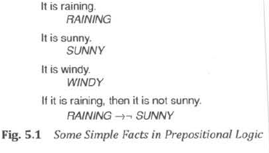

The following represents some facts in the real world and corresponding predicate calculus expressions.
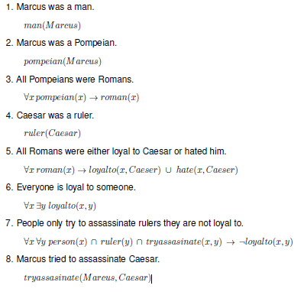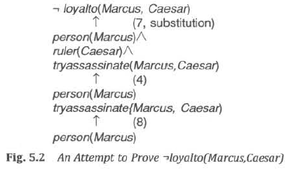

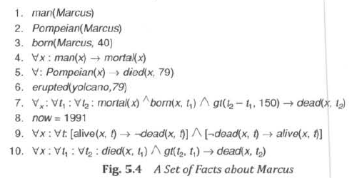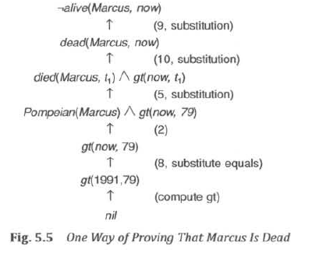

Resolution

Resolution produces proofs by refutation. In other words, to prove a statement (i.e., show that it is valid), resolution attempts to show that the negation of the statement produces a contradiction with the known statements (i.e. , that it is unsatisfiable). This approach contrasts with the technique that we have been using to generate proofs by chaining backward from the theorem to be proved to the axioms
Resolution is a technique for proving theorems in the propositional or predicate calculus. Resolution proves a theorem by negating the statement to be proved and adding this negated goal to the set of axioms.
Resolution proofs involve the following steps.
1. Put the premises or axioms in to clause form.
2. Add the negation of what is to be proved, in clause form, to the set of axioms.
3. Resolve these clauses together, producing new clauses that logically follow from them.
4. Produce a contradiction by generating the empty clause.
5. The substitutions used to produce the empty clause are those under which the opposite of the negated goal is
true. Resolution requires that the axioms and the negation of the goal be placed in a normal form called clause form. Clause form represents the logical database as a set of disjunctions of literals.

Conversion to clause form

The resolution procedure requires all statements in the data base to be converted to a standard form called clause form. The form is referred to as conjunction of disjuncts. The following is the algorithm for reducing any set of predicate calculus statements to clause form.

Algorithm: Convert to Clause Form

- Eliminate →, using the fact that a → b is equivalent to ¬ a V b.
- Reduce the scope of each ¬ to a single term, using the fact that ¬ (¬ p) = p, deMorgan's laws [which say that ¬ (a ∧ b) = ¬ a V ¬ b and ¬ (a V b) = ¬ a ∧ ¬ b ], and the standard correspondences between quantifiers [¬ ∀x: P(x) = ∃x: ¬ P(x) and ¬ ∃x: P(x) = ∀ x: ¬P(x)].
- Standardize variables so that each quantifier binds a unique variable.
For example, the formula
∀x: P(x) V ∀x: Q(x) would be converted to ∀x: P(x) V ∀y: Q(y)
- Move all quantifiers to the left of the formula without changing their relative order. At this point, the formula is in what is known as prenex normal form. It consists of a prefix of quantifiers followed by a matrix, which is quantifier-free.
- Eliminate existential quantifiers. We can eliminate the quantifier by substituting for the variable a reference to a function that produces the desired value..
So, for example, the formula
∃y : President(y) can be transformed into the formula President(S1)
where S1 is a function with no arguments that somehow produces a value that satisfies President.
∀x: ∃y: father-of(y, x) would be transformed into ∀x: father-of(S2(x), x)
These generated functions are called Skolem functions. Sometimes ones with no arguments are called Skolem constants.
- Drop the prefix
- Convert the matrix into a conjunction of disjuncts. In the case or our example, since there are no and’s, it is only necessary to exploit the associative property of or [ i.e., (a ∧ b) V c = (a V c) ∧ (b ∧ c)] and simply remove the parentheses
- Create a separate clause corresponding to each conjunct.

After applying this entire procedure to a set of wff's, we will have a set of clauses, each of which is a disjunction of literals. These clauses can now be exploited by the resolution procedure to generate proofs.

The Basis of Resolution

The resolution procedure is a simple iterative process: at each step, two clauses, called the parent clauses, are compared (resolved), yielding a new clause that has been inferred from them. The new clause represents ways that the two parent clauses interact with each other. Resolution operates by taking two clauses that each contain the same literal, in this example, winter. The literal must occur in positive form in one clause and in negative form in the other. The resolvent is obtained by combining all of the literals of the two parent clauses except the ones that cancel.
If the clause that is produced is the empty clause, then a contradiction has been found.
For example, the two clauses
winter
¬ winter
will produce the empty clause. If a contradiction exists, then eventually it will be found. Of course, if no contradiction exists, it is possible that the procedure will never terminate, although as we will see, there are often ways of detecting that no contradiction exists.

Resolution in Propositional Logic

In propositional logic, the procedure for producing a proof by resolution of proposition P with respect to a set of axioms F is the following.

Algorithm: Propositional Resolution

1 . Convert all the propositions of F to clause form.
2. Negate P and convert the result to clause form. Add it to the set of clauses obtained in step 1.
3. Repeat until either a contradiction is found or no progress can be made:
(a) Select two clauses. Call these the parent clauses.
(b) Resolve them together. The resulting clause, called the resolvent, will be the disjunction of all of
the literals of both of the parent clauses with the following exception: If there are any pairs of literals
L and ¬ L such that one of the parent clauses contains L and the other contains ¬ L, then select one
such pair and eliminate both L and ¬ L from the resolvent.
(c) If the resolvent is the empty clause, then a contradiction has been found. If it is not, then add it to
the set of clauses available to the procedure.

Let's look at a simple example. Suppose we are given the axioms shown in the first column of Fig. 5.7 and we want to prove R. First we convert the axioms to clause form, as shown in the second column of the figure.

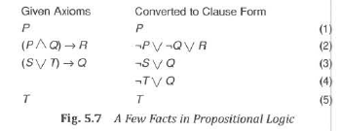

Unification Algorithm

In propositional logic, it is easy to determine that two literals cannot both be true at the same time. Simply look for L and ¬ L in predicate logic, this matching process is more complicated since the arguments of the predicates must be considered. For example, man(John) and ¬ man(John) is a contradiction, while man(John) and ¬ man(Spot) is not. Thus, in order to determine contradictions, we need a matching procedure that compares two literals and discovers whether there exists a set of substitutions that makes them identical. There is a straightforward recursive procedure, called the unification algorithm, that does just this.

The basic idea of unification is very simple. To attempt to unify two literals, we first check if their initial predicate symbols are the same. If so, we can proceed. Otherwise, there is no way they can be unified, regardless of their arguments.

Algorithm: Unify(L1, L2)

I. If L1 or L2 are both variables or constants, then:
(a) If L1 and L2 are identical, then return NIL.
(b) Else if L1 is a variable, then if L1 occurs in L2 then return {FAIL}, else return (L2/L1).
(c) Else if L2 is a variable, then if L2 occurs in L1 then return {FAIL} , else return (L1/L2).
(d) Else return {FAIL}.
2. If the initial predicate symbols in L1 and L2 are not identical, then return {FAIL}.
3. If LI and L2 have a different number of arguments, then return {FAIL}.
4. Set SUBST to NIL. (At the end of this procedure, SUBST will contain all the substitutions used to unify L1 and L2.)
5. For i ← 1 to number of arguments in L1 :
(a) Call Unify with the ith argument of L1 and the ith argument of L2, putting result in S.
(b) If S contains FAIL then return {FAIL}.
(c) If S is not equal to NIL then:
(i) Apply S to the remainder of both L1 and L2.
(ii) SUBST: = APPEND(S, SUBST).
6. Return SUBST.

Resolution in Predicate Logic

Algorithm: Resolution

1. Convert all the statements of F to clause form.
2. Negate P and convert the result to clause form. Add it to the set of clauses obtained in 1.
3. Repeat until either a contradiction is found , no progress can be made, or a predetermined amount of effort has been expended.
(a) Select two clauses. Call these the parent clauses.
(b) Resolve them together. The resolvent will be the disjunction of all the literals of both parent
clauses with appropriate substitutions performed and with the following exception: If there is one
pair of literals T1 and ¬ T2 such that one of the parent clauses contains T2 and the other contains T1
and if T1 and T2 are unifiable, then neither T1 nor T2 should appear in the resolvent. We call T1 and
T2 Complementary literals. Use the substitution produced by the unification to create the resolvent.
If there is more than one pair of complementary literals, only one pair should be omitted from the
resolvent.
(c) If the resolvent is the empty clause, then a contradiction has been found. If it is not, then add it to
the set of clauses available to the procedure.

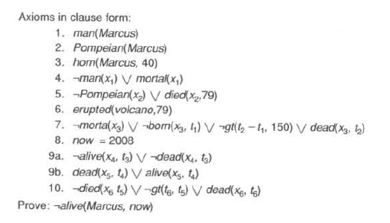
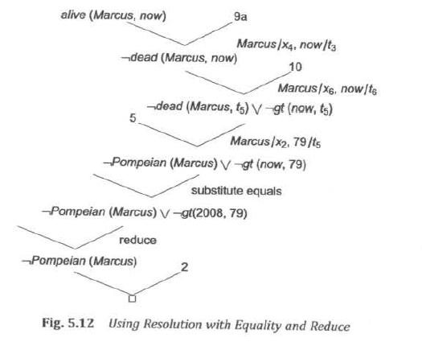

Question Answering

In this section, we show how resolution can be used to answer fill-in-the-blank questions, such as "When did Marcus die?" or "Who tried to assassinate a ruler?” Answering these questions involves finding a known statement that matches the terms given in the question and then responding with another piece of the same statement that fills the slot demanded by the question. For example, to answer the question "When did Marcus die?" we need a statement of the form died(Marcus, ??) with ?? actually filled in by some particular year. So, since we can prove the statement
died(Marcus, 79) we can respond with the answer 79.

It turns out that the resolution procedure provides an easy way of locating just the statement we need and finding a proof for it

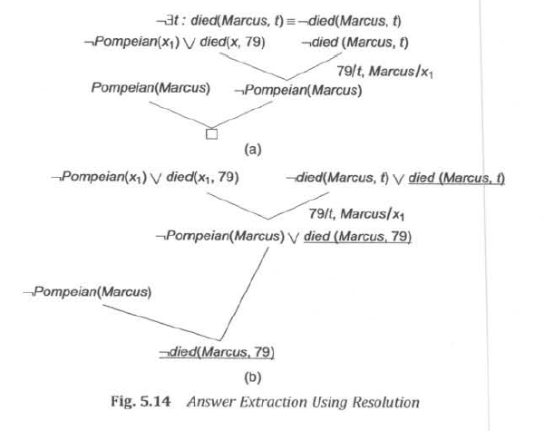

Forward Chaining and Backward Chaining

The completeness of resolution makes it a very important inference method. In many practical situations, however, the full power of resolution is not needed. Real world knowledge bases often contain only clauses of a restricted kind called Horn clauses. A Horn clause is a disjunction of literals of which at most one is positive. Inference with Horn clauses can be done through the forward and backward chaining algorithms. In both these techniques, inference steps are obvious and easy to follow for humans.

Forward Chaining

The forward chaining method is very simple: Start with the atomic sentences in the knowledge base and apply modus Ponens in the forward direction, adding new atomic sentences, until no further inferences can be made.
In many cases, the reasoning with forward chaining can be much more efficient than resolution theorem proving

Backward Chaining

Many inference techniques use backward chaining approach. These algorithms work backward from the goal, chaining through rules to find known facts that support the proof. The list of goals can be thought of as a stack waiting to be worked on: if all of them can be satisfied, then the current branch of the proof succeeds. The backward chaining algorithm takes the first goal in the list and finds every clause in the knowledge base whose positive literal or head, unifies with the goal. Each such clause creates a new recursive call in which the premise, or body, of the clause is added to the goal stack.

