MODULE 2
Best First Search

Best first search is a general informed search strategy. Here a node is selected for an expansion based on an evaluation function, f(n). Traditionally, the node with the lowest evaluation is selected for expansion. It is implemented using a priority queue.Best first search combines breadth first and depth first search. That is to follow a single path at a time, but switch paths whenever some competing path looks more promising than the current one does.
Best first search uses 2 lists, open and closed.
- Open is used to keep track of the current fringe of search, and
- Closed is used to record states already visited.
Here open acts as a priority queue. Algorithm orders the states in open according to some heuristic estimate of their
“closeness” to a goal. Each iteration of the loop considers the most promising state on the open list. At each iteration,best first search removes the first element from the open list. If it meets the goal conditions, the algorithm returns the solution path that led to the goal.
The best first search algorithm always selects the most promising state on open for further expansion. It does not
abandon all other states but maintains them on open. In the event, a heuristic leads the search down a path that proves incorrect, the algorithm will eventually retrieve some previously generated, next best state from open and shifts its focus to another part of the space

OR Graphs
Useful for certain problems where the solution involves decomposing the problem into smaller problems.We then solve these smaller problems. Here the alternatives often involve branches where some must be satisfied before we can progress
A* Search Algorithm

We need a heuristic function that estimates a state. We call this function f’. it is convenient to define this function as the sum of 2 components, g and h’.
- The function g is the actual cost of getting from the initial state to the current state .
- The function h’ is an estimate of the cost of getting from the current state to a goal state .
Thus f’ = g + h’The function f’, then, represents an estimate of the cost of getting from the initial state to a goal state (m) alongthe path that generated the current state .If this function f’ is used for evaluating a state in the best first search algorithm, the algorithm is called A*search algorithm.

Problem reduction

AND –OR graphs

Useful for representing the solution of problem by decomposing it into smaller sub-problems Each sub-problem is solved and final solution is obtained by combining solutions of each sub-problem.Decomposition generates arcs that we will call AND arc. One AND arc may point to any number of successors, all of which must be solved. Such structure is called AND–OR graph rather than simply AND graph.

To find a solution in AND–OR graph, we need an algorithm similar to A* with the ability to handle AND arc appropriately.In search for AND-OR graph, we will also use the value of heuristic function f for each node.

- Traverse AND-OR graph, starting from the initial node and follow the current best path.
- Accumulate the set of nodes that are on the best path which have not yet been expanded.
- Pick up one of these unexpanded nodes and expand it.
- Add its successors to the graph and compute f (using only h) for each of them.
- Change the f estimate of newly expanded node to reflect the new information provided by its successors.
- Propagate this change backward through the graph to the start.
- Mark the best path which could be different from the current best path.
- Propagation of revised cost in AND-OR graph was not there in A*.

AO* Algorithm

Algorithm for searching AND-OR graph is called AO*. Here we maintain single structure G, representing the part of the search graph explicitly generated so far rather than two lists, OPEN and CLOSED as in previous algorithms.
Each node in the graph will point both down to its immediate successors and up to its immediate predecessor.
have an h value (an estimate of the cost of a path from current node to a set of solution nodes) associated with it.

- A terminal node is labeled as"solved" if it is a goal node (representing a solution of sub-problem) ,"unsolved" otherwise (as we can not further reduce it)
- A non-terminal AND node labeled as"solved" if all of its successors are "solved","unsolved" as soon as one of its successors is labeled "unsolved".
- A non-terminal OR node is labeled as,"solved" as soon as one of its successors is labeled "solved","unsolved" if all its successors are "unsolved".

Constraint Satisfaction Search

Search can be used to solve problems that are limited by constraints, such as the eightqueens problem. Such problems are often known as Constraint Satisfaction Problems, or CSPs because a solution must be found that satisfies the constraints.

Games as Search problem

For AI researchers, the nature of games makes them an attractive subject for study. The state of a game is easy to
represent and agents are limited to a small number of actions. Precise rules are there for making these actions. By 1950, chess playing program was developed by Zuse, Shannon, Wiener and Turing.

Minimax Search Procedure

We will consider games with 2 players. The 2 players in a game are referred to as MIN and MAX. MAX represents the player trying to win or to MAXimize his advantage. MIN is the opponent who attempts to MINimize MAX’s score. MAX moves first, and then they take turns moving until the game is over. At the end of the game, points are awarded to the winning player and penalties are given to the loser.

A game can be formally defined as a kind of search problem with the following components.
- The initial state, which identifies the board position and identifies the player to move.
- A successor function, which returns a list of (move, state) pairs, each indicating a legal move and the resulting state.
- A terminal test, which determines when the game is over. States where the game has ended are called terminal states.
- A utility function (also called an objective function) which gives a numeric value for the terminal states.

In chess,the outcome is a win, loss or draw with values +1, -1 or 0.

Search Strategies

In a normal search problem, the best solution is a sequence of moves leading to a goal state. In a game, on the other
hand, MIN has a role. MAX therefore must find a contingent strategy. Even a simple game like tic-tac-toe is too complex for us to draw the entire game tree. The nodes are MAX nodes, in which it is MAX’s turn to move and the nodes are MIN nodes. The terminal states show the utility values for MAX.

Given a game tree, the optimal strategy can be determined by examining the minimax value of each node, which we
write as minimax-value (n). The minimax-value of a node is the utility for MAX of being in the corresponding state. The minimax-value of a terminal state is just its utility. Given a choice, MAX will prefer to move to a state of maximum value, whereas MIN prefers a state of minimum value. So we have

MINIMAX search algorithm for game trees. [Russel]
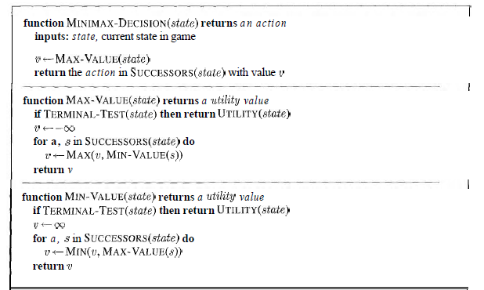

Alpha- Beta Pruning

The problem with minimax search is that a large number of states need to be examined. We can effectively cut it in half using a technique called alpha beta pruning. Here the trick is that it is possible to compute the correct minimax decision without looking at every node in the game tree. The general principle is this. Consider a node ’n’ somewhere in the tree; such that player has a choice of moving to that node. If player has a better choice ’m’ either at the parent node of ’n’ or at any choice further up, then ’n’ will never be reached in actual play.

Alpha beta pruning gets its name from the following 2 parameters, a and b.
- a– the value of the best (ie. Highest value) choice we have found so far at any choice point along the path for MAX.
- b – the value of the best (ie. Lowest value) choice we have found so far at any choice point along the path for MIN.

Alpha-beta search updates the values of a and b as it goes along and prunes the remaining branches at a node as
soon as the value of the current node is known to be worse than the current a or b value for MAX or MIN, respectively

Alpha Beta pruning algorithm for search trees [Russel]

